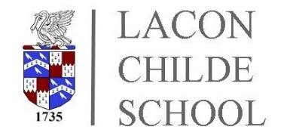

Lacon Childe School

EMERGENCY CLOSURE

In the event that school cannot open due to adverse weather conditions or an emergency situation, we will aim to send a ParentMail message to all parents/carers as soon as possible after the decision has been made, usually following liaison with bus companies. Notification of closure or change to school timings will also be sent to local radio stations (BBC Shropshire 96FM, WM 95.6FM & Sunshine Radio 105.9FM). The school website will be updated if possible.

In the case of bad weather during the school day, we often have to make quick decisions about whether to close the school in order to allow time for the school buses to start and complete their routes safely.

The method of communicating with all parents/carers via text message (ParentMail) is effective and we have found this has worked very well in the past.

We obviously need to make sure that all pupils get home safely with the minimum delay. The system we use involves sending all pupils home who travel on school buses or walk if they live locally. If this is necessary, we will send a text to the mobile number of the first contact to advise that the school is closing. If you normally transport your child(ren) to and from school, please make arrangements to collect them without delay. However, if you would like your child(ren) to walk to a local address, please inform the School Office. Please note that children can only use the bus for which they have a pass - they are not allowed to use any other route. In addition, it will not be possible for children not already using the school buses to be taken to any other relation/contact out of the immediate local area. In the case of special needs pupils, we will ensure that they are helped and fully understand what arrangements have been put in place for them.

PLEASE ENSURE THAT THE SCHOOL IS NOTIFIED IMMEDIATELY IF ANY CONTACT DETAILS CHANGE AND YOUR CHILD KNOWS WHAT ARRANGEMENTS ARE IN PLACE FOR THEM

