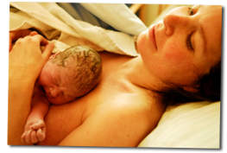
Childbirth
- What child birth choices are available to the pregnant mother?

- Some women are advised to have their baby in hospital. List 8 reasons why this medical advice may be given.

- Where is a woman most likely to have her baby today?

- Describe a birthing unit.

- List 6 advantages of having a baby
- At home

- In hospital

- Describe the Domino scheme and give 4 advantages of this to the expectant mother and her family.

- Name three pain relief options that are
- Drugs

- Drug free

- List 6 reasons why a woman may need help with the delivery of the baby.

- Explain what induction means.

- Give three reasons why a mother may be induced.

