Year 9 Independent Learning
- Look back at previous topic sentence builders to self quiz. ( e.g future plans, clothes, going out, past tense)
You can practise translation, speaking and writing to embed meaning, pronunciation and spelling of words
Refer to phonics sheet to remind you have to pronounce words (annotate in pencil to help e.g. syllables/ silent letters with a dot etc)
Cover English and translate into French – then check and correct
Cover French – look at English and try to write out translation – check – correct
Look Cover Write Check Correct Repeat until confident

- Read through new topic vocab Module 1 Qui suis –je and any sentence builders and follow above activities
- Practise 3 main tenses Present Past 1/ future 1 (past 2 and Future 2 – if want to) by referring to common Verbs sheet
- Design revision sheet for revision topic

On line resources
https://www.languagesonline.org.uk look at left hand side and click français to revise Y7 and 8 vocab click First or Second Year Learning (Encore Tricolore 1 or 2)
You could work through exercises
Second year – good perfect tense revision practice Les Questions au Passé Composé (Unité 5) (PAST TENSE) Les Verbes avec être au Passé Composé (Unité 6) (PAST TENSE)

https://quizlet.com/gb/topic/languages/french/ search for topic to practise vocab
www.memrise.com is another website where you can practise GCSE Edexcel French vocabulary (or make you own activities on this website) Some of the exercises have sound files to help improve listening skills
Search for Who am I / Qui Suis –je Edexcel GCSE French Higher or Foundation. There might be a picture as below

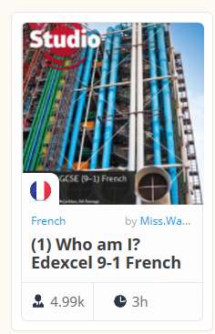
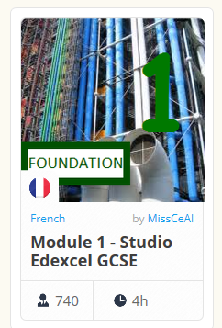

Year 9 Independent Learning
- Look back at previous topic sentence builders to self quiz. ( e.g future plans, clothes, going out, past tense)
You can practise translation, speaking and writing to embed meaning, pronunciation and spelling of words
Refer to phonics sheet to remind you have to pronounce words (annotate in pencil to help e.g. syllables/ silent letters with a dot etc)
Cover English and translate into French – then check and correct
Cover French – look at English and try to write out translation – check – correct
Look Cover Write Check Correct Repeat until confident

- Read through new topic vocab Module 1 Qui suis –je and any sentence builders and follow above activities
- Practise 3 main tenses Present Past 1/ future 1 (past 2 and Future 2 – if want to) by referring to common Verbs sheet
- Design revision sheet for revision topic

On line resources
https://www.languagesonline.org.uk look at left hand side and click français to revise Y7 and 8 vocab click First or Second Year Learning (Encore Tricolore 1 or 2)
You could work through exercises
Second year – good perfect tense revision practice Les Questions au Passé Composé (Unité 5) (PAST TENSE) Les Verbes avec être au Passé Composé (Unité 6) (PAST TENSE)

https://quizlet.com/gb/topic/languages/french/ search for topic to practise vocab
www.memrise.com is another website where you can practise GCSE Edexcel French vocabulary (or make you own activities on this website) Some of the exercises have sound files to help improve listening skills
Search for Who am I / Qui Suis –je Edexcel GCSE French Higher or Foundation. There might be a picture as below

