AQA Sample Paper: GCSE English Language

Paper 1: Explorations in creative reading and writing

Time allowed: 1 hour 45 minutes

- The marks for questions are shown in brackets.
- The maximum mark for this paper is 80.
- There are 40 marks for Section A and 40 marks for Section B.
- You are reminded of the need for good English and clear presentation in your answers.
- You will be assessed on the quality of your reading in Section A.
- You will be assessed on the quality of your writing in Section B.
You are advised to spend about 15 minutes reading through the Source and all five questions you have to answer. You should make sure you leave sufficient time to check your answers.

Source A
This extract is from a novel by Yann Martel. In this section the central character, Pi, is on a sinking ship. The ship is carrying the animals belonging to Pi’s father, who owns a zoo.
Life of Pi
Inside the ship, there were noises. Deep structural groans. I stumbled and fell. No harm done. I got up. With the help of the handrails I went down the stairwell four steps at a time. I had gone down just one level when I saw water. Lots of water. It was blocking my way. It was surging from below like a riotous crowd, raging, frothing and boiling. Stairs vanished into watery darkness. I couldn't believe my eyes. What was this water doing here? Where had it come from? I stood nailed to the spot, frightened and incredulous and ignorant of what I should do next. Down there was where my family was.
I ran up the stairs. I got to the main deck. The weather wasn't entertaining any more. I was very afraid. Now it was plain and obvious: the ship was listing badly. And it wasn't level the other way either. There was a noticeable incline going from bow to stern. I looked overboard. The water didn't look to be eighty feet away. The ship was sinking. My mind could hardly conceive it. It was as unbelievable as the moon catching fire.
Where were the officers and the crew? What were they doing? Towards the bow I saw some men running in the gloom. I thought I saw some animals too, but I dismissed the sight as illusion crafted by rain and shadow. We had the hatch covers over their bay pulled open when the weather was good, but at all times the animals were kept confined to their cages. These were dangerous wild animals we were transporting, not farm livestock. Above me, on the bridge, I thought I heard some men shouting.
The ship shook and there was that sound, the monstrous metallic burp. What was it? Was it the collective scream of humans and animals protesting their oncoming death? Was it the ship itself giving up the ghost? I fell over. I got to my feet. I looked overboard again. The sea was rising. The waves were getting closer. We were sinking fast.
I clearly heard monkeys shrieking. Something was shaking the deck, a gaur - an Indian wild ox -exploded out of the rain and thundered by me, terrified, out of control, berserk. I looked at it, dumbstruck and amazed. Who in God's name had let it out?
I ran for the stairs to the bridge. Up there was where the officers were, the only people on the ship who spoke English, the masters of our destiny here, the ones who would right this wrong. They would explain everything. They would take care of my family and me. I climbed to the middle bridge. There was no one on the starboard side. I ran to the port side. I saw three men, crew members. I fell. I got up. They were looking overboard. I shouted. They turned. They looked at me and at each other. They spoke a few words. They came towards me quickly. I felt gratitude and relief welling up in me. I said, "Thank God I've found you. What is happening? I am very scared. There is water at the bottom of the ship. I am worried about my family. I can't get to the level where our cabins are. Is this normal? Do you think-"
One of the men interrupted me by thrusting a life jacket into my arms and shouting something in Chinese. I noticed an orange whistle dangling from the life jacket. The men were nodding vigorously at me. When they took hold of me and lifted me in their strong arms, I thought nothing of it. I thought they were helping me. I was so full of trust in them that I felt grateful as they carried me in the air. Only when they threw me overboard did I begin to have doubts.
Section A: Reading
Answer all questions in this section.
You are advised to spend about 45 minutes on this section.

Q1. Read again the first part of the Source from lines 1 to 12.

List four things from this part of the text about the ship.
[4 marks]

Q2. Look in detail at this extract from lines 13 to 25 of the Source:

Where were the officers and the crew? What were they doing? Towards the bow I saw some men running in the gloom. I thought I saw some animals too, but I dismissed the sight as illusion crafted by rain and shadow. We had the hatch covers over their bay pulled open when the weather was good, but at all times the animals were kept confined to their cages. These were dangerous wild animals we were transporting, not farm livestock. Above me, on the bridge, I thought I heard some men shouting.
The ship shook and there was that sound, the monstrous metallic burp. What was it? Was it the collective scream of humans and animals protesting their oncoming death? Was it the ship itself giving up the ghost? I fell over. I got to my feet. I looked overboard again. The sea was rising. The waves were getting closer. We were sinking fast.
I clearly heard monkeys shrieking. Something was shaking the deck, A gaur-an Indian wild ox-exploded out of the rain and thundered by me, terrified, out of control, berserk. I looked at it, dumbstruck and amazed. Who in God's name had let it out?

How does the writer use language here to describe the narrator’s fright and confusion?

You could include the writer’s choice of:
- words and phrases
- language features and techniques
- sentence forms
[8 marks]

Q3. You now need to think about the whole of the Source.

This extract comes at the end of a chapter.

How has the writer structured the text to interest you as a reader?

You could write about:
- what the writer focuses your attention on at the beginning
- how and why the writer changes this focus as the Source develops
- any other structural features that interest you
[8 marks]

Q4. Focus this part of your answer on the second part of the Source from line 19 to the end.

A student, having read this section of the text, said: ‘The writer makes the reader feel sympathetic for the narrator.’

To what extent do you agree?

In your response, you could:
- write about your own impressions of the narrator
- evaluate how the writer has created these impressions
- support your opinions with references to the text
[20 marks]

Section B: Writing
You are advised to spend about 45 minutes on this section.
Write in full sentences.
You are reminded of the need to plan your answer.
You should leave enough time to check your work at the end.

Q5. You are going to enter a creative writing competition.

Your entry will be judged by a panel of people of your own age.

Either: Write a description suggested by this picture:

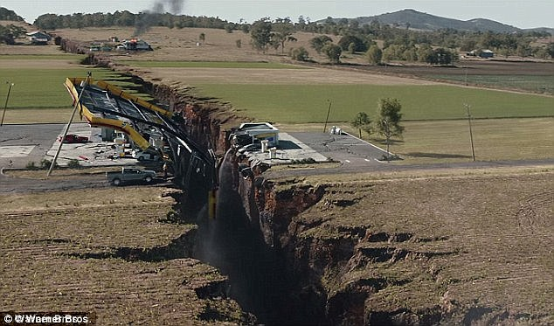

Or: Write a story opening in which a dramatic event occurs.

(24 marks for content and organisation
16 marks for technical accuracy)
[40 marks]

