AQA GCSE History Paper 2 – British Depth Study
Norman England c1066 – c1100 Revision Booklet

Name: ...........................................................
 | Specification content | Revision tasks complete? (Y/N) | RAG your confidence
1 | Anglo-Saxon England before 1066
2 | The death of Edward the Confessor and claims to the English throne
3 | The Battle of Stamford Bridge and the Battle of Hastings
4 | Revolts against the Normans and the Harrying of the North
5 | Norman military innovations, including castles
6 | William I’s control of England
7 | Government in Norman England
8 | Norman justice and the legal system
9 | Domesday Book
10 | Life in Norman England
11 | Similarities and differences between life in Anglo-Saxon and Norman England
12 | Norman reforms to the English Church
13 | Church organisation, reforms made by William Rufus
14 | Norman relations with the Papacy
15 | Monasteries and monastic life
16 | Norman church and education
Question types
- How convincing…

- Explain what was important about…

- Write an account..

- The main reason

Task 1 – Anglo-Saxon England before 1066
10 point summary
- England was a wealthy country with around 2 million people living in it. Most of these people lived in the south, with fewer in the north and west.
- Religion was important, everyone followed Catholic Christianity and accepted what the Church said as absolute fact.
- Edward the Confessor had ruled since 1042 and his reign had been largely stable and peaceful. His rule was aided by the Witan.
- Society was ordered by a hierarchy where people were ordered by their level of importance. The king was at the top, followed by the Church. Earls, thegns and then peasants at the bottom.
- There were hardly any castles in England and it was not very well defended.
- Most of the southern half of England was covered in forest and there were small villages where the forest had been cleared and land was farmed.
- The king had earls to help him rule England. Each earl helped rule a different part of England.
- The king had earls and housecarls who were professionally trained soldiers – there were around 2500-3000 housecarls in England.
- The most powerful earl in England was Earl Godwin who had a close relationship with King Edward but who had publicly fallen out with him in 1052.
- England had good trade links with other countries such as Norway and France. It had a sophisticated minting system – it made its own coins – and had one of the most advanced economic systems in the known world at this time.
Task: based on the 10 point summary, what were the positives and negatives of Anglo-Saxon England?
Positives of Anglo-Saxon England | Negatives of Anglo-Saxon England

Task 2 – The Death of Edward the Confessor and
Claims to the English Throne
Task: complete the paragraph, using the words in the box below
Confessor 4 1066 Witan Children Godwin 1042

Edward the ______________ had been king of England since _______. He had reigned England with the support of the __________ which was a council of English earls and bishops, such as Earl __________. Edward the Confessor died in January _______ without leaving any ____________. As a result, it was unclear who would become king. There were ______ powerful men who put their claim forward for the throne, however these claimants were from different countries and had different
levels of support.
Task: match up the claimants to the English throne in 1066 with the information that explains who they were and what their claim was.
The great nephew of Edward which made him the closest blood relative. He was not named as an heir by Edward, even though he had lived with Edward since he was a child and was treated as though he was Edward’s adopted son. He was an Anglo-Saxon and had the support of many earls, but he was young and inexperienced.

The King of Norway, he was a powerful Viking with a large and successful army. He was related to King Cnut who had ruled England from 1016-1035 and he claimed that as he was a relative of the previous king, that he should now be king of England.

Was a distant cousin of Edward the Confessor. Had grown up with Edward the Confessor and supported him when Earl Godwin had rebelled against him in 1051. Thought that he had been promised the throne by Edward several years before his death and claimed that he had the support of Harold Godwinson.
Was not a blood relation to the king, but was the brother in law of Edward the Confessor. He was the richest man in England and had helped Edward to rule – especially towards the end of his reign. He was a skilful military leader who had beaten a Welsh invasion and therefore had the support of the English lords. Edward’s dying wish was that this person become king of England.

Harold Godwinson

William of Normandy

Harald Hardrada

Edgar Aetheling

January – September 1066
Task: Fill in the gaps in the timeline of events leading up to the Battle of Hastings.
Edward the Confessor
________ on 5th January
1066. The next day, __________ _____________
is crowned king of England.
Harold Godwinson begins to
_________ for an
___________ from Normandy.

During this time, William’s preparations meant that he was well prepared for an attack.
In spring 1066, Harold’s brother Tostig raids England, attacking the south coast and Lincolnshire. He is fought off by Anglo-Saxon earls and flees to Scotland.

Tostig and _____ _________ landed near ______ and fought the Battle of __________. Anglo-Saxon earls Edwin and Morcar were ___________ but were not __________. York surrendered.
At the beginning of September, Harold sent his army home to gather in the _________. At the same time, Tostig and _______ ________ started sailing down the coast from Scotland.

Despite defeating and _________ Tostig and Hardrada, 3 days after his victory at Stamford Bridge, Harold heard that William had __________ ___ ____________.
Harold regathered his army and marched _______. Harold caught Tostig and Hardrada by ________ and defeated them at the Battle of _________ _________.

Task 3a – The Battle of Hastings

Task: illustrate the storyboard with the events of the Battle of Hastings.
4. The fyrd ran after the Norman soldiers BUT got stuck in marshy land at bottom of hill where they were slaughtered by Normans.

- Norman infantry then charged up hill BUT were blocked by housecarls using shield wall formation which remained firm.

- The battle starts at 9am. Norman archers fired at Anglo – Saxons BUT arrows flew over their heads.

3. Feigned retreat – after confusion over whether William was dead, some soldiers ran away and some Saxons ran after them, a section of Norman army then pretended to run away. This was a well-known Norman tactic which required experienced and well-trained knights.
5. Fighting paused to let both sides removed their dead/ injured. William moved his archers behind his cavalry, so the arrows wouldn’t fly over the Saxons’ heads – this caught the Saxons by surprise.
6. William ordered his cavalry to charge = heavy casualties on both sides. Normans’ pretended to run away again. He ordered his knights to get off their horses and charge at the Saxons with his infantry
7. Saxon shield wall starting to disintegrate – Normans were breaking through. King Harold was killed – the fyrd broke ranks and fled once they saw he was dead.

Task 3b - Why did William win the Battle of Hastings?
Task: complete this mind map to explain why William won the Battle of Hastings. Annotate around each heading with evidence to support that each factor helped William to win.
Luck
Troops
Preparations
Tactics
Why did William win?

Task 4 - Revolts against the Normans 1066 – 1075
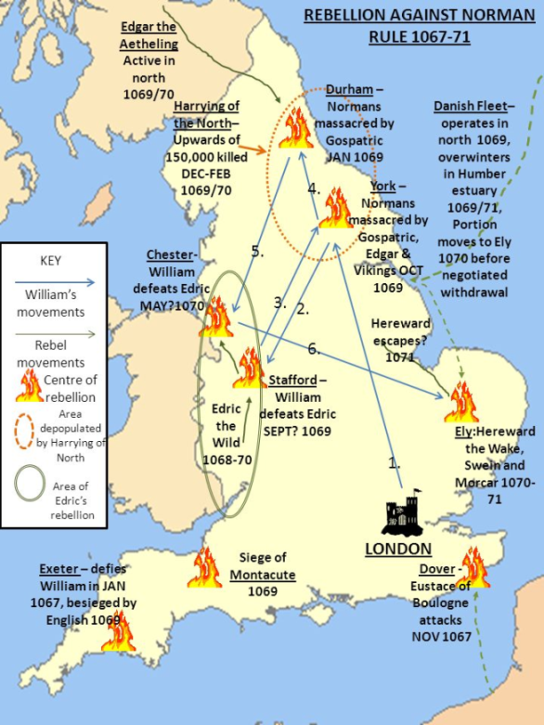
Task: Match the rebellion to the description.

1067 – The Welsh Borders
1067 – Northumbria
1068 – The South West
1069 – Harrying of the North
1070-71 – East Anglia
1075 – Norman Earls

Which rebellion? | Description
 | William appointed Copsig to rule part of England, which was an odd decision as Copsig had previously worked for Earl Tostig Godwinson. Copsig was soon ambushed by Northumbrian rebels and his head hacked off. William was angered and appointed a new Earl who permitted looting and killing.
 | The city of Exeter rebelled against William and was put under siege for 18 days. William then lowered taxes and built a castle to increase his control over the city. Despite two attempted rebellions from Harold Godwinson’s sons, Exeter remained loyal thanks to William’s actions.
 | Eadric the Wild was joined by two Welsh kings and attacked Herefordshire, but they could not gain control of the borders and retreated back to Wales
 | The final challenge that William faced, but this time from the Norman Earls Earl of Hereford and the Earl of East Anglia – with support from an Anglo- Saxon Earl Waltheof. William dealt with this rebellion relatively easily, and by the time the Danes arrived the rebellion was over. Waltheof was beheaded, the Earls titles and land was taken from them
 | A previously difficult to control area of England, the locals sought help from King Swein of Denmark, as well as rebelling several times themselves at places such as Durham. Edgar Atheling joined in and William was I peril. He paid the Danes to leave. Following the rebellion, William laid waste to the land, with mass killings and burnings. This became known as….
 | William faced a rebellion from the Danes who had remained in England despite agreeing to leave, and they teamed up with an Anglo-Saxon called Hereward. The Danes were offered favourable terms to leave. Hereward continued to cause trouble…

Task 5 – Norman military innovations: motte and bailey castles
Task: label the motte and bailey castle diagram using the grid below.
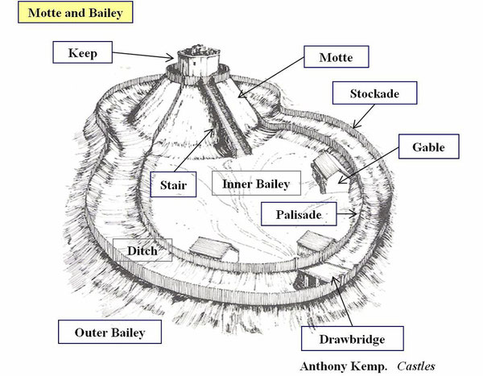

Keep  A wooden or stone fortified tower on top of a motte. | Outer Bailey  An outer ward that protected the inner bailey. | Drawbridge  A bridge, especially one over a castle's moat, which is hinged at one end so that it may be raised to prevent people crossing
Motte  A raised mound or earthwork with a stone or wooden keep (a fortified tower) on top. | Inner Bailey  The bailey is a courtyard enclosed and protected by a ditch | Palisade  A wall made from large wooden stakes.
Stair  The stairs connecting the keep on the motte with the inner bailey. | Stockade  A barrier formed from upright wooden posts or stakes, especially as a defence against attack | Gable  The triangular end of a house.

Task 5a- how and why were castles built?
Task: complete the paragraphs, using the words in the box below
Edward the Confessor control burhs defend central symbolic reminder soldiers governing rebellions day’s taxes strategic troops motte burn keep palisade lookout bailey

Castles were ________ to Norman ________ of England. Very few castles had been built by ____________ the _____________ and the defensive fortifications that the Anglo-Saxons used were called __________. The difference between burhs and castles was that burhs were built to ___________ the population, whereas castles were built to control the rebellious English. The first castles that the Normans built were called ________ and _________ castles. A motte was an earth mound, and a _______ was built on top of it. The ditches around the
motte made it harder to attack. The bailey was the outer area of the castle which was defended by a wooden ______________. Norman ___________ were stationed in the bailey along with their horses. These troops could retreat to the keep if they needed extra protection, but the keep was also used as a _________________. A motte and bailey castle could be erected very quickly, but the wooden structure was a weakness because they could __________. Castles had two main functions: _____________ and _____________.
- Strategic: they housed Norman ____________ who could help to stop any _____________. Norman soldiers were never more than a __________ march away from a Norman castle.
- Symbolic: castles were a permanent _____________ to the English of who was now ___________________ the country. The Normans charged the English __________ to help them maintain the castles.

Task 6 – Norman control of England

Task: complete this mind map to explain how the Normans controlled England after 1066.
Castles/ Military Presence
How did the Normans control England?
Force/Fear/Terror
Legitimacy
Patronage/Concessions
Task 7 – Government in Norman England

Task: Annotate each pyramid to explain who each section of society contained.

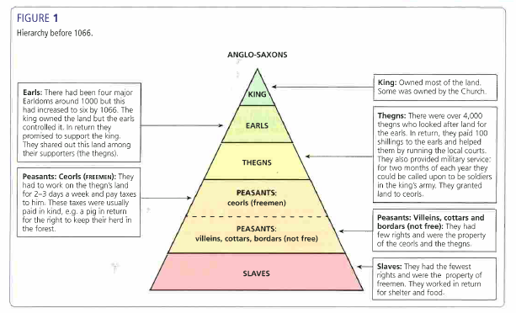

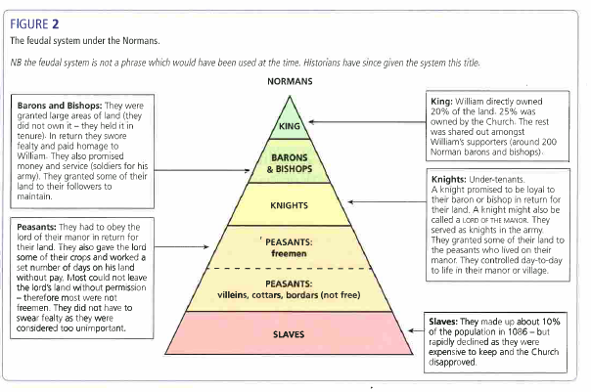

The feudal system under the Normans

Feature | Anglo-Saxon | Norman
Feudal System | Six major earldoms in 1066  4,000 thegns  King owned most of the land, followed by the Church. | King owned about 20% of the land, with the Church owning around 25% of land. Remaining land shared between 200 Norman barons and bishops. By 1086 only 4 thegns owned land.  Royal Forests and Forest Law created.
Military Control | The main part of the king’s army would be made up from housecarls.  For the rest of the army, the Anglo-Saxons used the fyrd. | Knights made an ____ to their lord – it was a religious duty to provide service.  Knights always had to carry out military service.  By 1100 the Norman king had 5,000 knights he could call on.
National government | The king was in charge and the nobility were involved in the process of decision making through the W____.  Anglo-Saxon government issued orders in writing – these were called writs. This was a short document which gave orders to be sent around the country and he system was known as government by writ. | Norman kings continued to take the advice of their leading subjects through the Curia Regis (Great Council).  The Normans continued government by writ but issued far more orders, which allowed William to create a more centralised government.
Local government | Under the Anglo-Saxon, England had been split into 134 shires. A shire-reeve (the original word for sheriff) was in charge of each shire and organised justice, punishment and the collecting of taxes. Each shire was split into smaller areas known as hundreds. | The Normans found the Anglo-Saxon system effective so still used sheriffs. The sheriff acted as second to a baron in an area, and was a vital link between the king and the local area.  Anglo-Saxon sheriffs were replaced with N_______ sheriffs.

Task 8 – Norman legal system
Task: complete the missing words.
- The legal system also kept many features from ____________ - __________ England.
- This was because it helped to prove that the Normans were ____________ rulers.
- The most important courts remained e.g.the ____________ court and the _____________ court.
- From 1076, _________________ courts were introduced to deal with ecclesiastical matters.
- There was no ___________ force in Norman England, therefore the law was enforced by a range of different people.
- In vulnerable areas such as the ____________, the earls effectively had their own royal powers.

Task: decide whether each statement is either true or false.
Statement | True or False?
Constables were not paid much, but had the power to arrest people, break up fights and put out fires. They also held the keys to the stocks.
Watchmen were paid to do their job. Their role was to ensure that people abided by curfews, prevent crime and catch criminals.
Hue and cry was the system for raising the alarm after a crime had taken place. If anyone witnessed a crime, they had a duty to report it and could be punished if they did not.
A tithing was a group of 10-12 men who all promised to stop the others committing crimes. If one did, it was the duty of the others to reveal the guilty party, or risk the whole group being fined.
If a Norman was killed and their murderer was not found within 5 days, the whole population of the hundred would be fined. This murdrum fine helped to reduce hostile acts against the Normans, but when these hostile acts did occur, the money from fines proved useful for the king.

Task 8a – Trials in Norman England

Task: Summarise each form of Norman justice

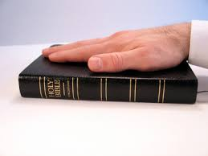
...................................................................
...................................................................
...................................................................
...................................................................
...................................................................
...................................................................
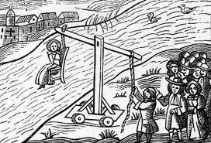
...................................................................
...................................................................
...................................................................
...................................................................
...................................................................
...................................................................

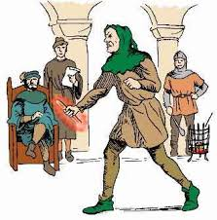
...................................................................
...................................................................
...................................................................
...................................................................
...................................................................
...................................................................

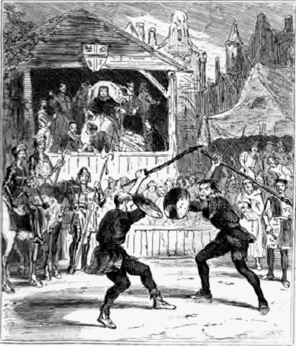
New!...................................................................
...................................................................
...................................................................
...................................................................
...................................................................
...................................................................

Task 9 – Domesday Book
Task: bullet point information about Domesday under each heading.

What information was collected?

Aims of Domesday Book:

How was information collected?

Task 10 – Life in Norman England

Task: Describe a Norman village with 5 facts. Hint: think about change:
- Who lived there
- What they did
- What their houses were like
- Who had power
- Hygiene and diet

Task: describe continuities and changes to life in a town with 5 facts:
- Who lived there
- What they did
- What their houses/businesses were like
- Who had power
- Hygiene and diet

Task 11 – Similarities and differences between Anglo-Saxon and Norman England

Task: Place each bullet point on the spectrum to show how far you think it changed.
- Feudal system
- Military control
- National government
- Local government
- Legal system and trials
- Life in villages
- Life in towns
Big change from Anglo-Saxon England

Small change
gland

Task 12 – The English Church
Task: complete the paragraphs, using the words in the box below
Pope heaven powerful Roman Catholic hell

Religion was very important in Norman England and everybody was a ___________ ____________ and believed in God. If you went to church and led a good life, you would go to ____________, however if you were bad and did not go to church, you would go to ________.
The leaders of the Church were very __________________ – sometimes as powerful as kings. The __________ – the overall leader of the Church – was probably the most powerful individual in Europe.
prayers tithe quarter souls landowner

The Church was the largest single ____________________ in Europe – by 1086 it held a ____________ of all land in England. It was given land by rich people who wanted to ensure that they would go to heaven or they instead left money for ____________ for their ________.
Everyone in England had to pay a tax to the Church called a ________ which was one tenth of anything that was produced. Additional taxes were also paid at certain times of year and surplice fees for ceremonies such as weddings and funerals.
education politics religion health law money

__________: The main role of the church was to ensure that people showed that they believed in God by going to church.
__________: The Church was a major landowner in England. Peasants had to work on Church land for free even though they had their own land to look after. They believed that God would know if they had not done their work on the Church land and that God would punish them. The Church also collected taxes called tithes.
___________: The Church heard court cases for crimes carried out on Church lands. If the Church found somebody guilty of a crime, they would hand down justice in the king’s name.
____________: Leading members of the Church advised the king on important national issues as members of the Witan.
___________: The Church was the only institution that produced books. In this way, the Church could control which books were published.
___________: people in the twelfth century did not understand the cause of diseases and thought that they were a punishment from God. As a result, priests tried to cure the sick by praying for them or recommend they pay a penance in the form of money, pain or prayer.

Task 12a – Norman reforms to the Church
Task: summarise each change in 1-2 words
Change | Description
 | Archbishop Stigand was replaced by Archbishop Lanfranc. Normans replaced Anglos-Saxons at the top levels within the church.By 1080, there was only one Anglo-Saxon bishop, Wulfstan, left.
 | The Normans soon began rebuilding Anglo-Saxon churches and cathedrals in the Romanesque style (which was already familiar to them and used in France). Romanesques style is….
 | The Church was separate from all the rest of society and giving it a special role in the legal system through Church courts. In 1076, the Council of Winchester ordered that only Church courts could try clergy for crimes. This meant that people who worked for the church would only be tried for their crimes in Church courts rather than local courts.
 | Dioceses (areas of land served by a church or cathedral e.g. Hereford) were sub-divided into archdeaconries, which were further divided into deaneries. Archdeacons became more common, and had the role of enforcing Church discipline in their area, presiding over Church courts. Deans looked after the deanery, and made sure that religious laws (called canon law) were being kept and that the priests were conducting themselves well, allowing increased control and organisation
 | Anglo-Saxon cathedrals in isolated rural locations were knocked down and moved to more strategic locations such as market towns, so that the bishop was in a more secure location with an overview of his area of control e.g. Thetford was moved to Norwich.
 | Church Synods (councils) were introduced King William I and Lanfranc made sure that the church leaders met in synods, or national church councils, to discuss key matters of organisation, church law and spiritual life. They held eight synods between 1071 and 1086.
The Normans aimed to reduce corruption in the church. LanFranc wanted to get rid of:
Simony which means…

Pluralism which means…

Nepotism which means…

They also wanted to enforce the vow of celibacy..

Task 13 – Changes to Church organisation
Task: rank the changes from ‘biggest change’ to ‘smallest change’ – 1 is the biggest change, 8 is the smallest change.
- What had not changed was the people at the top of the Church hierarchy. The Pope was still head of the Catholic Church and therefore the most powerful Catholic.
- King William was certain that members of the Church in England should not obey the Pope over the king.
- William controlled communication between the leaders of the English Church and the Pope in Rome. This meant that William could influence the information that Church leaders had access to.
- William was also in control of who was appointed to the English Church.
- The Church under the Normans became more centralised – this means that it was answerable to the Archbishop of Canterbury and in turn the king.
- There were also new positions introduced such as archdeacons and deans.
- The new Norman structure allowed bishops to have far greater control of their diocese.
- There were more parish priests under the Normans than there had been previously.

Rank | Summary of change
1
2
3
4
5
6
7
8

Task 13a – William Rufus and the Church
Task: draw images to describe the conflicts that William Rufus had with the Church
Conflict with William of Saint-Calais 1088
1. There was a rebellion against Rufus in 1088. The Bishop of Saint-Calais had informed Rufus about this plot, and promised to bring reinforcements to help him. However, Saint-Calais then changed his mind and never returned with his troops. Rufus put him on trial for treason.
2. Saint-Calais argued that as a member of the clergy, he should be tried in a Church court rather than in a secular court. Rufus refused, arguing that the Bishop had broken his oath of fealty (loyalty) to the king and should be tried by a king’s court.
3. The Bishop of Saint-Calais did eventually return to England in 1091 and served a Bishop of Durham until 1095, but the trial was significant. It showed how determined Rufus was to control the Church rather than be controlled by it.
Conflict between Anselm and Rufus 1093-94
- When Lanfranc died in 1089, he was not replaced. This was a deliberate move by Rufus as he wanted to take the income from the Church lands that Lanfranc had held before his death.
- In 1093, Rufus suffered a serious illness and thought that God was punishing him. To please God, he decided to appoint a new Archbishop of Canterbury – Anselm.
- Relations between Rufus and Anselm were difficult from the beginning and by 1094, Anselm was preaching about the lack of morals at Rufus’ court.
- Rufus was not happy with Anselm’s comments; he felt that he owned the abbeys and that Anselm should not get involved in his affairs.
The Council of Rockingham 1095
- Rufus had stopped Anselm travelling to Rome to get Papal approval for his appointment as archbishop; Rufus argued that this would show that Anselm was really giving his loyalty to the Pope (Rufus wanted to limit the power of the Pope in England). They could not agree, so the Council of Rockingham was called.
- There was much debate and little agreement and so a truce was called. Rufus had been forced to accept Pope Urban II as Pope, but Urban agreed to stay out of English affairs whilst Rufus was king.
- Relations did not stay good for long, and Rufus blocked Anselm’s efforts to reform the Church through Church councils. Anselm also didn’t want to pay Rufus extra taxes or provide the number of knights the king required.
- By 1097, Anselm had fled to Rome – this left Rufus able to profit from the money raised by Anselm’s empty position in the Church.
Simony
- As well as conflict with different people in the Church, Rufus also brought back the practice of simony (selling jobs in the Church). This had been outlawed by Lanfranc in the 1070s. For example, Rufus sold the bishopric of Thetford to Herbert Losinga for 1000 marks.
- One of Rufus’ key allies, Ranulf Flambard, was very good at raising money from the Church – this made him popular with Rufus but unpopular with the clergy. Rufus rewarded him by making him Bishop of Durham – for £1000!

Task 13b – Norman relations with the Papacy
Task: for each Norman king, decide whether or not their relation ship with the Pope was good 10/10 or bad.
King | What happened? | Good or bad relations? /10
William I | - Pope Alexander II (1061-1073) gave William the papal banner to fight under at the Battle of Hastings, blessing his invasion. Both Pope Alexander and William wanted to reform the corrupt English Church and bring it into line with Christianity in the rest of Europe.  - Pope Alexander also wanted to get rid of any corrupt or incompetent bishops. William supported this, and also promised to abolish the practices of nepotism and simony, as well as to ban clerical marriage. However, William's main aim was to get rid of untrustworthy Englishmen from powerful roles in the Church and to replace them with Normans.  - Pope Gregory VII wanted bishops to travel to Rome to report to him, but this did not happen - even Lanfranc did not do this. Whilst William did agree to bring back a tax called Peter's Pence which was paid to Rome, he was clear that he did not want the Pope to interfere with his rights has king.
William Rufus | - William Rufus had first damaged his relationship with the Papacy after his trial of William of Saint-Calais in 1088-9 after his came into a lot of conflict with the Pope, particularly after his appointment of Archbishop Anselm.  - Pope Urban II (1088-1099) also had a bad relationship with Rufus. This was due to Rufus' actions in stopping Anselm from travelling to Rome and blocking Anselm's reforms to the Church. Eventually, Anselm had been exiled and fled to Rome in 1097, further damaging the relationship between Rufus and the papacy.
Henry I | - Archbishop Anselm refused to be made bishop by King Henry. He was exiled in 1103. This led the Pope to threaten Henry with excommunication, the worst punishment that the Church could give.  - Eventually, in 1107, Henry reached an agreement with the Pope. Henry agreed to give up his right to invest bishops. This meant that they would still have to swear loyalty and provide services when required. The investiture controversy had caused clashes between other rulers and the pope  - After this, Anselm supported Henry and in return was allowed to bring in Pope Gregory VII’s reforms, for example condemning simony.

Task 14 – Monasteries in Norman England
Task: around the monk, write 10 facts about monasticism in Norman England. Think about the vows monks took, changes that Normans such as Lanfranc made to monasteries.
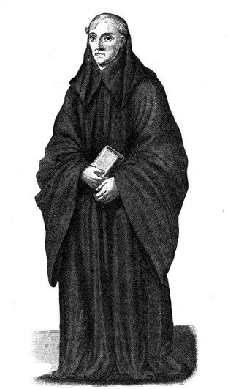

Task 15 – Education in Norman England
Task: complete the paragraphs, using the words in the box below
towns & cities Christianity trade 40 Latin French English

Before 1066, education in monasteries was conducted in __________ rather than __________, and the teachers were monks or nuns.
When the Normans arrived in 1066, education moved out of monasteries and convents and into the _______________. As the size and number of towns increased under the Normans, so did the need for a better education system. People needed better literacy and numeracy skills in order to conduct __________. Furthermore, the Norman barons and knights who lived in England wanted their children educated to the highest possible standards.
Reforms within monasticism meant that children were no longer allowed within monasteries or convents, therefore schools moved out of monasteries and became separate buildings. There was an explosion in the number of schools – by 1100 there were ______ schools and by 1200 there were 75.
In schools, __________ was spoken and began to influence the English language (and vice versa). However, Latin was still used for writing and was seen as the language of ___________.
harvest university clergy 10 Latin questions grammar

At the age of ______, some children moved on to ___________ schools, which were separate from Church schools. Students stayed at grammar school for at least 4 years, learning ___________ grammar as well as how to speak and write the language.
The school year lasted from September to June, which enabled peasant families to bring in the ___________ during the summer months. The school day started as soon as the sun was up and ended late afternoon. During lessons, the teacher sat in the middle of the room and children sat on benches around the outside, answering __________ directed at them by their teachers.
If students were successful at school, they moved on to _____________ where all books and lectures were in Latin. Students who did not go to university could become merchants, parish _________ or secretarial clerks. Subjects such as maths, accountancy and law were not taught in grammar schools and were taught when students started work.

