Training Plan – Unit 6 Sports Leadership
Date: |  |  | Time: | Name of Coach/Leader:
No. of Participants: |  |  | Gender of Participants:  Male = Female= |  |  | Age Range:
Duration: |  |  | Location of Session:
Medical Issues: |  |  |  |  | Any other Issues:
Activity:

Aims of the Session:

Equipment needed:

Risk Assessment: Is the Risk Assessment complete and informed consent given? (Please tick and attach)

Timings | Session Content

Example of Pass
Training Plan – Unit 6 Sports Leadership
Date: |  |  | Time: | Name of Coach/Leader:
No. of Participants: |  | 10 | Gender of Participants:  Male = 5 Female= 5 |  |  | Age Range:  14-17
Duration: 1 hr 10 mins |  |  | Location of Session: Sports Hall
Medical Issues: No |  |  |  |  | Any other Issues: Injuries
Activity: Badminton

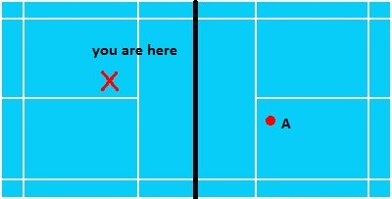
Aims of the Session: To get better at a flick serve and when to use it in game

Equipment needed: A Net, Shuttlecock, Racket

Risk Assessment: Is the Risk Assessment complete and informed consent given? (Please tick and attach)

Timings | Session Content
20 mins | Warm up : Flicking the shuttle into the hoop to try so you how much you need to put on a flick serve there will be five on each team and see who can get 20 through the hoop first. (As shown in the diagram where A and B are standing)
30 mins | 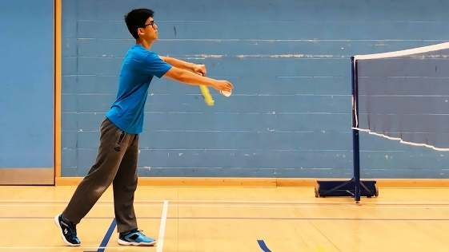  With about 20 shuttles see how many you can flick over the net into the square and they are put into pairs and then one is on one side and other person has to be diagonally opposite and then each pair do three serves each and swap over.  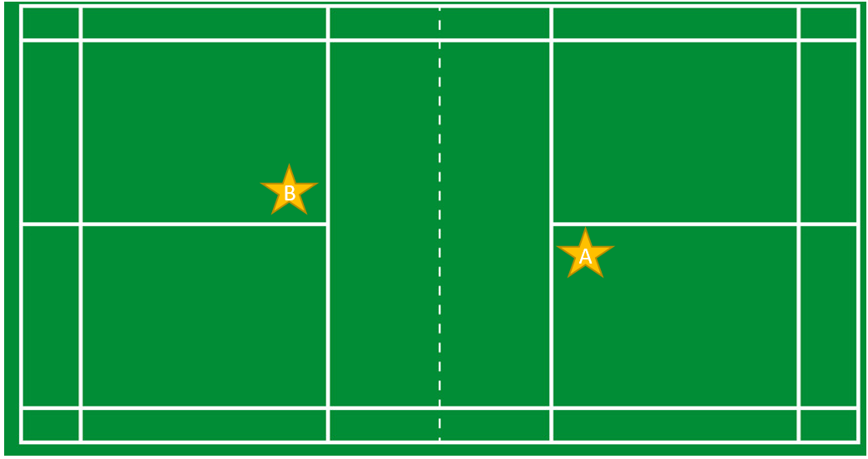  Person ‘A’ will serve 20 shuttles to person ‘B’ and count how many land in the service box.Once all 20 shuttles have been served, person ‘B’ will serve 20 shuttles to person ‘A’ and count how many land in the service box.Repeat this 5 times.
10 mins | 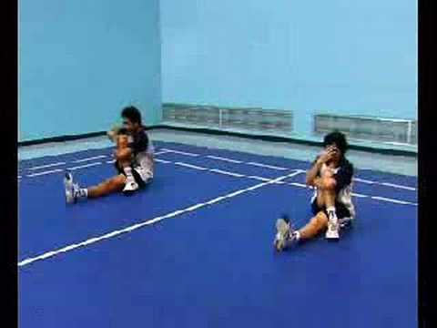  Cool down: A gentle jog around the court and back so you don’t get lactic acid building up in your muscles and then do some dynamic and static stretching so after you done your sesion you don’t pull any muscles.

Example of Merit
Training Plan – Unit 6 Sports Leadership
Date: 10 June 2019 |  |  | Time: | Name of Coach/Leader:
No. of Participants: |  | 14 | Gender of Participants:  Male = Female= |  |  | Age Range: 15-16 year olds
Duration: |  | 1 hour | Location of Session: Inside sports hall
Medical Issues: |  |  |  |  | Any other Issues:
Activity: Netball

Aims of the Session: Learn how to play in a competitive situation (not a game situation) as well as knowing where you can go in any position you are playing in by applying this using the drills taught beforehand in the session.

Equipment needed: 2 full sets of netball bibs, 28 cones, 15 netballs

Risk Assessment: Is the Risk Assessment complete and informed consent given? (Please tick and attach)

Timings | Session Content
5 minutes | Warm up: Run around netball court 4 times, on first time full jog around, second time high knees on sidelines and jog on backlines, third time heel flicks on sidelines and jog on backlines, fourth time side step on sidelines and sprint on backlines.
10 minutes | Stretching: (width of court) lunges, sumos, windmills, pull arm across body, heard the sheep, open the gate, close the gate, finish with light jog then walk.
20 minutes | Collect 4 cones & 1 ball for drill: B runs around red cone.  A feeds the ball to B.  B runs around yellow cone.  This continues with all cones twice.  Then swap.  Drill works on chest pass from both players and when working in the centre to go around the cones learning to not turn your back to the ball and push off when running back around.
15 minutes | 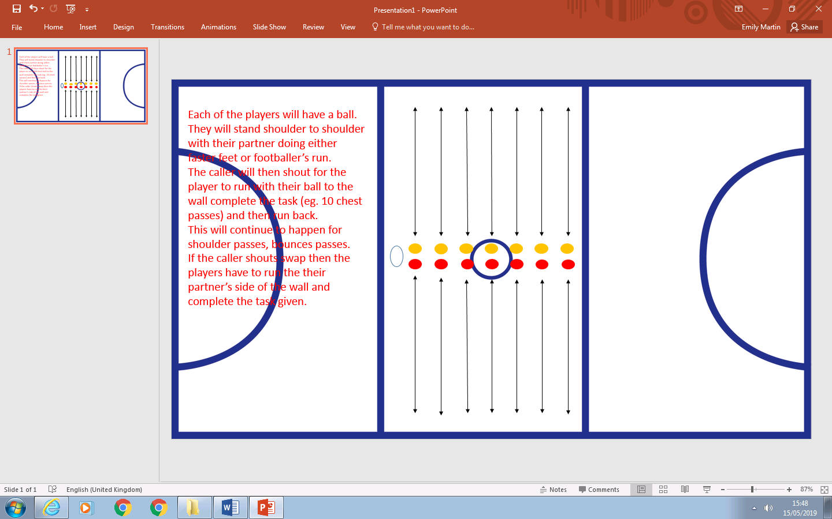  Drill works on coordination of each type of throw as well as dodging past another player when put in a isolated situation practising for game situations.
10 minutes | 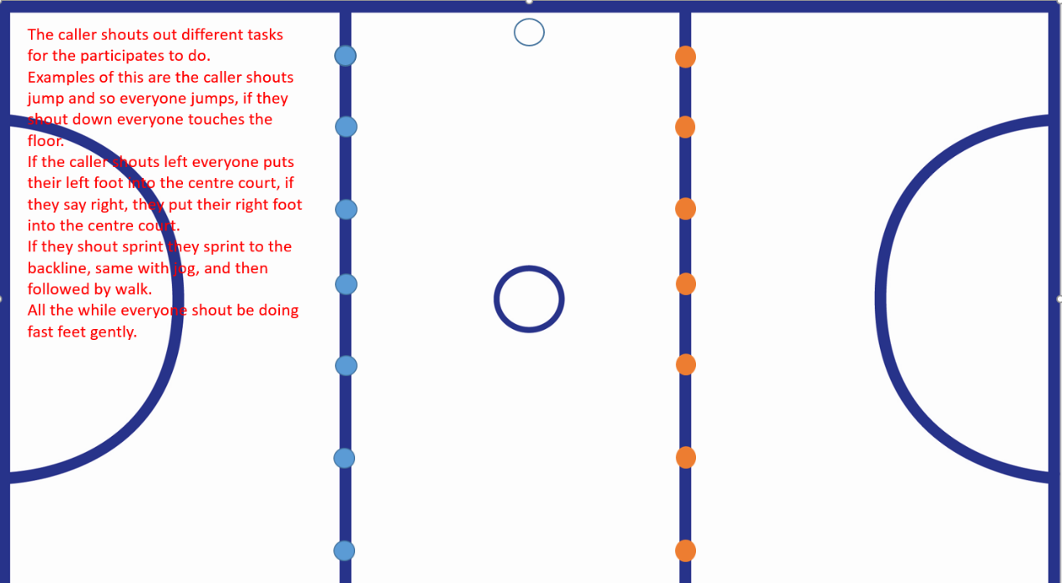  Cool down:
When thinking about my warm up I am letting the people taking part get used to the space they have with the jogging and pulse raises they are doing. At the same time this allows me to set up the cones for the first drill so that the players don’t have to do and so then I come across a being organised within what I am doing. If I have not set up everything within the time they have done the warm up I can explain the stretches and perform some of them and then while they are stretching I can continue setting up.
The reason I chose to do these drills when doing netball is because in the first drill it helps with passing skills, all bounce, shoulder and chest passes as well as catching and one to one communication with a partner. When asked to complete this drill it also makes the other person work by going around the cones and then back to the middle which brings in the communication of when to pass the ball into the middle. The reason I am doing this drill for 20 minutes is because one person does it for 10 minutes making them work really hard making sure they are never turning their back on the ball and then they swap around with their partner so both people get a go at the drill by working in the middle and feeding the ball in. This means that if put into a game situation they can include some parts of this drill and it should help their movement around the court. As it is the first drill it needed to be easier than the others as they progressively started to get harder and more intense. The first drill let the working person learn how to twist their body and receive the ball back into the middle when calling for it. As people may not have played netball before I am not including a game but competitions within the drills to keep everyone going. It also gets the heart rate up as well as what the original warm up has already done previously.
When choosing my second drill, I want to advance on what I have done in my first drill but leave time for a good cool time but make sure that this drill is more intense and includes a bit of a competition to keep the participates on their feet. This drill also focuses on passing and catching but working in isolation (by themselves). This drill will last for 15 minutes as it’s not only individual but also a little more intense. Up until the participants understand the drill the competition doesn’t begin. This is where they will have to get back to the starting point the fastest without bumping into anyone. This drill contributes to communication as you have to listen and respond to the given stimulus as well as being able to quickly move out of the way if having to run past your partner. This drill is designed to be intense so therefore only to be performed a short period of time (15 minutes). After 15 minutes the player can become bored and very tired therefore will not be putting in as much effort and it won’t be as productive and slowly the drill will become pointless so that’s why the time is so short.
My cool down concludes with a gradual cool down instead of an instant one. As well as a cool down it relates to reaction time and although possibly tired after what they have just done throughout the session they can show how well their endurance is. To start with the caller will shout instructions quickly and then they will become slower letting the body start to relax until completely finished the session.

