Lesson 3
Population
Print out this sheet. Use a dictionary or google to match the correct Key Word with the correct definition and a correct example. Either cut out and stick your table, or write it out neatly.
Example
Key Word or Phrase | Definition | Example
Population distribution | Where people are living | A high density of people in urban areas.

Now, check your answers – Correct in Purple if necessary
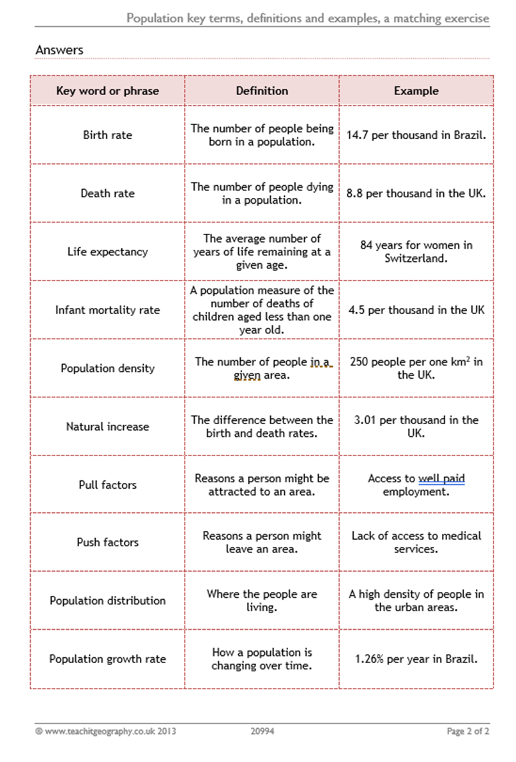
NOW, you need to try to learn these key terms and definitions.

This graph shows the structure of the population in India. It shows the number of males and females in each a year age group. Use this graph to answer the following questions.
4. What proportion of India’s population is:-
Under the age of 15? …………………………………………..
Over the age of 65? …………………………………………….
Try to write down one advantage and one disadvantage of this age spread.
Advantage ………………………………………………………………………………..
……………………………………………………………………………………………………
…………………………………………………………………………………………………..
Disadvantage …………………………………………………………………………….
……………………………………………………………………………………………………
…………………………………………………………………………………………………
- Using the graph, what size was the population of India and China in:-
1950 ……………………………………………………………………………..
2010 ……………………………………………………………………………..
- Since the 1990’s which country’s population has grown fastest? Why? ………………………………………………………………………………………
………………………………………………………………………………………
………………………………………………………………………………………
- When are the two countries predicted to have the same
Population size? ………………………………………………………….

Put a tick in the table to show if you think the following statements are true or False. The first on has been done for you! You may need to do some research to answer these questions.
STATEMENT | TRUE | FALSE
Most people live in southern India. |  | √
Most people live near the coast.
Most people live along the Ganges Valley.
Fewest people live in the north-west desert.
India has few large cities
India’s population is evenly spread.
India has three of the world’s largest cities
India’s population is not evenly spread.

