Year 7 French Distance Learning. Week beginning 11th May
We know these are difficult and unusual times for everyone. Please let us know if you are struggling for whatever reason to complete the work. If you need more support, please email us.
Please email completed work / feedback by Friday 15th May to your French teacher.
You can write written activities on a word document, in your red books or on paper. Once you have completed it, email your teacher the work by sending the word document, or by attaching a photo of your work to the email. Our emails are:
(karen.vernon@laconchildeschool.co.uk or marianne.salmon@laconchildeschool.co.uk )

Task 1. En Ville – Quizlet.
To access Quizlet on your computer, you can click on this link www.quizlet.com

You can also download the free app through the App store for Apple or the Play store for Android and complete exercises on your phone -
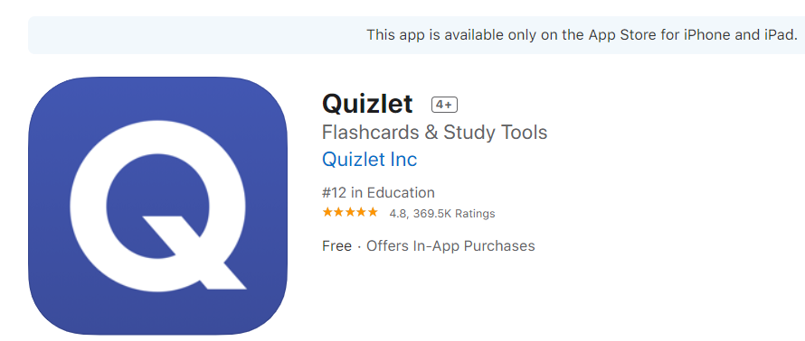

On this website www.quizlet.com it states that this app supports any web browser on any device please see link https://quizlet.com/en-gb/mobile
To find the file, you must
- Click search and type in ‘En ville’ (by) Pauline-Gilme ( there are lots of similarly named files but this is the best one for you)
- If you are on a computer a flashcard will appear, you need to scroll down and a list of the vocabulary will appear (see below) . If you are using the App, you scroll down to terms and you will see the list of words / phrases. It is important to listen to the words/ phrases first so you learn to match the sound to spelling as well as recognise the meaning. Click speaker to hear correct pronunciation.
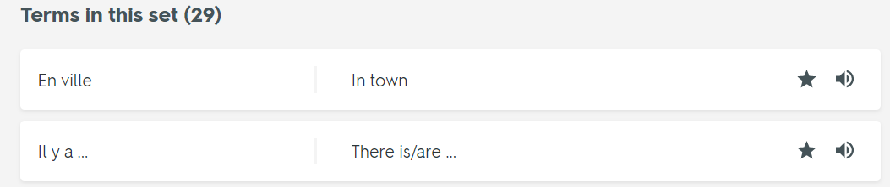

3. Listen to all the phrases and repeat each one until you feel comfortable with the pronunciation.
4. Now complete the other activities in order to memorise and embed the meaning as well as the pronunciation
If you have the Quizlet app on your phone you can complete this activity anywhere or you can have a go at other ‘en ville’ activities.
Let you teacher know how you found this activity.

Task 2
Design a poster titled ‘En Ville’ (= In Town). It does not have to be true – it could be your ideal town or you could say that there is a theme park in Kinlet!
You can complete this task in any medium on paper or in your book or in word or publisher etc.
It needs to be bright and bold. It could be a collage even.
All the French you need is in your grammar book (in particular, you should refer to the following vocab sheets or sentence builders - Qu’est-ce qu’il y a dans ta ville ? (What is there in your town?) and
Qu’est-ce qu’il y a dans ta ville/ ton village / ta région ?
The sentence builder is also on the website from 20th April.
You can ONLY use FRENCH on the poster and only words or phrases that you have learnt.
The sort of phrases you can use in French are ‘ In my town / near my house there is a lively café’ (remember adjectives normally go after the noun in French) You can give opinions e.g ‘ I like my town/ I like to live there because ……….’)

Now send your feedback on the Quizlet activity and your poster to your French teacher.

