How to add accents when typing
As you know, accents are very important in French as they can change the pronunciation of the letter.
When typing a word document, to add accents, you need to complete following steps
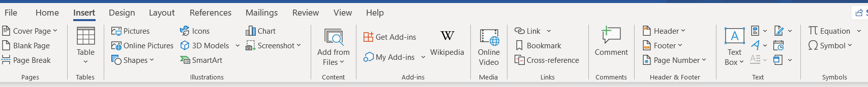
- click Insert in tool bar

- Go to far right hand side and click on symbol
- Click on ‘more symbols and the box below appears
- Find the fractions symbols and then the French, German Spanish accents in capitals appear on the end of this line and the next 2 lines, followed by the lower case letters on the following 2 lines. You will see there are hundreds of accents after these ones but you ignore them.
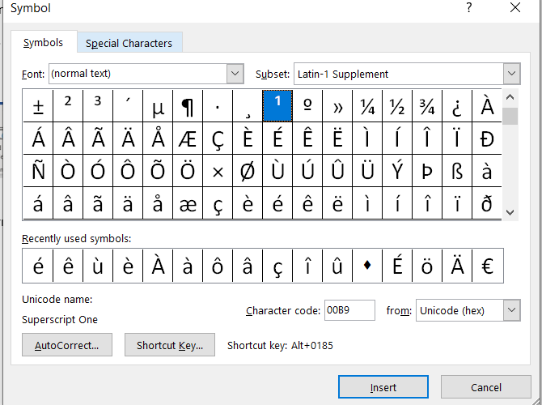

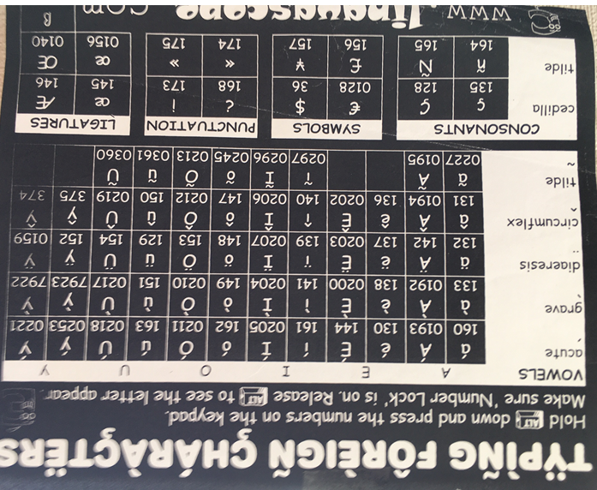
- If you want to add an ‘é’ you click on the correct accent in the box and then click insert or you can double click the letter and it will appear in your text.

- Another way is to follow the instructions on my
mouse-mat.

Hope these instructions are useful.

