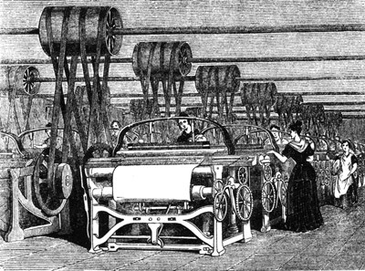
The changing UK economy:

- How has the UK economy changed in the last 200 years?

- Use the grid below to draw a divided rectangle to show how the UK economy has changed since 1800.
1800
1900
2006
2015

Key:
Primary Industry
Secondary Industry
Tertiary Industry
Quarternary Industry

- Why has the economy of the UK changed?
- De-industrialisation:
What is this?

Why did it occur in the UK?

- Globalisation:
What is this and why did it lead to a change in the UK economy?

- Government policy:
2010 onwards
1979 - 2010
1945 - 1979

A post-industrial economy:
- What is a post – industrial economy? | 5. How has the use of information technology transformed life and work in the UK?  1.  2.  3.  4.
6. How have developments in IT affected the UK economy?  1.  2.  3.  4. | 7. How much does the service sector contribute to the UK economy? ___________  What does the finance industry include? __________________________________________________  How much of UK GDP is from finance?  How many people are employed?
8. Research:  Jobs:  £ to UK  Some UK research organisations: | 9. Describe the work of the British Antarctic Survey.
10. What is science park?  University of Southampton Science Park.  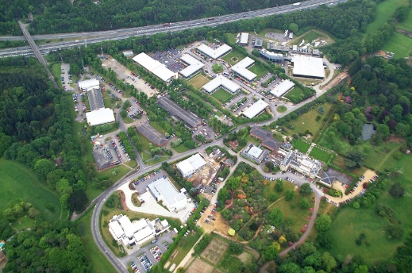  Date opened?  Examples of companies in the science park:  Benefits of the science park for companies?  1.  2.  3.  4. | 11. What is a business park?  Why are they usually located on the edge of towns?  a.  b.  c.  d.  Cobalt Business Park.  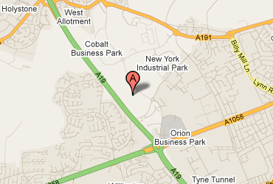  Describe the main features of the Cobalt Business Park.
The impact of industry on the physical environment.
12. What impact can extractive industries have on the environment?
13. Name 4 effects that manufacturing industry can have on the environment.
1.

2.

3.

4.

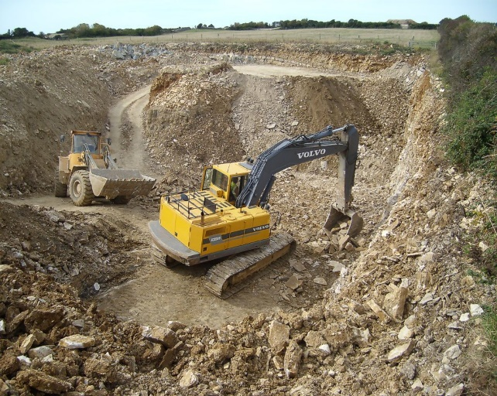

14. How can industrial development be more sustainable?

15. How does quarrying damage the environment?

16. Companies are expected to restore or improve a quarry after it has been used. Give examples of restoration.

17. Using page 241, describe the main features of Torr Quarry, Somerset.
(Location, jobs, income, material mined, annual amount, use of materials)______________________
____________________________________________________________________________________________________________________________________________________________________________________________________________________________________
18. How is Torr Quarry environmentally sustainable?
____________________________________________________________________________________________________________________________________________________________________________________________________________________________________________________________________________________________________________________________________________________________________________________________
19. Describe the impact of the quarry on the environment. (Photograph D)______________________________
____________________________________________________________________________________________________________________________________________________________________________________________________________________________________
Changing rural landscapes:
An area of population growth:  South Cambridgeshire | An area of population decline: The outer Hebrides
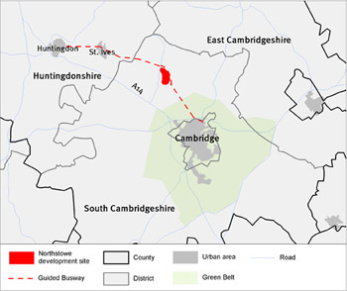 | 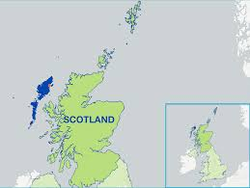
20. Describe the location of South Cambridgeshire. | 24. Describe the location of the Outer Hebrides.
21. Why is the 150 000 population increasing? | 25. What is the population total and why is it declining?
22. What are the 3 main features of the South Cambridge population?  1.  2.  3. | 26. What are the social and economic impacts of a declining population?
23. Read the table on page 242.  Write out the challenges of a growing population in order from the most serious to the least serious.  Colour code them to show economic/social effects | 27. Describe the economic impacts of a declining population on the following:  Farming:  Fishing:  Tourism:  What could be done to reduce out-migration from the area?
28. Contrast the economic challenges associated with rural areas of population growth and decline. 6M

Improvements and new developments in road and rail infrastructure, port and airport capacity in the UK.
29. Why are transport developments important to the UK economy?

30. Describe the plans outlined in the 2014 Road Investment Strategy. Include costs.

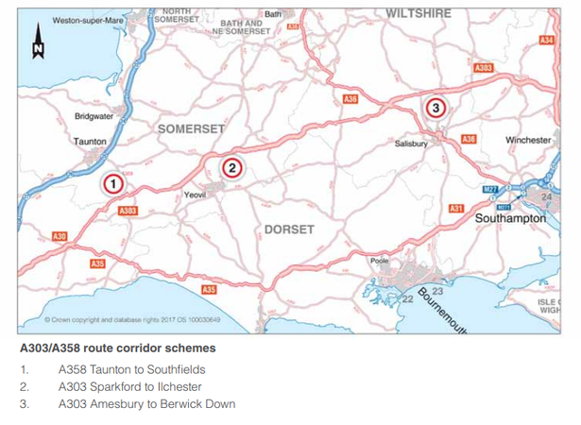
31. Add labels and notes to describe the South-west ‘super highway’.

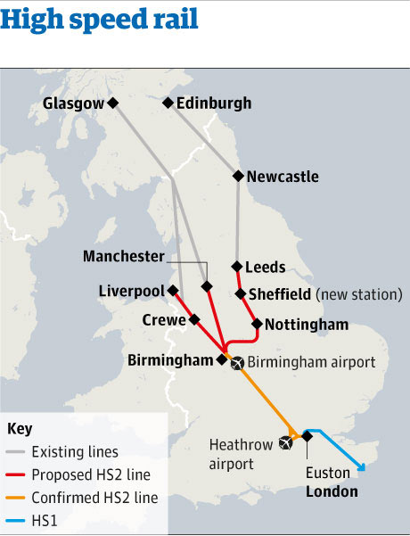  32. What are the 3 main rail network improvements that are planned? | London’s Crossrail:  33. What is Crossrail?  34. How much will it cost?  35. What benefits will it bring?

Improvements and new developments in road and rail infrastructure, port and airport capacity in the UK.
36. Using the map on page 246 – add the missing ports and add detailed labels to describe UK ports in 2014. Especially Bristol, Belfast, Felixstowe and Harwich, Liverpool2 and Dover.
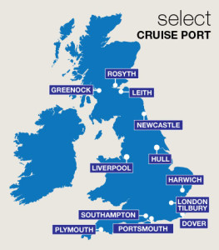

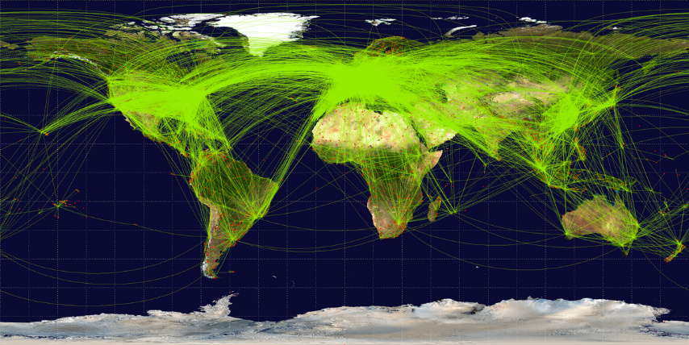
Airport development.
37. Why are airports and the aviation industry so important to the UK?
1.
2.
3.
4.
38. Using the information on page 247, discuss the arguments for and against expanding the capacity of London’s airports. (6M)
________________________________________________________________________________________________________________________________________________________________________________________________________________________________________________________________________________________________________________________________________________________________________________________________________________________________________________________________________________________________________________________________________________________________________________________________________________________________

The north-south divide in the UK and strategies used in an attempt to resolve regional differences.
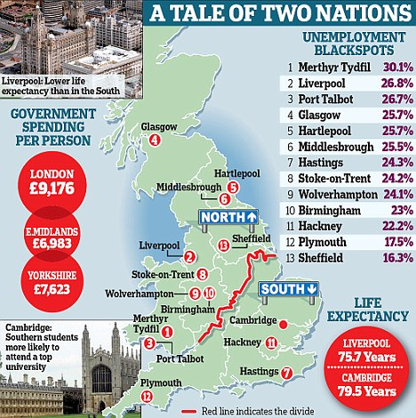
39. What is the north-south divide?

40. What evidence is there for the north-south divide?

41. Why is there a north-south divide?

42. How can regional strategies address the issue?
A. Foreign investment: ________________________________________________________

B. The ‘Northern Powerhouse’: __________________________________________________
________________________________________________________________________________________________________________________________________________________
C. Transport improvements: ____________________________________________________
________________________________________________________________________________________________________________________________________________________
D. Enterprise zones: ___________________________________________________________
________________________________________________________________________________________________________________________________________________________
43. What is a local enterprise partnership?

44. How does the Lancashire LEP plan to encourage more business in the area?

The place of the UK in the wider world. Links through trade, culture, transport and electronic communication.
45. What international organisations does the UK belong to?

46. Rank order the top 10 countries that the UK exports to. Shade in the EU countries. (Trade)  1.  2.  3.  4.  5.  6.  7.  8.  9.  10. | 47 .Rank order the top 10 countries that the UK imports from. Shade in the EU countries. (Trade)  1.  2.  3.  4.  5.  6.  7.  8.  9.  10
- What is culture?

- What cultural links does the UK have with the rest of the world?

49. What transport links do we have with the rest of the world?

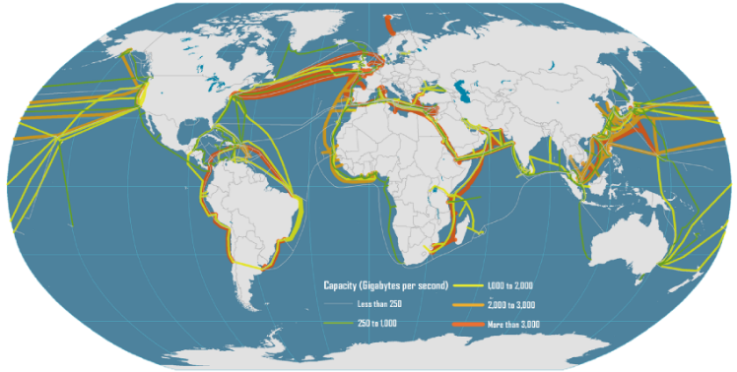
50. Describe and suggest reasons for the pattern of submarine e-communication cables shown on the map. (Map D page 251 may be clearer)

51. How does the UK benefit from having close links with the rest of the world?

The place of the UK in the wider world. Links with the European Union and the Commonwealth.
52. When did the UK join the EU?
53. How many member states are there?
54. What was the outcome of the 2016 referendum?
55. Read the diagram below. Shade the positive and negative points in different colours.

56. What is the Commonwealth Secretariat?

57. Check the list on page 253 and write the Commonwealth countries in the appropriate box. Use an atlas.
 | Rich | Poor
Large

Small

58. How does the UK benefit economically and politically from membership of either the EU or Commonwealth?

