The impact of industry on the physical environment.
Lesson 2 - You will be expected to have an overview of INDUSTRY in the UK. Refer to Year 7 work if necessary.
What impact can extractive industries have on the environment?
Name 4 effects that manufacturing industry can have on the environment.
1.

2.

3.

4.

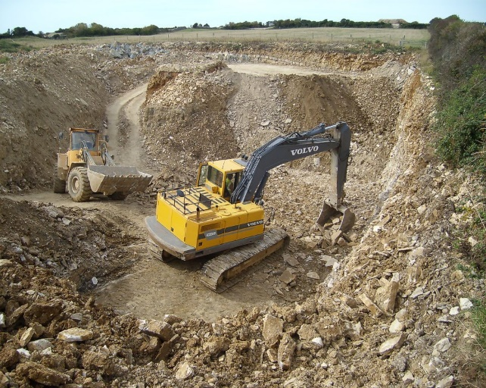

How can industrial development be more sustainable?

How does quarrying damage the environment?

Companies are expected to restore or improve a quarry after it has been used. Give examples of restoration.

Describe the main features of Clee Hill Quarry
(Location, jobs, income, material mined, annual amount, use of materials)______________________
____________________________________________________________________________________________________________________________________________________________________________________________________________________________________
How is Clee Hill Quarry environmentally sustainable?
____________________________________________________________________________________________________________________________________________________________________________________________________________________________________________________________________________________________________________________________________________________________________________________________
Describe the impact of the quarry on the environment. ______________________________
____________________________________________________________________________________________________________________________________________________________________________________________________________________________________

Changing rural landscapes:
An area of population growth:  South Cambridgeshire | An area of population decline: The outer Hebrides
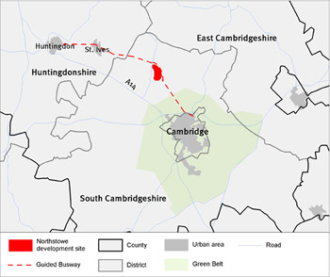 | 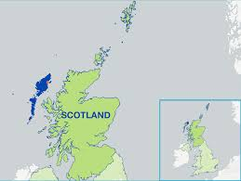
Describe the location of South Cambridgeshire. | Describe the location of the Outer Hebrides.
Why is the 150 000 population increasing? | What is the population total and why is it declining?
What are the 3 main features of the South Cambridge population?  1.  2.  3. | What are the social and economic impacts of a declining population?
Write out the challenges of a growing population in the order you from the most serious to the least serious.  Colour code them to show economic/social effects | Describe the economic impacts of a declining population on the following:  Farming:  Fishing:  Tourism:  What could be done to reduce out-migration from the area?

