Improvements and new developments in road and rail infrastructure, port and airport capacity in the UK.
Why are transport developments important to the UK economy?

Describe the plans outlined in the 2014 Road Investment Strategy. Include costs.

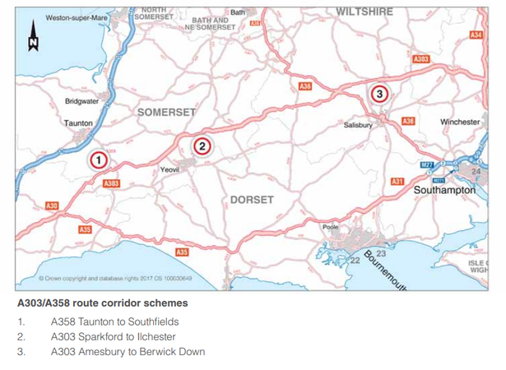
Add labels and notes to describe the South-west ‘super highway’.

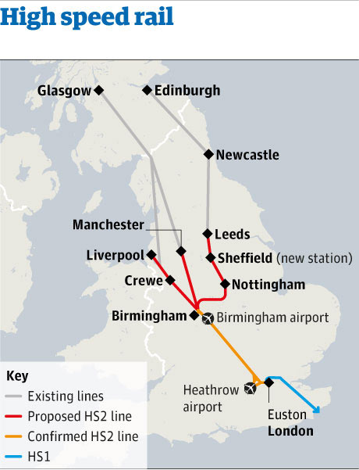  What are the 3 main rail network improvements that are planned? | London’s Crossrail:  What is Crossrail?  How much will it cost?  What benefits will it bring?

Improvements and new developments in road and rail infrastructure, port and airport capacity in the UK.
36. Using the map on page 246 – add the missing ports and add detailed labels to describe UK ports in 2014. Especially Bristol, Belfast, Felixstowe and Harwich, Liverpool2 and Dover.
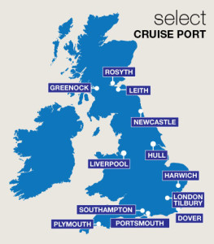

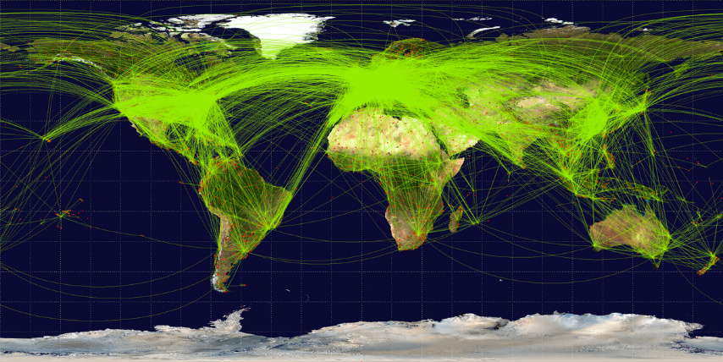
Airport development.
37. Why are airports and the aviation industry so important to the UK?
1.
2.
3.
4.
38. Using the information on page 247, discuss the arguments for and against expanding the capacity of London’s airports. (6M)
________________________________________________________________________________________________________________________________________________________________________________________________________________________________________________________________________________________________________________________________________________________________________________________________________________________________________________________________________________________________________________________________________________________________________________________________________________________________

