Year 7 Self Study French Summer 2020
For the summer term we have set a variety of challenges and tasks to help you practise and reflect upon your French.
Have fun and keep yourself tuned into French for when we next see you.
Please contact us with any work or thoughts as you complete tasks – we love hearing from you.

BBC Bitesize KS3 French https://www.bbc.co.uk/bitesize/subjects/zgdqxnb
Revise the phonics section and practise the other topics we have covered.
2) Oak National Academy are producing 2 French lesson a week for Y7
This link shows you the lessons on offer which you can do in any order. Complete your work in your class book and note down or take a photo of your final task score
https://www.thenational.academy/online-classroom/year-7/french#subjects

3. Quizlet
To access Quizlet on your computer, you can click on this link www.quizlet.com

You can also download the free app through the App store for Apple or the Play store for Android and complete exercises on your phone -
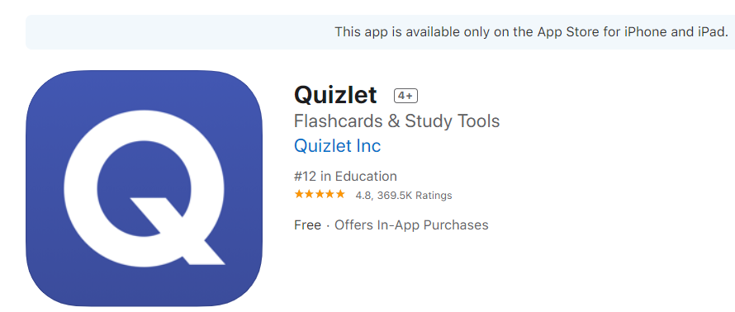

On this website www.quizlet.com it states that this app supports any web browser on any device please see link https://quizlet.com/en-gb/mobile
To find a file, you must
1.Click search and type in key word for the topic you want to practise – you may need to try French or English words e.g ‘ville’ town – météo ( weather) ma famille (my family) Collège ( school) matières – subjects ma maison/ chez moi ( my house) Les directions / directions etc
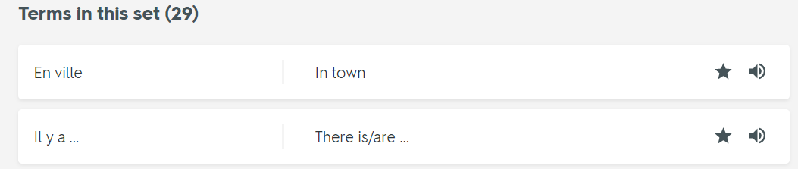
- If you are on a computer a flashcard will appear, you need to scroll down and a list of the vocabulary will appear (see below) . If you are using the App, you scroll down to terms and you will see the list of words / phrases. It is important to listen to the words/ phrases first so you learn to match the sound to spelling as well as recognise the meaning. Click speaker to hear correct pronunciation.

3. Listen to all the phrases and repeat each one until you feel comfortable with the pronunciation.
4. Now complete the other activities in order to memorise and embed the meaning as well as the pronunciation
If you have the Quizlet app on your phone you can complete this activity anywhere.

4. Linguaflix or on Youtube – Lingua Tube
If you have access to YouTube or Netflix then you have a fantastic opportunity to improve your French through TV and Film. Watch a video in French (with English subtitles) on a TV channel such as Netflix or free on youtube.
Netflix - How to turn the audio of a TV Show into French and put English subtitles on.
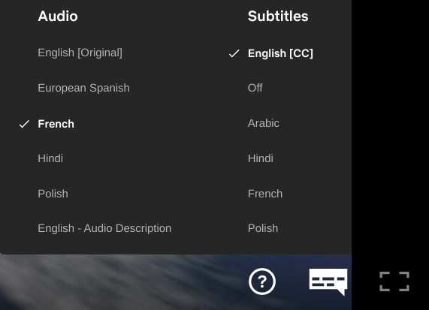
If the option is available (I’ve used Shrek as an example) then hover over the button that looks like a speech bubble and the following should pop up.
You can then select the audio language (the language that the characters will speak in and the language you will hear)
Also you can select the subtitles language (the languages that words at the bottom will appear in so you can understand what the characters are saying)
I recommend you do this with a film or TV show that you already know pretty well as you will understand the story and you can focus on listening to the French.

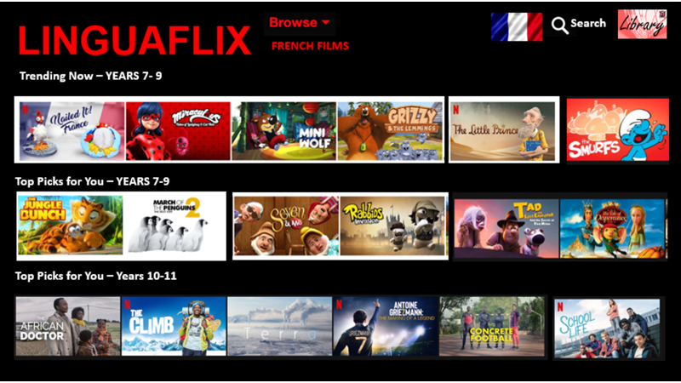

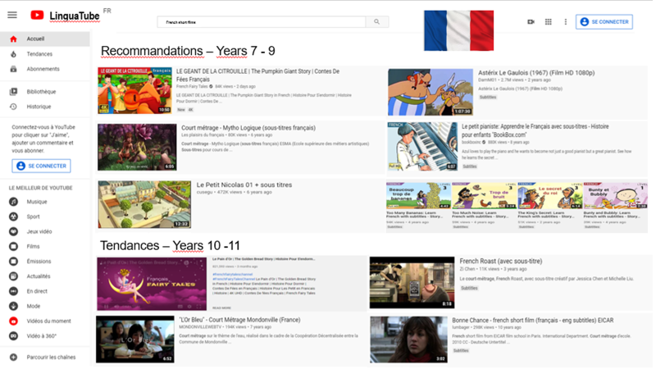

Having watched a film or clip on YouTube or another channel, could you complete a review – see example of one below.
Or write down your thoughts on how you found listening to the film in a different language - Was it odd? Did it change your thoughts on the film? Have you managed to understand any new French words?
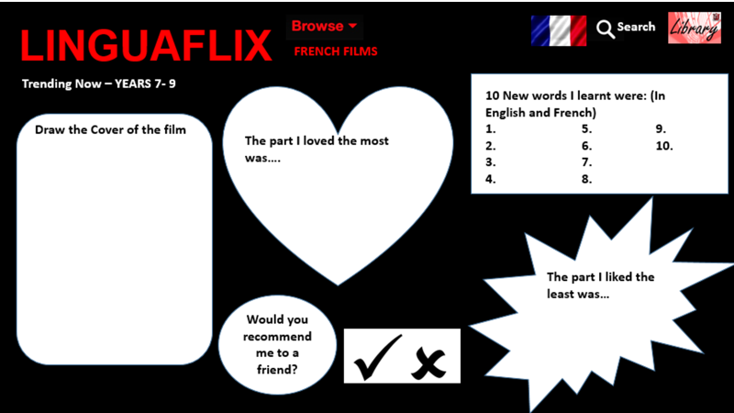

5) Be Creative
Look through your grammar book and class book – could you design yourself some study / revision notes – using lots of colours to help you spot patterns and note key points
Could you a calligram ( a picture with words) in French - -it could be any picture you like – try to use French words or sentences
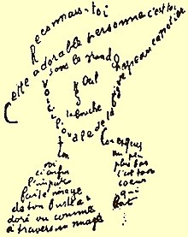

6) Teachvid https://www.teachvid.com/resources
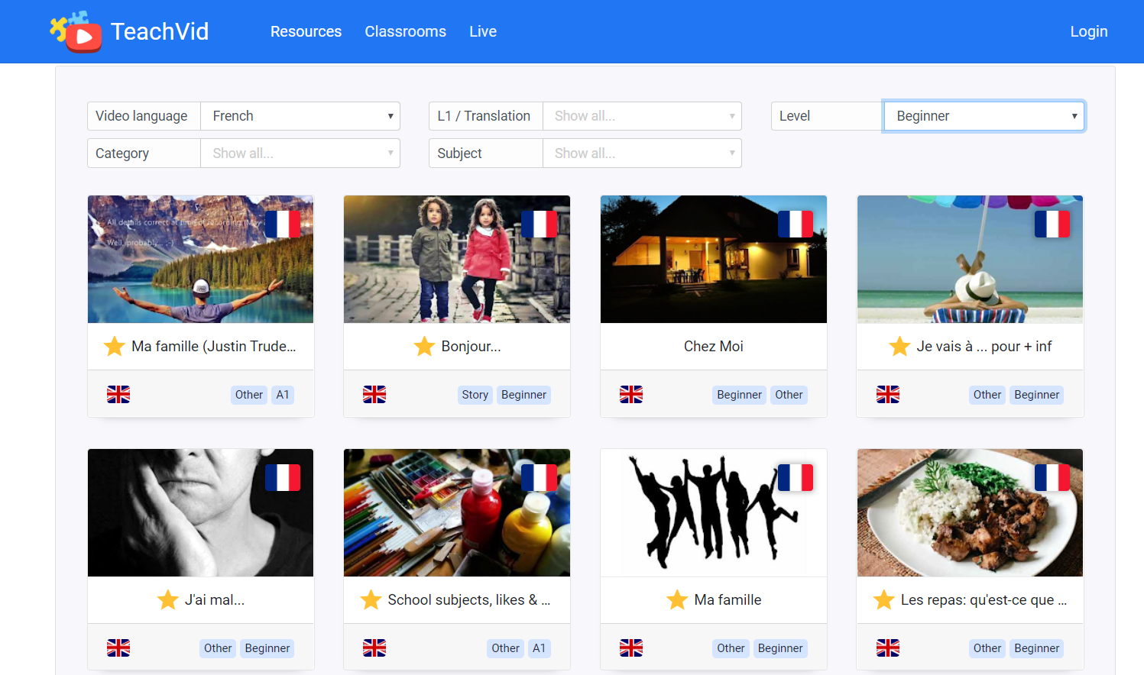
Choose video language French, level beginner and then you could also choose by subject e.g family, town etc

7) Music. You could listen to the songs in the French chart and write a music review, in English.
You will notice how many English songs are in the top songs each week inn France. However, listen to some French songs or watch the video on Youtube
https://www.billboard.com/charts/france-digital-song-sales or https://www.youtube.com/playlist?list=PLhp9gj0sRcTxfqPOkOJRJ6ql1oSKQ9ra0 Hits du moment / les meilleurs des tubes du moment
Disclaimer - I cannot guarantee that every song by these artists will not contain bad language.
Please excuse any bad language – they don’t always filter English rude words

Discover a new French musician!
You could research Vianney, Daft Punk, Christine & the Queens and Maitre Gims.
Below is a list of suggested artists to listen to and their most famous songs. You will find them on Youtube and/or Spotify.
Task 1 - Find the lyrics and write down 10 new words in French that you have learnt from each song.
Task 2 - Write a review of the song and what you thought of it (in English or French)

- Bigflo et Oli (rappers)
  - Dommage (Shame)
  - Demain (Tomorrow)
  - Plus tard (Later)

- Vianney (Singer-songwriter)
  - Je m’en vais (I’m leaving)
  - La même ft Maître Gims (the same)

- Louane (semi finalist in the French version of the Voice)
  - Avenir - (Future)
  - Immobile (Motionless)
  - Je vole (I’m flying)

- Stromae (Belgian electronica artist)
  - Alors, on danse (So, let’s dance)
  - Formidable (Strong)
  - Papaoutai (Dad, where are you?)

8) Language learning also includes learning about the countries and cultures where the language is spoken.
Can you find out how many countries speak French as one of their official languages and create a fact file on five of them. Include details such as location, capital, currency, climate, population, food and drink, popular sports, popular music etc

9) Prepare a fact-file about your favourite French sportsperson.
In the summer term of Y7, we usually study the topic of freetime, sport and leisure activities. Research a famous French sportsperson and write a fact file about them in English or maybe include some details in French, using mainly language from your grammar book. Feel free to include pictures/drawings of them. You should try to include the following.
- Their name and age
- What they like and don’t like
- How often they play their sport
- Two reasons why they are your favourite sportsperson.

10) Eiffel Tower challenge. This is a tweet from the Eiffel Tower

Remember: Have fun and keep yourself tuned into French for when we next see you.

Please contact us with any work or thoughts as you complete tasks – we love hearing from you.

