Lacon Childe School Uniform
Blazer
Maroon Blazer with school badge
Shirt
White Shirt
Skirt
Plain Black Pleated Skirt – tailored and knee length, Available from the school shop at the following link. DL972 Senior Girls Black Pleated School Skirt – Simply School Uniform
Trousers
Plain black school trousers - bootcut, straight or tapered.
(No skinny fit, combat style, jeans, leggings, denim or cropped styles are accepted)
Shorts
Tailored knee length shorts.
Tie
Yr7 to 10 – standard school tie Lacon Childe Tie – Simply School Uniform
Y11 Lacon Childe Year 11 Tie – Simply School Uniform
Socks
Plain black
Shoes
School type polishable black shoes.
(No trainers and no shoes with a branded logo, Air force trainers etc are not acceptable)

The images below are NOT acceptable as school shoes.
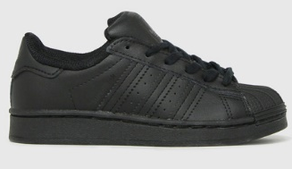
School Skirt – Pleated and knee length
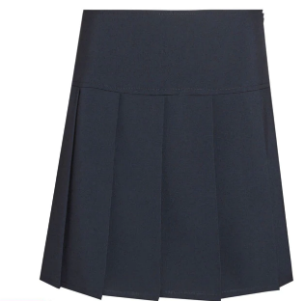
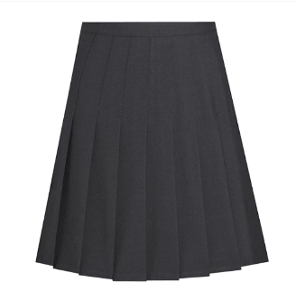
Optional Items
Jumper - Maroon ‘V’ Neck Pullover

Lacon Childe School
PE Kit and Guidelines
PE kit must be brought to every lesson- “Fit or sick, bring your kit”.
Hairstyles - Long hair must be tied up for all PE lessons.
All jewellery must be removed for every PE lesson. Taping is not allowed
PE Polo Maroon/White with school logo
(Initials optional)

PE black unbranded shorts

PE black ¾ or full-length leggings with school logo

Black unbranded knee length socks

Trainers
Optional Items
Black PE Jumper with school logo
(Initials optional)
Shin Pads
Students in Y8-11 can still use the hoodies that they have previously purchased
All items including those with a logo are available from Simply School Uniform in Kidderminster (Formally the School Shop)
Lacon Childe School – Simply School Uniform
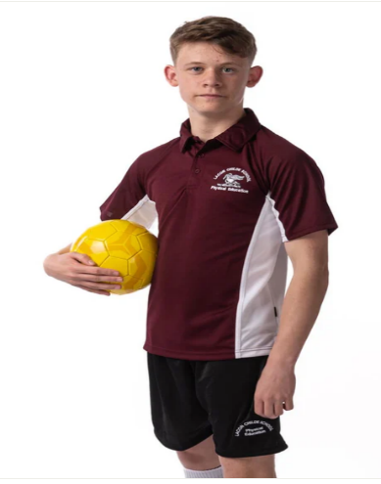
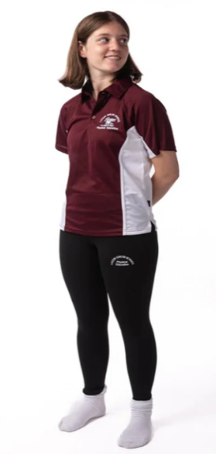
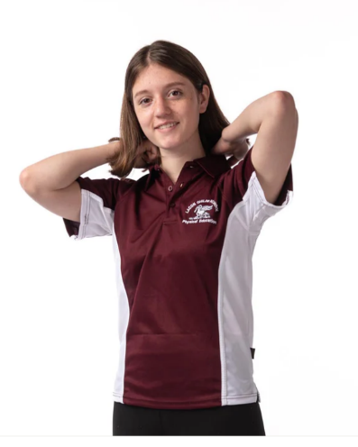

General information

Hairstyles
- Hair should be smart, we do not permit any extreme styles such as tramlines, shaven hair below grade 2 and stepped hairstyles where there are noticeable differences in hair length.
- Any coloured hair should be of a natural tone, and dip dyed/ombre hair is not acceptable.

Unacceptable Hairstyles
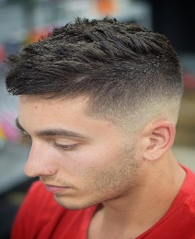 |  | 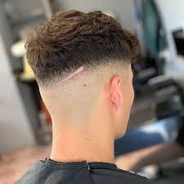 | 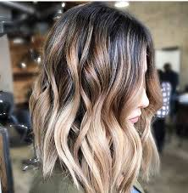

Make Up
- Years 7-9 no make-up or nail varnish is allowed.

Jewellery
- Only one stud earring is permitted in each ear lobe, please note that this will have to be removed for P.E.
- Additional earrings and piercings in other parts of the ear are not acceptable.
- Students may wear a watch and one small ring on each hand.
- Pandora bracelets and other wrist accessories are not permitted.

If students are seen with additional jewellery items, they will be asked to remove it and it will need to be collected by parents.

Coats
We ask pupils to wear plain, dark-coloured, sensible coats, appropriate for school (ex-service garments in camouflage colours or of obvious military origin, leather jackets, imitation leather jackets, denim jackets, badges or motifs are not allowed).

If it is necessary to wear a scarf, it should be appropriate for school.

Mobile Phones
Students are not allowed to use their mobile phones on school premises. If a student has their mobile phone out or is seen to be using their mobile phone, it will be confiscated by the member of staff and taken to the school office.

