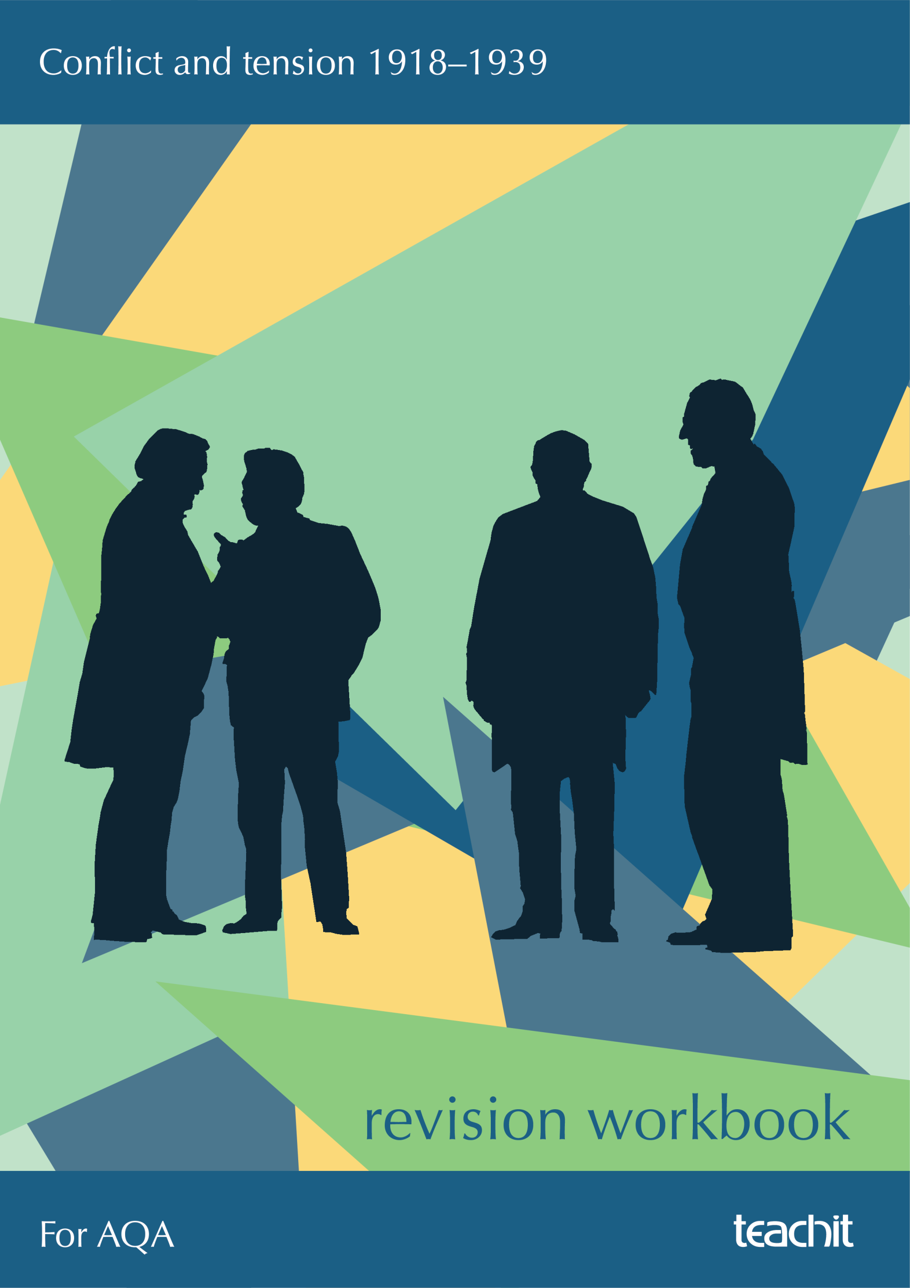

Contents
4 | Introduction to this workbook
6 | Topic 1: Peacemaking |  | Revise | Practise | Refresh
6 |  | The aims of the ‘Big Three’
8 |  | Clashes between the ‘Big Three’
9 |  | The Treaty of Versailles: Did the peacemakers achieve their aims?
10 |  | Who was satisfied with the Treaty of Versailles?
11 |  | Was the Treaty of Versailles fair?
13 |  | How did Germany react to the Treaty of Versailles?
15 |  | What happened at the rest of the peace conferences?
18 | Topic 2: The League of Nations and international peace
18 |  | The aims of the League
19 |  | What did America’s absence mean for the League?
20 |  | How did the structure of the League undermine it?
21 |  | Was the League doomed to fail?
21 |  | What was the role of the League’s agencies?
22 |  | How successful was the League in the early 1920s?

26 | What was the effect of the Great Depression on world peace?
27 | What was the impact of the Manchurian Crisis on the League?
28 | What did the Abyssinian Crisis show about the League?
30 | How did the Disarmament Conference of 1932−34 go so wrong?
31 | Topic 3: The origins and outbreak of the Second World War |  | Revise | Practise | Refresh
31 |  | What were Hitler’s aims as Chancellor of Germany?
32 |  | Hitler’s foreign policy
37 |  | Why did Britain and France follow a policy of Appeasement?
39 |  | How was Appeasement a cause of WWII?
39 |  | Who was to blame for the Second World War?
42 | Exam practice
42 |  | Question type 1 – Source A is critical/supportive of X. How do you know?
44 |  | Question type 2 – How useful are these sources for a historian studying X?
46 |  | Question type 3 – Write an account of …
48 |  | Question type 4 – X was the main reason for Y. How far do you agree with this statement?
49 | Appendix: Further notes and ideas on sources in this pack

Introduction

Overview of the exam
Section B of Paper 1 is about how Europe went from making peace in 1918 to making war in 1939. It includes the following cornerstone events of the period:
- The Treaty of Versailles
- The Great Depression
- Manchuria and Abyssinia
- The Anschluss
- The Annexation of Czechoslovakia and the Munich Conference
- The outbreak of the Second World War

There are three key topics that you will need to study:
Topic 1 | Peacemaking
Topic 2 | The League of Nations and International peace
Topic 3 | The origins and outbreak of the Second World War

Assessment objectives
Assessment objective | What does it mean?
AO1  Demonstrate knowledge and understanding | - Knowledge and understanding of Germany 1890−1945.  - Your ability to recall and apply a range and depth of factual knowledge of Germany’s history during this period.  - Tip: Try to use two or three pieces of knowledge each time you approach a question with an AO1 focus.
AO2  Explain and analyse historical events | - This is your ability to communicate and explain Germany’s history using different second order concepts such as description, causation, change, continuity and consequence.
AO3  Analyse, evaluate and use sources | - This is your ability to analyse, evaluate and use sources from the period to make judgements about the events you’ve studied.

Which questions assess which objectives?

You will be given a source booklet containing three sources.
You will be asked four questions worth 44 marks in total. They will look similar to this:
Question | Marks | Assessment objective | Approx. time to spend on this question
Source A is critical/supportive of X. How do you know? | 4 marks | AO3 | 6 minutes
How useful are sources B and C to a historian studying X? | 12 marks | AO3 | 14 minutes
Write an account of how … | 8 marks | AO1 and AO2 | 10 minutes
‘X was the main reason for Y’. How far do you agree with this statement? | 16 marks + 4 SPaG marks | AO1 and AO2 | 20 minutes

How to use this workbook

The first part of this guide will help you to refresh your knowledge of the three key topics you have studied on this period and to apply your knowledge using a variety of tasks.

The second part will guide you through how to answer each of the four types of question, with lots of tips and advice.
Disclaimer: The suggested approaches and sample questions in this exam skills pack have been written to complement the teaching of the specification. AQA have not endorsed the sample questions or approved the content.
The suggested answers and source notes provided are for exemplification. There are many ways of answering most history questions (for example structuring essay questions). You should draw on your own knowledge and understanding as much as possible to find approaches that suit you. This guide is a good starting point.

Peacemaking
Topic 1

Background information
The First World War had two ‘ends’. The first, which ended the fighting, was the armistice of 11 November 1918. The armistice agreement was a temporary truce, which forced both sides to stop fighting and withdraw their troops. The armistice favoured the Allies (Britain and France), while Germany retreated from all battlegrounds, surrendered many of its weapons and withdrew its troops from all conquered land. The reaction to the armistice was fairly calm – most soldiers and countries were happy to end the fighting − and it was expected that a formal peace treaty would soon be drawn up.
The Treaty of Versailles, signed in 1919, was the second ‘end’ which formally and finally ended the First World War. Germany had surrendered and signed an armistice in November 1918, but the full terms of the peace treaty were not finalised or announced until June 1919. The talks for the peace treaty were known as the Paris Peace Conference and the treaty which dealt with Germany was called the Treaty of Versailles.

The aims of the ‘Big Three’
Three countries dominated the Paris Peace Conference: Britain, France and the United States. Germany was not invited. These were the victorious powers in the First World War. Their leaders were:

France − Georges Clemenceau
France had three priorities: peace and protection, revenge, and money to rebuild. Clemenceau was known as ‘the Tiger’ because he was believed to be keen to destroy Germany, so that it could never attack France again, and to make sure it paid for the rebuilding of France.

Britain − David Lloyd George
Britain had four priorities: trade, its navy, the British Empire, and avoiding blame for the War. Lloyd George was known as ‘the Banker’ because his priorities were mainly economic, and he was looking out for British economic interests most of all. He thought that if Germans were punished too harshly they might begin another war.

America − Woodrow Wilson
America had a published plan which was very transparent. Wilson attended the conference after publishing his Fourteen Points. The Fourteen Points were a set of proposals for peace which Wilson drew up – they were published before the armistice and were a major reason Germany agreed to stop fighting (believing the eventual peace treaty would be based on the points). These points included:
- freedom of the seas
- self-determination for all (every national group should rule themselves)
- access to the sea for Poland
- a League of Nations to be established as an international peacekeeping and cooperation centre.
Wilson was known as ‘the Dreamer’ because he was idealistic in his aims for the post-war world.
 | 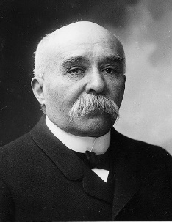 |  | 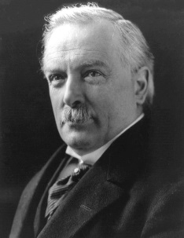 |  | 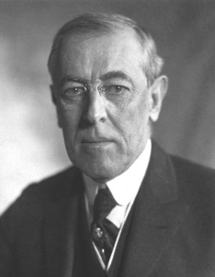
Georges Clemenceau |  | David Lloyd George |  | Woodrow Wilson

Task | Summarise the goals and opinions of each peacemaker in no more than five words and five symbols.

Clemenceau | Lloyd George | Wilson

Source activity | Use your knowledge to annotate the cartoon below. Two elements have been completed for you. What else can you add? (See Appendix for further ideas about this source.)

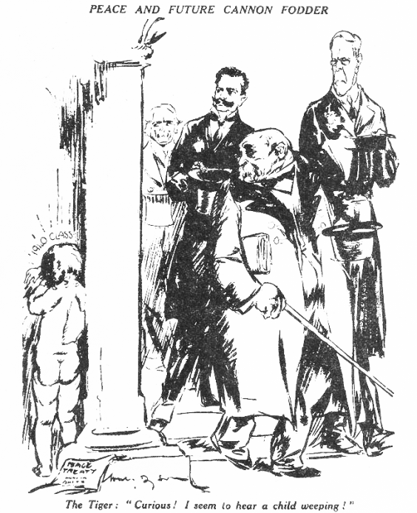
The title is important − ‘Cannon Fodder’ means that the Treaty is going to create resentment in the future, and cause another war. This reflects how Lloyd George feared that the Treaty was only a ‘20 year armistice’, and that Europe would face another war for German revenge.

By saying ‘Curious! I seem to hear a child weeping!’, the cartoonist is suggesting that the peacemakers, and Clemenceau in particular, don’t actually care about Germany – that they are being selfish in the Treaty. This reflects how Clemenceau was seen to be the harshest of the ‘Big Three’, as he wanted to destroy Germany completely, hence his nickname ‘The Tiger’.

Clashes between the ‘Big Three’
Task | Can you work out who each of the following disagreements was between and why they disagreed? Complete the following table. (See Appendix for further ideas.)  The first disagreement has been completed for you.

Disagreement | Country 1 | Country 2 | Explanation
The seas  Who would have the strongest navies and control the seas? | Britain – Britain wanted the British navy to be the strongest and to control imperial trading routes. | America – America wanted freedom of the seas, with free-trade routes for all. | Britain and America disagreed because America thought Britain was being selfish, whereas Britain thought America’s idea threatened the security of the British Empire and control of it through the British navy.
Germany’s military
How much of a military force should Germany have?
Revenge
What should be done with Germany to punish it for causing WWI?
Colonies
What should happen to German, British and French colonies?
The German economy How much should Germany pay and how rich should it be allowed to become?

The Treaty of Versailles: Did the peacemakers achieve their aims?
The Treaty of Versailles was eventually signed on 28 June 1919, seven months after the armistice of November 1918.
Here is a reminder of the main terms of the treaty.
Task | Some of the terms have been explained in full, some are hinted at, and some are left completely blank. Complete the list! (See Appendix for further notes on this.)

Territorial terms
- Germany lost a strip of land that ran right through the middle of Eastern Germany. This left two parts of Germany disconnected. This land was given to Poland, to ensure it had access to the sea, and was called the ‘Polish Corridor’.
- Next to the Polish Corridor, Germany also lost a rich city called
- Overall, Germany lost % of its land. This included Alsace−Lorraine, which was given back to
; and , which were given to Belgium; and North Schleswig, which was given to .
- The Rhineland (bordering France) was
- Germany’s African colonies were

Economic terms
- Germany had to pay

- The Saar

Military terms
- The German military was limited to 100,000 men.
- Conscription was

- The Germany navy was

Germany was not allowed to have an

Blame
- Germany had to sign Article 231, the War Guilt Clause. This meant that Germany had to take full responsibility for the First World War.
- Article 231 justified

International affairs
- The League of Nations would be created.
- Germany was not allowed

Task | Which terms of the treaty do you think were the harshest? Explain your decisions in each box.

Harshest
Quite harsh
In the middle
Not that harsh
Least harsh

Who was satisfied with the Treaty of Versailles?
Task | Read the information below and see how many terms of the treaty you can link to each leader. Highlight what each leader would have found pleasing in the treaty.

Wilson was outraged and largely dispirited by the final treaty. He felt that Britain and France had taken advantage of him in order to get what they wanted. In particular, Wilson hated how harsh the treaty was, and was sure that it would create problems in the future. Whilst he had got some of his Fourteen Points, he only got one in full: the League of Nations.
When Wilson returned to America, to get the treaty signed by the United States Senate, they refused. As a result, America never signed the treaty − this was a significant blow to its reputation. Furthermore, as a result of not signing the treaty, America never joined the League of Nations.

Wilson – the least satisfied
There were many things about the treaty which Clemenceau greatly disliked, and the French people disliked even more. Most obviously, Germany was still a country. Similarly, Clemenceau was annoyed not to have control over the Saar or Rhineland and was angry that Germany still had some form of military. Finally, Clemenceau felt that the reparations bill was too small and would not cover French damages or punish Germany enough.
It is important to remember that France had lost the most during the war so wanted the most from Germany, and consequently felt most let down by the treaty.
On the other hand, Clemenceau was happy that there were to be some substantial reparations. Furthermore, he and France were pleased to get Alsace−Lorraine back and to have the Rhineland demilitarised. Most French people were happy to be part of the League of Nations as they thought it would commit America to helping France if Germany ever became a problem again.

Clemenceau – in the middle
In general, Britain got the majority of what it wanted. In particular, Britain was pleased that Germany would still be economically strong enough to trade with but would also be paying reparations. Similarly, Britain was pleased to get German colonies, along with control over the associated trade routes, and happy that the German navy would be vastly reduced. Finally, Britain was relieved that all war guilt was assigned to Germany.
Whilst the British public were pleased, Lloyd George was less so. He privately feared that the treaty was too harsh and could result in another war. He also worried that the Polish Corridor was a bad idea, and that the separation of so many German people from the country would create anger and a desire for revenge.

Lloyd George – the most satisfied

Key question | ‘Wilson was the most dissatisfied by the terms of the Treaty of Versailles.’ Do you agree?

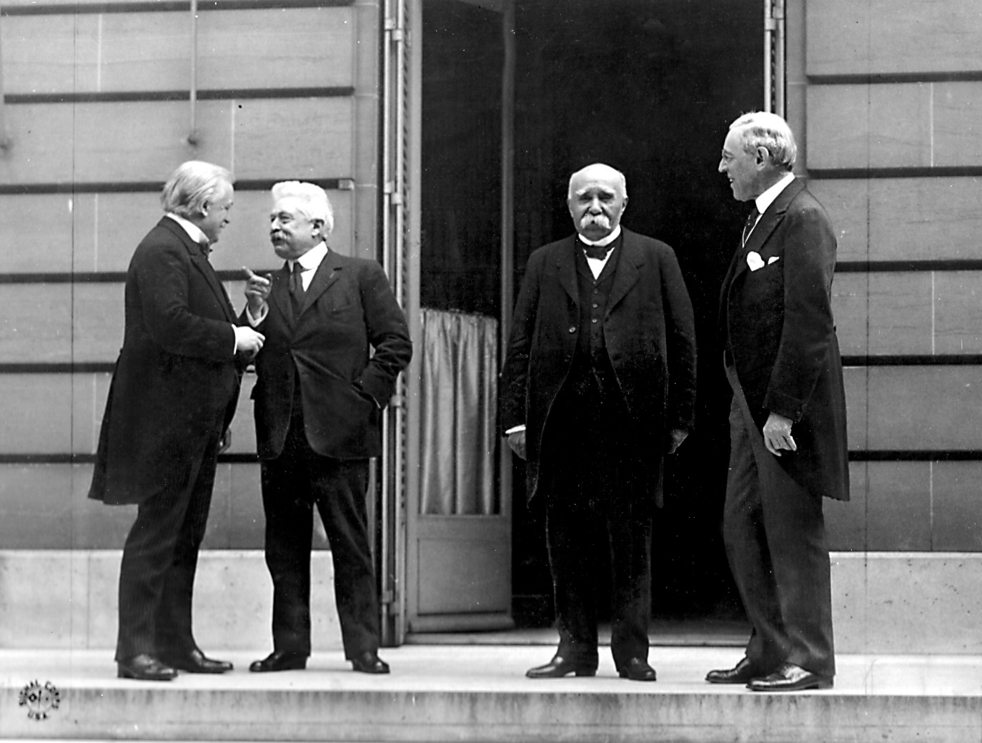

From left to right: Lloyd George, Orlando, Clemenceau and Wilson in Versailles

Was the Treaty of Versailles fair?
The extent to which the treaty was unfair has been debated endlessly by historians. There are varying interpretations and understandings of both the terms of the treaty, and the events that followed them. The main arguments revolve around:
‘The treaty was unfair’ arguments | ‘The treaty was fair’ arguments
- The treaty was a ‘Diktat’ (dictated) treaty.  - The League of Nations did not allow Russia or Germany to join – some saw it as a ‘winners’ club’.  - Self-determination was applied inconsistently to different countries; Germany lost some territories because of self-determination (for example the Polish Corridor) but did not gain any new land through self-determination (such as Austria, which Germany considered to be its sister country, sharing a culture and language).  - Empires – Britain and France grew their empires at Germany’s expense.  - There were many critics of the treaty who simply argued that the total harshness, when all terms were taken into consideration, was just too great. They feared that this would create a generation of Germans who hated Britain and France and would want revenge. | - Germany did play a significant part in starting the war, so it seemed reasonable to many that it should pay the highest price.  - The peacemakers did the best job they could – against impossible odds.  - It could have been much worse – especially in comparison to Brest-Litovsk.  - In history, we tend to judge things by the standards of the time – to judge historic events using modern standards is called ‘anachronism’. In 1919, it was a normal attitude to expect a losing power to pay severely at the end of a war.  - This is shown in the Treaty of Brest-Litovsk, which Germany signed in 1918 with Russia. In this treaty, Germany made enormous demands of Russia. People accused Germany of hypocrisy when it complained about its own harsh treatment in 1919.

Task | Using these arguments and your own notes, complete the revision grid below by adding detail to the arguments for and against the Treaty of Versailles.

 | No: Diktat |  |  | No: the fourteen points |  |  | No: the League of Nations
 |  |  | No: Diktat | No: the fourteen points | No: the League of Nations
 | Yes: it could have been worse |  | Yes: it could have been worse | Was the treaty fair? | No: self-determinat-ion |  | No: self-determinat-ion
 |  |  | Yes: it was the ‘best possible peace’ | Yes: German blame | No: Empires
 | Yes: it was the ‘best possible peace’ |  |  | Yes: German blame |  |  | No: Empires

How did Germany react to the Treaty of Versailles?
With so many vested interests, and so many challenges in putting it together, the treaty was never going to please everyone. There were mixed reactions in all countries, often with different opinions from politicians and everyday people. Germans, though, were all horrified.

German reactions to the treaty
The terms of the treaty were announced on 7 May 1919 to a horrified German nation. Germany was to lose:
- 10% of its land
- all of its overseas colonies, which became League of Nations mandates
- 12.5% of its population
- 16% of its coalfields and almost half of its iron and steel industry
- reparations payments to the winning countries, of an amount yet to be decided.
Many Germans had hoped for a fair settlement based on Wilson’s Fourteen Points and were shocked by the treaty. There were mass protests throughout Germany, including an attempted communist revolution. The Treaty was referred to as a ‘Diktat’ − a settlement forced on them and in which they had no say.
Many did not believe that the German army had actually been defeated. They were angry at being blamed for causing the war as they knew other countries had been part of the outbreak. The German politicians who signed the armistice were known as ‘the November Criminals’.
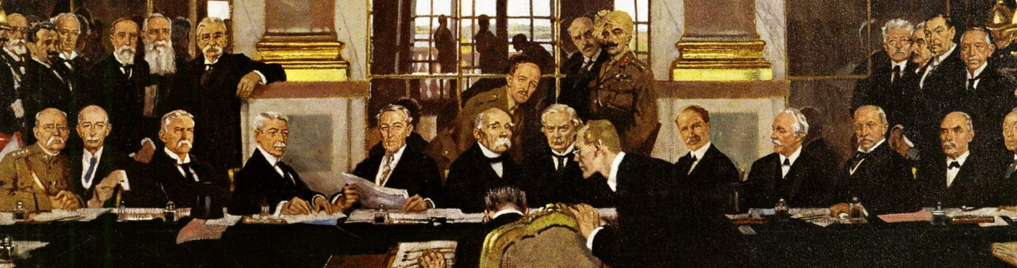
The Signing of the Peace in the Hall of Mirrors

Task | Summarise the main things that Germans would have been angry about in the Treaty of Versailles. (See Appendix for further notes.)

Blame
Reparations
Armed forces
Territory
The League of Nations

‘November criminals’ and the ‘stab in the back’ myth
Those in Germany who particularly disliked the treaty (especially the army) were outraged at the actions of the government. This gave birth to the nickname ‘the November criminals’ for Ebert’s government, which had accepted the armistice of November 1918, and to the myth that this government had ‘stabbed Germany in the back’. This myth was later used to great effect by the Nazi party, to gain power in Germany.
Source task | Annotate these sources with:  - the symbols used  - the message they are trying to convey about the treaty  - the ways they are useful to a historian studying reactions to the treaty.  You can find more notes about the sources in the Appendix.

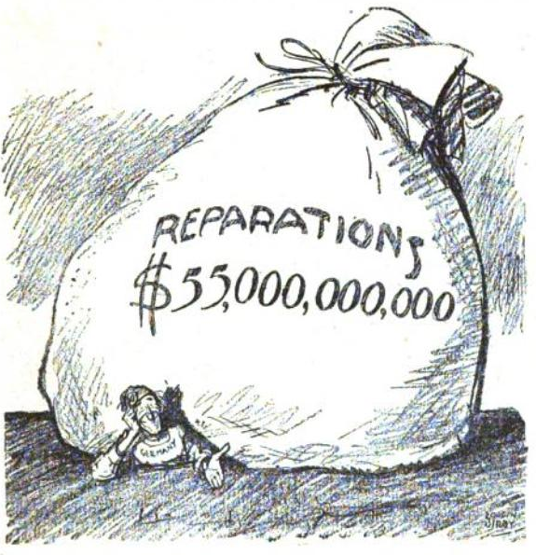
An American political cartoon from 1921. The caption read ‘Let’s see you collect it!’
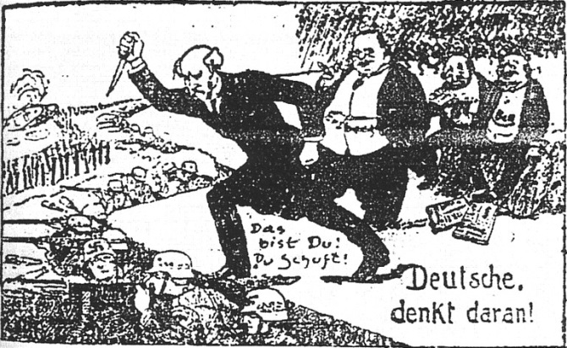
A political cartoon from 1923 showing Philipp Scheidemann and Matthias Erzberger stabbing German soldiers in the back

The Ruhr Crisis
The German reactions to the treaty led to a crisis in 1923, as German resentment came head-to-head with French frustration at a perceived lack of severity.
- In 1922, Germany fell behind with reparation payments.
- In response to this, French and Belgian soldiers entered the industrial Ruhr region to take what was ‘owed’ to them in the form of goods and raw materials.
- The German government ordered the workers to go on strike to prevent France and Belgium from being able to take anything. The French, however, killed 100 workers and expelled 100,000 protesters from the region.
- The strike also meant that Germany no longer had enough goods to trade in order to make money.
- The government attempted to solve this problem by printing more money. This in turn caused hyperinflation (money became virtually worthless). Workers had to be paid daily instead of weekly as they had to carry all the money in wheelbarrows and the price of food soared.
Task | After the Treaty of Versailles in 1919, and the Ruhr Crisis in 1923, how would many Germans be feeling?

What happened at the rest of the peace conferences?
The Treaty of Versailles was one part of the Paris Peace Conference. The following treaties were also agreed with Germany’s allies:
Country | Treaty | Year
Bulgaria | Treaty of Neuilly | 1919
Austria | Treaty of St Germain | 1919
Hungary | Treaty of Trianon | 1920
Turkey | Treaty of Sèvres | 1920

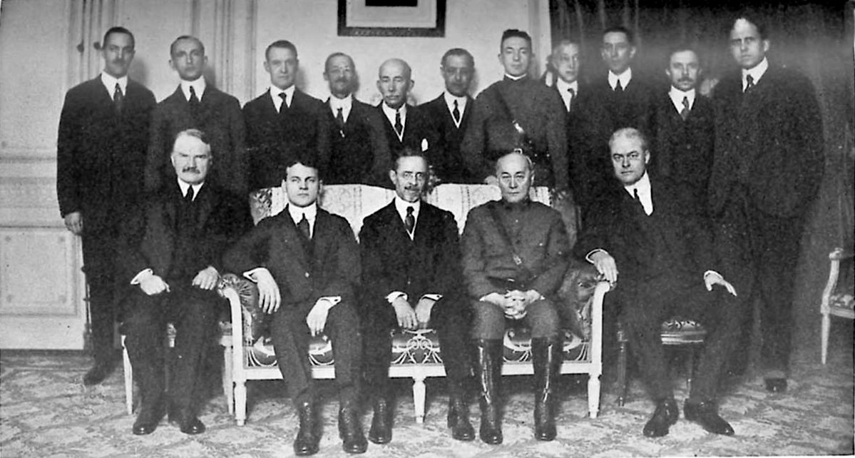
A 1919 photo of inquiry members at the Paris Peace Conference

Task | Use your prior knowledge, and research if necessary, to complete the following profile cards for the four treaties.

Treaty:  Key details:  Date:  Countries:  + / - ?  Military terms  Territorial terms  International terms  Consequences | Treaty:  Key details:  Date:  Countries:  + / - ?  Military terms  Territorial terms  International terms  Consequences
Treaty:  Key details:  Date:  Countries:  + / - ?  Military terms  Territorial terms  International terms  Consequences | Treaty:  Key details:  Date:  Countries:  + / - ?  Military terms  Territorial terms  International terms  Consequences

The Treaty of Lausanne, 1923
After the treaty of Sèvres the Turkish people overthrew their government and the new government threatened war with the Allies over the terms of the treaty. This meant a new treaty, the Treaty of Lausanne being agreed in 1923 on the following terms:
- Turkey regained some land in Europe and on the Anatolian peninsula, which Greece had previously been given.
- It was allowed more control and autonomy over the Dardanelles.
- It had full control over its own military.
- Reparations were cancelled.
- Allied forces and military bases were withdrawn.
Why was Lausanne so significant?
- Lausanne significantly undermined the Allies and the other Paris Peace treaties.
- A small show of force had meant that Britain and France were not prepared to go to war to enforce the Paris Peace Conference– they backed down instead.
- This later encouraged Mussolini and Hitler, as they felt their own countries had been treaty unfairly too.
- Whilst Italy had been a winner of the First World War, Mussolini felt that Britain and France had gained everything from the Peace Conferences, and Italy had gained almost nothing.
- Lausanne showed that even in three years, Allied governments had changed and the US had retreated back into isolationism, so their position of dominance no longer applied.
Task | Which country do you think was dealt with the most harshly, and why?

The new states
The Paris Peace Conference led to a dramatically different map of Europe. The Austro-Hungarian Empire was split into several new countries.
Czechoslovakia | - Czechoslovakia declared itself independent from Austria−Hungary in 1918 and this was accepted at the Paris Peace Conference.  - The Allies hoped that it would become a country which would be economically and politically stable in central Europe.  - In reality, it was not very stable, as it contained many different national groups, and as a result there were ethnic tensions. A fifth of the population was German and resented being part of a new country.
Poland | - The Allies wanted to recreate Poland so that it could act as a watchdog on Germany and form a barrier against communist Russia.  - Poland had no natural frontiers such as rivers or mountains, however, which made it vulnerable to attack.  - From the very outset there was fighting between Poland and Russia.  - Poland had also been given access to the sea, through the Polish Corridor which covered a German city called Danzig. This was bitterly resented by the Germans.  - Poland was surrounded by hostile states.
Yugoslavia | - Yugoslavia was formed from several ethnic groups, between which there was often tension.  - However, the country remained relatively stable in this period.

The League of Nations and international peace
Topic 2
The League of Nations was an international organisation which brought together different countries. It started with 42 member states in 1920, and was intended to grow and include as many countries as possible as time went on.

The aims of the League
The League had four main aims:
- to keep the peace and prevent war, through improved international cooperation
- to facilitate disarmament (reducing weapons)
- to improve working and living conditions for people around the world
- to help end deadly diseases around the world.
Task | The League planned to keep peace through the idea of ‘Collective security’. Can you define what is meant by this? (See Appendix for a suggested definition.)
Source task | Below is a cartoon published in Britain in March 1919 called ‘Overweighted’. Complete the questions below. Further ideas about this source can be found in the Appendix.

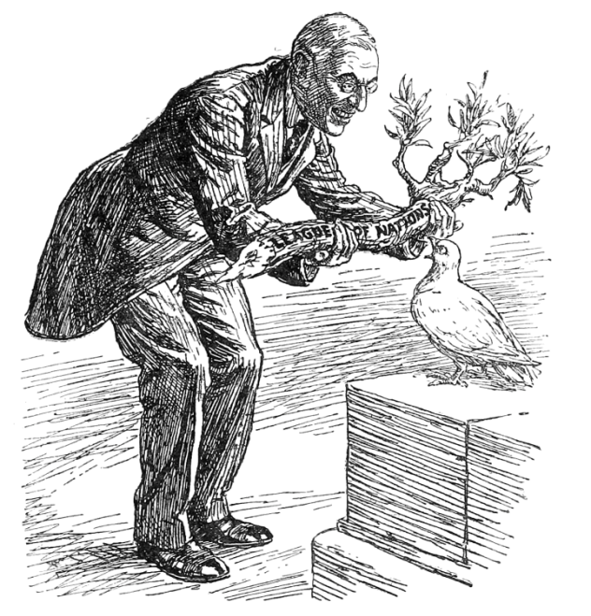 |  | - What can you see in the source?  - What does the title reveal?  - What does the caption reveal?
President Wilson: ‘Here’s your olive branch, now get busy.’
Dove of Peace: ‘Of course I want to please everybody; but isn’t this a bit thick?’
- What can we learn from this source about feelings about the League?

Who didn’t join, and why?
United States | Isolationist Republicans in the US Senate blocked Wilson from signing the Treaty of Versailles. They thought the treaty was unfair and betrayed the Fourteen Points. Also, they didn’t want to get involved with European problems and have to ‘bail Europe out’.
The USSR | The ‘Big Three’ and especially Lloyd George greatly feared communism. The Allied powers also felt betrayed that Russia had pulled out of the First World War in 1918. Now, Russia was seen as unreliable and even dangerous.
Germany | Germany was largely kept out of the League for revenge. Britain and France officially told Germany that it had to prove it could be a cooperative and ‘peace loving’ country, before it would be allowed to join. In reality, Britain and France were worried that Germany would try to use the League to undermine the terms of the Treaty of Versailles and get reparations reduced.

What did America’s absence mean for the League?
American absence undermined the League in several ways:
- It was Wilson’s idea, so without America it lacked a leader.
- The League lacked the money that America would have provided to help run it.
- Without America it lacked significant legitimacy – especially in the hands of Britain and France it looked like a ‘winners’ club’ to run their colonies.
- The League lacked America’s power to help stop aggressive nations.
Source task | The impact of America’s absence is perhaps best shown in this famous cartoon. It was published in Punch magazine on 10 December 1919. Answer the questions below.

- What can you see in the source? |  | 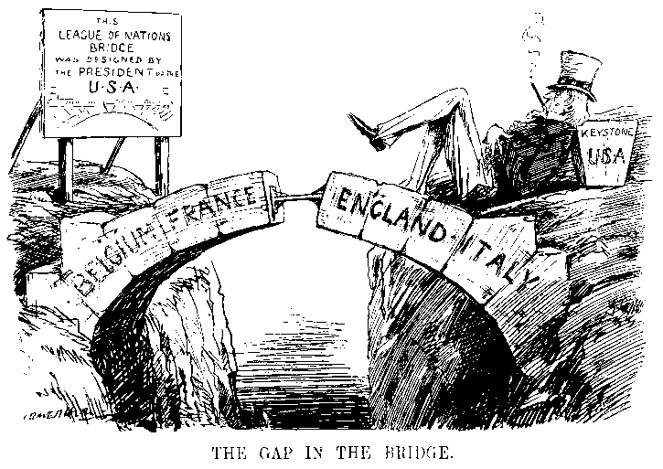
- What is the message of this cartoon?

 |  | The Gap in the Bridge, a cartoon from Punch magazine published on 10 December 1919
- What specific knowledge do you have about this?

How did the structure of the League undermine it?
After America refused to sign the Treaty of Versailles, Britain and France were left running the League, but both were low on money after the war and had other priorities (like their empires). Germany and the USSR were not allowed to join. Yet some historians argue it was really the structure of the League which made its failure more likely.
Task | Using your notes, and research if necessary, can you complete this diagram to show the structure of the League?
The League of Nations
The powers of the League
Secretariat |  |  | Assembly |  |  |  | Council of the League
International Labour Organisation |  |  |  |  |  |  | Permanent Court of International Justice
Special commissions

Was the League doomed to fail?
Some historians argue that the League was doomed to fail as a result of its structure. They make the following arguments:
- The assembly met only once a year and had to pass resolutions unanimously. This made it almost impossible to make any decisions in the League.
- The veto made this problem even worse because any member could block a motion with one vote.
- The sanctions sounded good in principle but had several significant problems:
  - Mediation was great when it worked, but required a willingness to talk and to accept the resolution.
  - Moral condemnations did absolutely nothing.
  - Economic sanctions were almost pointless when many of the world’s strongest economies were outside of the League, including the US.
  - Military sanctions were never used – the League had no army of its own so relied entirely upon member states to send troops. It was never able to convince member states to do so.

Timeline of the League’s membership

 | 1920: | The League was set up with Britain, France, Japan and Italy as the permanent members of the Council.
 | 1926: | Germany joined the League after Britain and France promised it could at the Locarno Conference (this was negotiated outside of the League).
 | 1933: | Japan left the League after the Manchurian Crisis. Germany left the League after the failed Disarmament Conference.
 | 1934: | The USSR joined the League in an attempt by Britain and France to bring them onside, after they saw the danger of losing Japan and having limited influence in Asia.
 | 1936: | Italy left the League.
 | 1939: | The USSR was expelled from the League.

What was the role of the League’s agencies?
One aim of the League was to improve people’s lives and reduce discontent, therefore making conflict less likely. It was mostly successful in this during the 1920s. These activities tended to be carried out by the League’s agencies. The League highlighted global social problems and made positive steps towards eradicating diseases such as leprosy. Its work in relocating refugees had never been achieved before by any organisation.

The agencies’ achievements … and limitations
The International Labour Organisation was able to persuade members to introduce a minimum wage and limits on working hours. It also helped Greece set up social insurance to help unemployed and sick people. However, it didn’t manage to stop children under the age of 14 from working and it failed to limit the working day to eight hours.
The Commission for Refugees helped to resettle millions of refugees who had fled their homes during WWI and sent over 500,000 prisoners of war back home. 1.5 million refugees from Russia were resettled. However, in 1933 Nazi Germany vetoed the League’s attempt to help refugees who were fleeing Germany.
The Slavery Commission did manage to set 200,000 slaves in Sierra Leone free, though it was unable to ban slavery universally.
The Health Committee worked to combat the spread of serious diseases such as malaria, leprosy and plague. In 1948 this committee was renamed the World Health Organisation (WHO), which still exists today.

Task | Make a set of flashcards to help you remember the key successes and limitations of the League’s agencies.

How successful was the League in the early 1920s?
The League was called upon fairly quickly to exercise its peacekeeping powers.
The following are five key disputes that you need to know about:
1920: | the Vilna dispute
1920-1: | the Upper Silesia plebiscite
1921: | The Åland Islands dispute
1923: | the Corfu crisis
1925: | the Greece−Bulgaria crisis

Task | Using your notes, and research if needed, complete the summary boxes of the League’s interventions in the 1920s.  For each event you should include:  - key details and dates  - the countries involved  - the end result  - whether the event was a success or failure for the League.

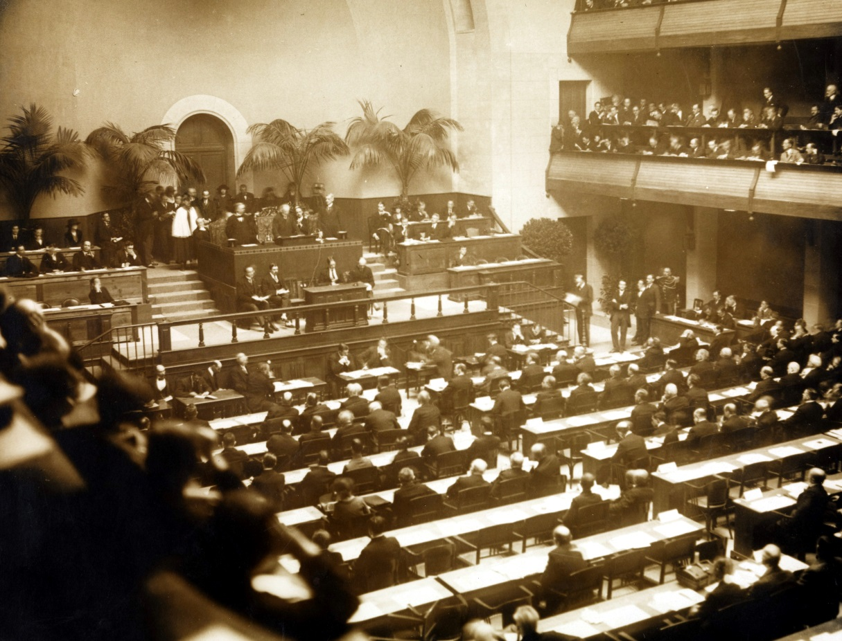
The first meeting of the Assembly of the League ,15 November 1920, Geneva

Vilna  Countries involved:  Why was there a crisis? The crisis started when Poland invaded the city of Vilna. This was because the Treaty of Versailles had given it to the new Lithuania, but the people there were Polish.  What happened?  Success or failure for the League? |  | The Åland Islands  Countries involved:  Why was there a crisis? Both Sweden and Finland wanted these islands, which are halfway between the two countries.  What happened?  Success or failure for the League?
Upper Silesia  Countries involved:  Why was there a problem? Both Poland and Germany wanted this land and both Polish and German people lived there.  What happened?  Success or failure for the League? |  |  | 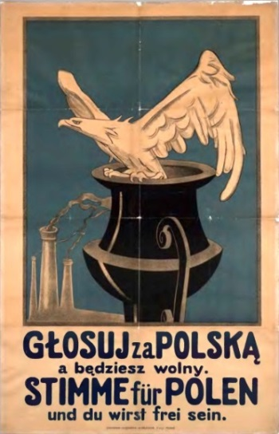 |  | 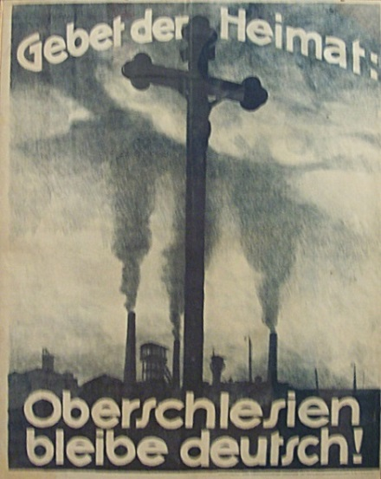
 |  |  | A Polish propaganda poster: ‘Vote for Poland and you will be free’ |  | A German propaganda poster: ‘Prayer for the Homeland: Upper Silesia remain German!’

The Greece−Bulgaria crisis  Countries involved:  Why was there a crisis? Greek soldiers were killed on the border with Bulgaria. Greece invaded Bulgaria in reply.  What happened?  Success or failure for |  | The Corfu crisis  Countries involved:  Why was there a crisis? An Italian general was killed near Greece and Mussolini got extremely angry.  What happened? Mussolini bombarded the island of Corfu.  Success or failure for the League?
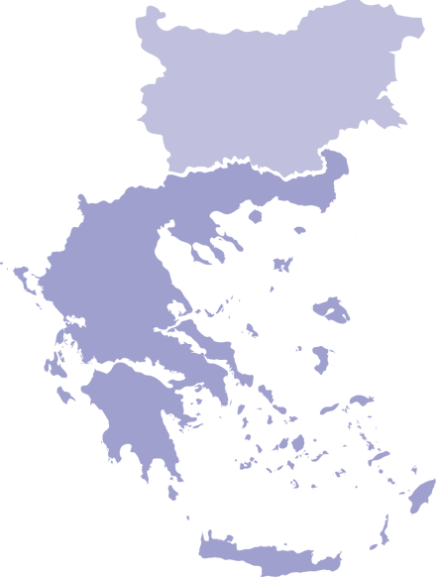  Bulgaria  Greece  Petrich |  | 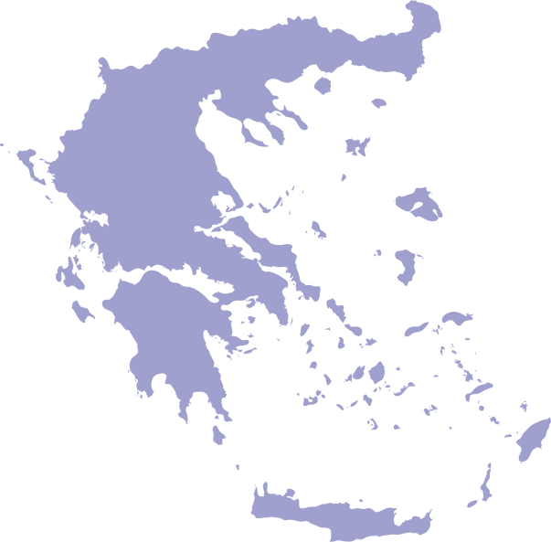  Greece  Corfu

Overall, how successful was the League in the early 1920s?
Task | Summarise the overall strengths and weaknesses of the League in the 1920s, including what the outcomes of its efforts at peacekeeping meant for how it was seen by world leaders.

Strengths | Limitations

How did diplomacy outside of the League undermine it?
In the 1920s, countries began making treaties between themselves, bypassing the League altogether. This either showed that they were learning to get on peacefully and that there was an air of optimism about diplomacy in the 1920s, or that they had no confidence in the League to keep peace!

Treaty: | The Locarno Treaties, 1925 | The Kellogg−Briand Pact, 1928
What happened? | - France, Britain, Belgium, Germany, Poland, Italy and Czechoslovakia agreed not to invade each other.  - Germany agreed to keep troops out of the Rhineland (already a point of the Treaty of Versailles).  - Germany agreed to honour the western borders in the Treaty of Versailles. It gave up its claim to Alsace-Lorraine.  - Stalin was not invited.  - All signatories agreed to settle disputes peacefully.  - Germany would be allowed to join the League. | - The US Secretary of State (Kellogg) and the French Foreign Minister (Briand) set up a group of 62 countries.  - They signed a treaty to promise never to use war as a way to resolve a dispute (again, what the League already did).  - No sanctions were agreed upon for those who did not follow the promises.
Why did this undermine the League? | - The Treaty was conducted outside of the League. This was the largest peacetime conference since the Treaty of Versailles, so having it outside of the League made the League look unimportant.  - It greatly angered Stalin and made European peace efforts look elitist.  - The lack of discussions and promises made about Poland and the East made the Treaty of Versailles look weak, as Britain and France seemed only to care about the west of Europe.  - Germany was allowed into the League via a conference that did not involve the League. This ‘short cutting’ of the League was becoming more frequent. | - What did the Kellogg−Briand Pact do that the League didn’t do already? This made it seem as though countries didn’t trust the League to do what it was set up to do.  - Having the United States involved in the Kellogg−Briand Pact suggested that peace could only work if America was involved – so the League also looked weak.  - This all suggested that even by 1928, countries weren’t that committed to the League.

What was the effect of the Great Depression on world peace?
On Tuesday 4 October 1929, the United States stock market collapsed. Owners of stocks and shares began panic selling. This frenzy quickly affected the banks, employment and peoples’ savings. Over 1,000 banks per year failed between 1929 and 1932. This was the worst period in the history of the United States’ economy and became known as the Great Depression

The Great Depression spreads to Europe
Within America the consequences were severe, but the effects weren’t limited to the United States. The Great Depression affected Europe for several reasons.
Task | Colour code the chart below to show the impact of the Great Depression:  - issues affecting Germany  - issues making all countries more aggressive  - the growth of nationalism
The Dawes and Young Plans
What was it like before?  Germany was struggling to make the reparations repayments. In 1923 Germany suffered a hyperinflation crisis, partly because of the burden of the reparations. This crisis wiped out the savings of the middle classes and drove some Germans to support extreme politics. |  |  | What happened?  America made two loans to Germany in the 1920s.  The Dawes Plan of 1924. (This also included negotiations to get Germany into the League of Nations).  The Young Plan of 1929. |  | Why did this affect Europe?  This had a positive impact, as the loans enabled German recovery. Following the Dawes Plan, Germany (and the rest of Europe) entered a period of peace and recovery. This coincided with the Locarno Treaty of 1925, and is therefore called the ‘Locarno Honeymoon’.
American loans to Europe from WWI
What was it like before?  The Locarno Honeymoon was a period of peace and rebuilding. These ‘golden years’ in Germany saw extremist politics become less popular – the Nazis had very little support and had what are known as their ‘wilderness years’. |  |  | What happened?  When the Wall Street Crash hit America, the US recalled its loans from Germany.  This led to Germany taking the largest hits of any European country in the Great Depression. Unemployment skyrocketed, and the country couldn’t pay reparations. These impacts also hit many other European countries. |  | Why did this affect Europe?  In the economic pressures of the Great Depression, many countries withdrew support and funding from the League of Nations. This particularly affected the Disarmament Conference (1932−4), as countries saw rearming as an opportunity to boost their economies. More widely, many countries also became more aggressive and nationalistic.
The Great Depression in Germany
What was it like before?  The impact of the Great Depression caused homelessness and bankruptcy to skyrocket. This was the second major economic catastrophe in 10 years, with the middle classes again losing their savings. |  |  | What happened?  The discontent in Germany and economic crisis was a major factor in Hitler’s rise to power – many of the previously moderate German middle classes sought extremist politics as an alternative the centrist coalitions which had let them down in 1923 and were letting them down again in the 1930s. Once in power, Hitler used these concerns to massively rearm. |  | Why did this affect Europe?  Hitler was elected on a platform to undo the hated Treaty of Versailles. This meant he got straight on with rearming and remilitarising. This put Britain, France, and the League in a difficult spot – they couldn’t afford to challenge Hitler as it would be expensive and risky, but that meant they had to sit back and watch him break the Treaty of Versailles.
The Great Depression in Germany
What was the impact of the Manchurian Crisis on the League?
Japan had been badly hit by the Great Depression. Manchuria was an area in China that was rich in minerals and resources – other nations, including Japan, had factories there. Japan wanted to expand and exploit the riches of the area.

Why did Japan invade Manchuria?
- It is the part of China closest to Japan. It is closer to Japan than it is to Beijing, the Chinese capital.
- People in the area spoke Japanese as well as Chinese.
- Japan had fought, and won, a war against Russia in 1905. Russia was also still recovering from their Revolution in 1917. They wanted to push this advantage by taking more land near Russia.
- The Japanese people were not happy with the effects of the Great Depression. They also weren’t sure whether they supported the army or the government more. The army thought that some success abroad would make the people more likely to support them.
Tasks | - Colour code the boxes of this table to show causes, events, and consequences.  - Number the boxes to show the chronological order of the events.  (See Appendix for a completed version.)
Exam-style question | Write an account of how events in Manchuria became an international crisis in the years 1931 to 1933  (8 marks)

causes
events
consequences

The League asked Lord Lytton to go and investigate in Japan after the Mukden Incident. | Not only did the Japanese stay in Manchuria, but in July 1937 they also invaded the rest of China. China appealed to the League and didn’t even get a meeting. | The League tried to pass a resolution to order Japanese troops out of Mukden. Japan vetoed the resolution.
In September 1931, the Japanese claimed that Chinese soldiers had sabotaged the Manchurian railway in Korea, which Japan controlled. This was called the Mukden Incident. | Meanwhile, in January−March 1932, Japan attacked, bombed and captured the city of Shanghai in China itself. In March 1932, China appealed to the League of Nations again. | A week after leaving the League in February 1933, Japan continued to invade more of China, taking the Jehol Province.
In April 1932, a League delegation led by Lord Lytton arrived in Manchuria to see what was happening, and in October 1932 it finally reported. The report declared again that Japan should leave. | The League also discussed banning arms sales to Japan, but the member countries could not even agree about that. They were worried that Japan would retaliate and the war would escalate. | Japan attacked Manchuria. The official government in Japan told the Japanese army to withdraw, but its instructions were ignored.

By February 1932, Japan had brutally conquered Manchuria. They renamed it Manchukuo and installed a puppet emperor. | In February 1933, a special assembly of the League voted against Japan, so the Japanese walked out. | As well as not backing economic sanctions, it was also clear that Britain and France were not prepared to send an army.
The League, however, could not agree on sanctions. Without the USA, Japan’s main trading partner, they would be meaningless. Besides, Britain seemed more interested in keeping up good relations with Japan than in agreeing to sanctions. | After the Mukden incident, China appealed to the League, claiming it was under threat of invasion. | Japan claimed it was not invading as an aggressor, but simply settling a local difficulty. The Japanese argued that China was in such a state of anarchy that they had to invade in self-defence to keep peace in the area.
 | The League didn’t really take China seriously, as no invasion had happened yet, and China was so far away, and already in internal chaos.
What did the Abyssinian Crisis show about the League?
Japan was not the only country to lash out during the Great Depression. After the First World War, Italy had been taken over by the dictator Mussolini. One of Mussolini’s goals was to create a ‘Second Roman Empire’, and spread Italy’s power. Italy was not recovering well from the Depression even by 1935, so he sought a distraction. Abyssinia was a name for what we now call Ethiopia. It was one of only two free countries left in Africa. Italy had tried to invade it in 1896, but had been humiliatingly defeated.
Why did Mussolini want to invade Abyssinia?  - He needed to distract the Italian people with something. Mussolini’s popularity was falling in Europe as he struggled to recover the economy. A successful foreign conquest sounded like the perfect way to regain this popularity.  - He wanted revenge for Italy’s humiliating defeat in 1896.  - It was one of the only places he could invade that was not already in someone else’s empire.  - He had been successful in Corfu so he was quite confident that the League would do nothing. |  | 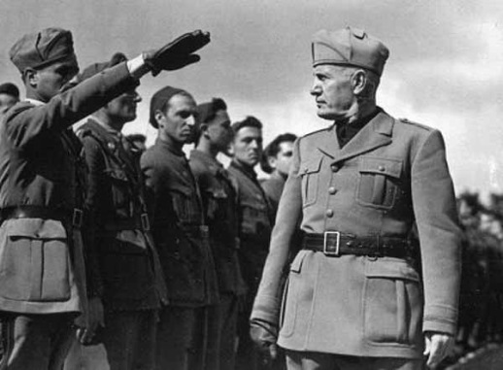
 |  | Mussolini inspecting his troops
- Mussolini was encouraged by Japan’s success in Manchuria.
- Italy already had very small colonies next to Abyssinia – Eritrea and Italian Somaliland. Mussolini wanted to connect these and expand them.
- Italy had just signed the Stresa Front with Britain and France. They were desperate to keep Mussolini as an ally against Hitler. As such, he was confident they wouldn’t oppose him over Abyssinia.

What happened?
Tasks | - Read through the information about Abyssinia. Which words can you remove, whilst keeping the important meaning?  Here is an example of what you have to do to the Abyssinia paragraphs, so you can see it in practice. Now you try it.  - Now highlight the causes, events, and consequences in separate colours.

In December 1934 there was a dispute between Italian and Ethiopian soldiers at the Wal-Wal oasis – 80km inside Abyssinia. Mussolini claimed it was Abyssinia’s fault, even though the incident had taken place inside its territory. Mussolini demanded an apology from Abyssinia, and began preparing the Italian army for an invasion. The Abyssinian emperor Haile Selassie appealed to the League for help.
Between January and October 1935 Mussolini was supposedly negotiating with the League to settle the dispute, while at the same time he was shipping his army to Africa and whipping up war fever among the Italian people – he was preparing for a full-scale invasion of Abyssinia. During the period of negotiations, Britain and France signed the loose friendship of the Stresa Front (1935) with Mussolini, against Hitler. At the meeting to discuss this they did not even raise the question of Abyssinia. On 4 September, after eight months’ deliberation, a committee reported to the League that neither side could be held responsible for the Wal-Wal incident. The League put forward a plan that would give Mussolini some of Abyssinia, which bordered their colonies in Africa. Mussolini rejected it, as he wanted more.
In October 1935 Mussolini’s army was ready. He launched a full-scale invasion of Abyssinia. Despite brave resistance, the Abyssinians were no match for the modern Italian army equipped with tanks, planes and poison gas. The Covenant of the League made it clear that sanctions must be introduced against the aggressor (Italy). A committee was immediately set up to agree what sanctions to impose. The League imposed an immediate ban on arms sales to Italy while allowing them to Abyssinia. It banned all loans to Italy. It banned all imports from Italy. It banned the export to Italy of rubber, tin and some metals. The initial sanctions did not ban the sale of oil, coal, food or steel.
Some members of the League pushed for oil sanctions, but the League hesitated. It feared the Americans would not support the sanctions. It also feared that its members’ economic interests would be further damaged. In Britain, the cabinet was informed that 30,000 British coal miners were about to lose their jobs because of the ban on coal exports to Italy. Privately, it was suggested that Britain and France should close the Suez Canal to strangle the Italian supply lines. They refused.
In December 1935, while sanctions discussions were still taking place, the British and French Foreign Ministers, Hoare and Laval, were hatching a plan. This aimed to give Mussolini two-thirds of Abyssinia in return for him calling off his invasion! This was called the Hoare−Laval Pact. Laval even proposed to put the plan to Mussolini before they showed it to either the League of Nations or Haile Selassie. Laval told the British that if they did not agree to the plan, then the French would no longer support sanctions against Italy. Details of the plan were leaked to the French press in December of 1935. It proved disastrous for the League. In both Britain and France it was seen as a blatant act of treachery against the League. Hoare and Laval were both sacked. But the real damage was to the sanctions discussions, which lost all momentum.
In February 1936 the sanctions committee concluded that if they did stop oil sales to Italy, the Italians’ supplies would be exhausted in two months, even if the Americans kept on selling oil to them. But by then it was all too late. Mussolini had already taken over the majority of Abyssinia. The Americans were even more disgusted with the dithering of the French and the British and so blocked a move to support the League’s sanctions. American oil producers actually stepped up their exports to Italy.
On 7 March 1936 the fatal blow was delivered. Hitler, timing his move to perfection, marched his troops into the Rhineland and up to the border with France. If there had been any hope of getting the French to support sanctions against Italy, it was now dead. The French were desperate to gain the support of Italy and were now prepared to pay the price of giving Abyssinia to Mussolini.
Italy continued to defy the League’s orders and by May 1936 had taken the capital of Abyssinia, Addis Ababa. On 2 May, Haile Selassie was forced into exile. On 9 May, Mussolini formally annexed the entire country. The League watched helplessly. Collective security had been shown up as an empty promise. The League of Nations had failed. In November 1936 Mussolini and Hitler signed an agreement of their own called the Rome−Berlin Axis. Mussolini left the League of Nations and the Stresa Front.

How did the Disarmament Conference of 1932−34 go so wrong?
One of the main aims of the League of Nations was to promote world disarmament. This meant encouraging countries to have fewer weapons and smaller armies. From the very beginning of the League, they had planned to run a conference to start countries talking about disarming. In 1932, the League finally got a Disarmament Conference together.
Task | Fill in the blanks in the flowchart, using the terms below.

Treaty of Versailles | Ruhr Crisis | Hitler | League of Nations | France
Collapsed | Suspicious | Storm out | Rearm | 1933

was elected Chancellor of Germany in . One of his main aims was to destroy the . This would involve rearming Germany.
At the Disarmament Conference, Hitler demanded that if Germany was not allowed an army, then should not be allowed one either. He even claimed that the of 1923 showed how vulnerable Germany was.
France was outraged – it was still of Germany. They refused Hitler's conditions.
Hitler used this as an excuse to of the conference. He even said the French refusal was a sign that France was planning to invade Germany, and so Germany now had to .
Hitler didn't just leave the Conference, he took Germany out of the . This made other countries nervous that Germany was rearming, so they also left the Conference and started rearming. The Conference ..

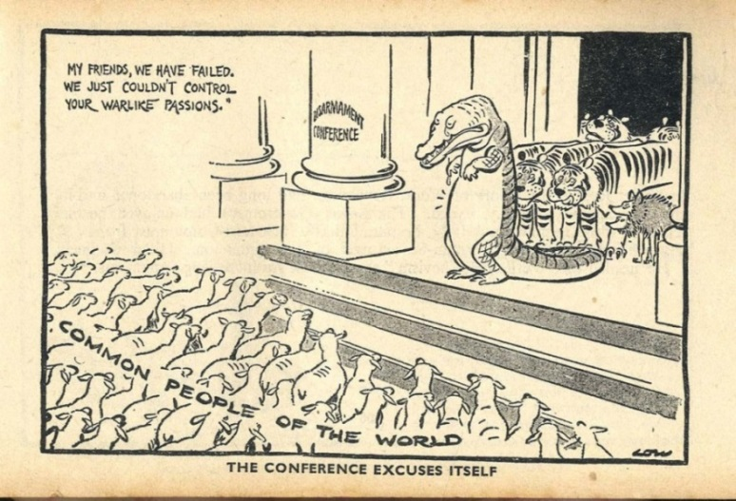
A David Low cartoon from 1934, criticising the League for its failings at the conference
.

The origins and outbreak of the Second World War
Topic 3
What were Hitler’s aims as Chancellor of Germany?
Hitler came to power in 1933 after the Great Depression had hit Germany hard and eroded popular support for the central parties. The Nazis used tactics of propaganda, grassroots campaigning and targeted discrimination (e.g. highlighting Jews as scapegoats for Germany’s problems).
Hitler’s main goals were:
- To undo the Treaty of Versailles.
- To rearm Germany and restore its pride as a military nation.
- Lebensraum – ‘living space’ for Germans to grow and expand into Eastern Europe.
- To unite all German-speaking peoples (Volksdeutsche) under one country – a ‘Greater Germany’.
- To destroy communism.
- To remove Jewish people from Germany.
Task | Put these goals onto the diagram below. At the top should be the goal which would make the most problems for peace. In each box, add some more detail from your own knowledge.

How did Hitler begin to go about achieving these aims?
- Germany left the League of Nations Disarmament Conference in 1933.
- Hitler made a Non-Aggression Pact (deal) with Poland in 1934. Both countries agreed to settle any disputes peacefully. This made Hitler look peaceful and reduced Polish fears of German aggression. It gave him more chance to rearm and upset France, which was an ally of Poland.
- In March 1935, Hitler reintroduced military conscription, expanding his army to one million men, and built an airforce (Luftwaffe), both of which broke the Treaty of Versailles.
- Concerned by German rearmament, Britain, France and Italy agreed to stand united to maintain peace in Europe and to defend Austrian independence. However, this agreement was undermined by the Anglo-German Naval Agreement (1935), which allowed Germany to build up its navy to 35% of the size of the British navy. Hitler knew that Britain had some sympathy with Germany, and that it thought the terms of the treaty were too tight and that a stronger Germany would act as a buffer to protect Britain against the USSR. By signing this agreement, Britain allowed Hitler to break the Treaty of Versailles once again.
Question | From his early foreign policy actions (1933−5), did it seem that Hitler intended to cause a wider war?

Hitler’s foreign policy  From 1933 Hitler spent two years building support within Germany. Then, in 1935, he started a more aggressive foreign policy. Ironically, it started with the Saar plebiscite, which was neither aggressive nor illegal, and was even promised in the Treaty of Versailles. However, the 90% result of Saarlanders voting to rejoin Germany gave Hitler the justification he needed to the break the Treaty of Versailles.  The key events you need to know about in this period are:  - The Saar Plebiscite: 1935  - Conscription and Rearmament: 1935  - Remilitarisation of the Rhineland: 1936  - Anschluss with Austria: 1938 (you should also know about the Dolfuss Affair of 1934)  - The Munich and Sudeten crises 1938  - The Annexation of Bohemia and Moravia: 1939  - The Nazi−Soviet Pact and Invasion of Poland: 1939 |  | 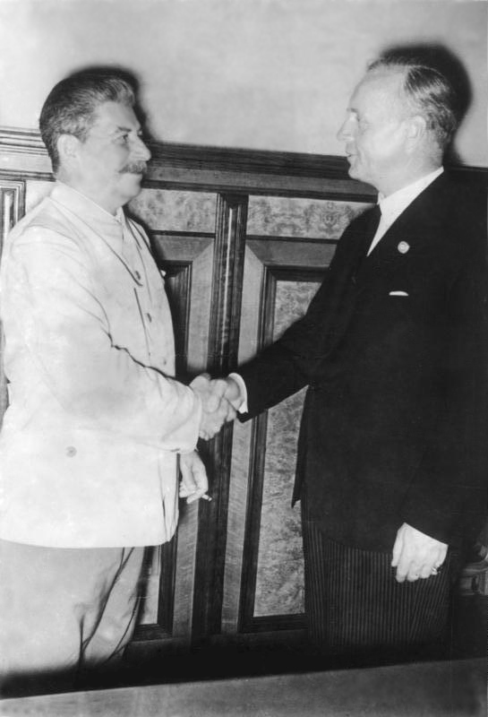
 |  | Stalin shakes hands with Ribbentrop after signing the pact, 23 August 1939

Task | Timeline: Start this section by completing a timeline of the events. It is crucial that you know the order of these events, as well as their main causes and consequences.  On your timeline you should include dates, key events, why each event was important and how significant it was (you could give it a score).

1935
1939

Task | Sort the foreign policy events in order of significance for making Hitler more powerful. The most significant should go at the top.  Inside each hexagon you should include the key details of each event, using only proper nouns, numbers and symbols. (Using images to represent key terms is called ‘dual coding’ and is one of the most effective ways to remember information.)

Task | Annotate Hitler’s foreign policy on the map – make sure that you include the years. You will see that Hitler started in the West, and then moved around in ‘anticlockwise’ order.

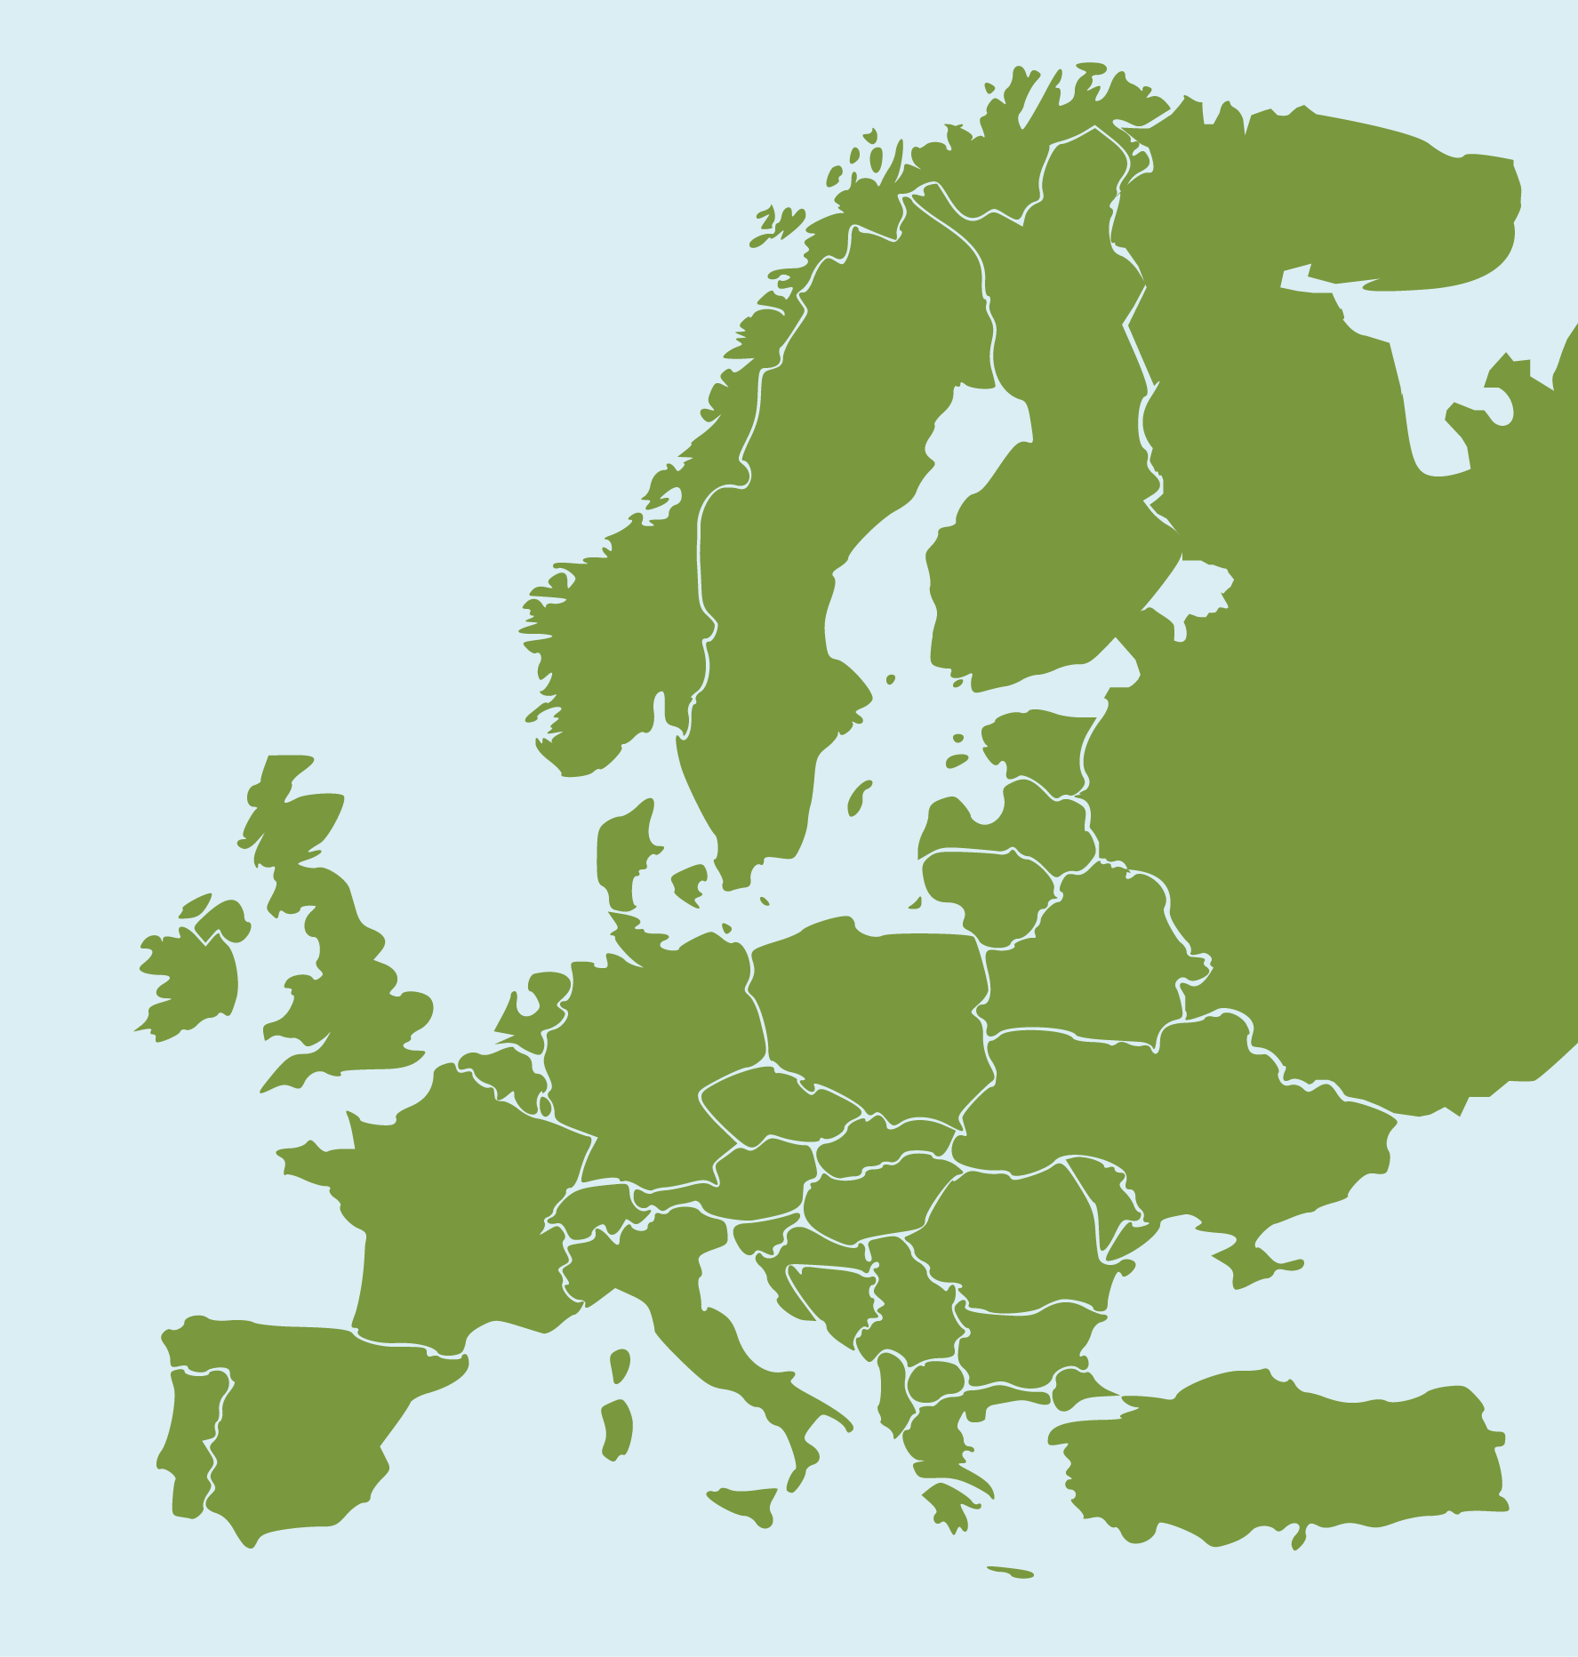

Memory-refreshers
The below mind-map is a basic reminder of the key events in this period.
The Rhineland was meant to be kept demilitarised under the Treaty of Versailles, but it remained German land. In March 1936 Hitler ordered German soldiers to enter. They went on bicycles and were greeted with flowers. Nobody stopped them – if they had, the German soldiers had orders to retreat rather than fight. This greatly strengthened Hitler’s position against France. Britain said Germans were only ‘walking in their own back garden’.

Remilitarising the Rhineland, 1936
Anschluss (union) with Austria had also been banned at the Treaty of Versailles. Hitler had attempted this first in 1934, but been stopped by Mussolini before they were allies. In 1938, Hitler started stirring up trouble in Austria through loyal local Nazis. These ended up forcing the Chancellor, Schuschnigg, to step down. His replacement, Seyss-Inquart, was a Nazi and he invited Hitler in to ‘restore order’. Hitler then held a fake plebiscite which ‘passed’ by 99%. Hitler now controlled Austria.

Anschluss with Austria, 1938
The Sudetenland had never been German, but was home to three million German speakers. As part of his policy of Volksdeutsche, Hitler claimed it should become German. He bullied Chamberlain into convincing Czechoslovakia to agree to a plebiscite, and France into not keeping its alliance with Czechoslovakia. Hitler then decided that he wanted the Sudetenland without a plebiscite, causing a crisis conference in Munich (organised by Mussolini). At this conference Britain and France agreed to give Hitler the Sudetenland. Czechoslovakia had no choice.

The Munich Crisis and Sudetenland, 1938
At the Munich Conference Hitler had promised that Czechoslovakia was his final territorial claim. He even signed the ‘Anglo-German Declaration’ never to go to war with Britain. Chamberlain left Munich feeling like he had secured ‘peace in our time’. Then, in March of 1939, Hitler invaded the rest of Czechoslovakia, after using the same tactics as in Austria (sending Nazis to stir up trouble and riots, so he had to ‘restore order’). This outraged Britain and France, and they started preparing for war.

The Annexation of Bohemia and Moravia, 1939
Nobody ever expected Stalin and Hitler to become allies – after all, Hitler had promised to destroy communism as one of his main goals. Yet, in August 1939 they signed a shock pact in which they agreed not to fight each other. This was an excuse that the two countries used to divide Poland between them. Neither really trusted the other, but Stalin was angry at being ignored by Britain and France and wanted to use Poland as a buffer zone against Hitler. Similarly, Hitler wanted land in western Poland for Lebensraum and access to the nearly three million Jews living in Poland. As such, Germany and the USSR both invaded Poland on 1 September 1939. Britain gave Germany two days to withdraw its troops and when it did not Britain and France declared war on 3 September. This started the Second World War.

The Nazi-Soviet Pact and Invasion of Poland, 1939
Hitler’s foreign policy

The Saar Plebiscite, 1935
The Saar was handed over to the League for safekeeping for 15 years as part of the Treaty of Versailles. It was given back to Germany following a plebiscite in 1935 in which 90% of Saarlanders voted to rejoin Germany. This gave Hitler confidence.
Hitler promised to destroy the Treaty of Versailles by rebuilding Germany’s military. He revealed this in 1935 at the ‘Freedom to Rearm Rally’ in Nuremberg. He showed off over a million soldiers, his new tanks and a new air force, the Luftwaffe.

Conscription and Rearmament,1935
Why was there a crisis? Both Sweden and Finland wanted these islands, which are halfway between the two countries.
What happened? The League decided that the islands would belong to _________, but they were not allowed to …
Success or failure for the League?

Success or failure for the League?

35

Why did Britain and France follow a policy of Appeasement?
Appeasement was the big idea of Neville Chamberlain, British prime minister from 1937 to 1940. It had been started before him, but he was the biggest believer in it.

Defining Appeasement
Task | The main debates are over why Appeasement happened. Fill in each piece of the jigsaw on the next page with a key detail about Appeasement. You can use the ones on the cards here, or make up your own. You should think carefully about the positioning of each event and use the corner pieces for the ideas that hold everything together. Each piece needs to link to the pieces next to it.

Luftwaffe | Maginot Line
Elections in France | Chamberlain
Reasonable German demands | Memories of WWI
Fear of communism | Respect for Hitler
Lack of public support for war | Treaty of Versailles
American isolationism | Economic problems
Spanish Civil War | Mussolini joining Hitler
The RAF wasn’t ready | Would the empire support?
You can use this technique for revising any other topic.

How was Appeasement a cause of WWII?  - It gave Hitler time to build up his armed forces and his economy to be ready for war. He could have been stopped in the Rhineland in 1936 when the French army was bigger than his, but by appeasing him he was able to gain stronger armed forces than Britain and France by 1939 when WWII did start.  - It gave Hitler confidence to demand more after each time he was appeased; the Rhineland led to Austria, which led to the Sudetenland. These successes also made him more popular in Germany, which made him more powerful.  - It allowed Hitler to repeatedly break the Treaty of Versailles. Appeasement was just an act of weakness that further encouraged Hitler.  - It made the USSR angry with Britain and France. Stalin knew that Hitler hated the USSR and had been willing to resist him over Czechoslovakia. When the USSR wasn’t invited to the Munich Conference it became convinced that there was no point in trying to work with Britain to stop Hitler and began to think of doing a deal with Hitler instead. This deal made WWII a certainty. |  | 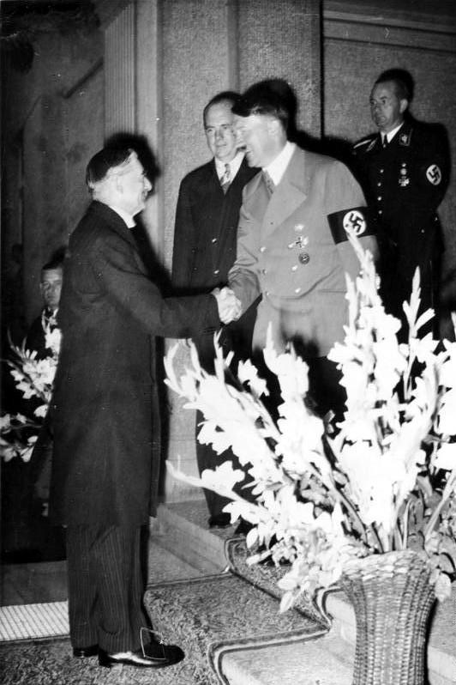
 |  | Chamberlain and Hitler shake hands during Chamberlain’s visit to Germany, September 1938
- Chamberlain misjudged Hitler. He didn’t realise until it was too late that Appeasement just encouraged Hitler to go further.
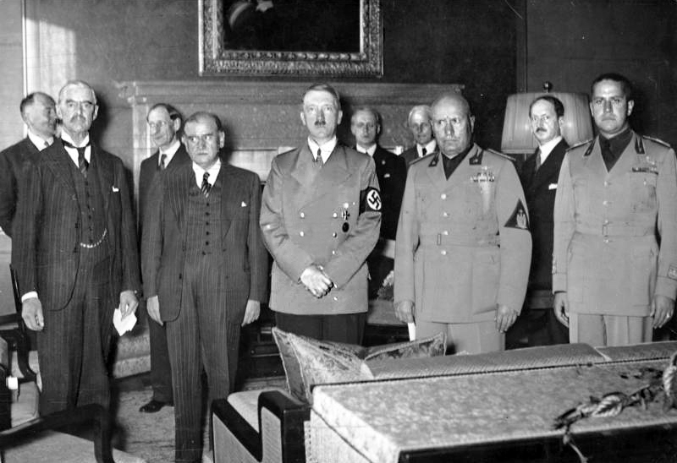 |  | Who was to blame for the Second World War?  The Second World War began after Britain and France declared war on Germany for invading Poland. Both sides’ allies joined soon after, and the main fighting began in early 1940. The key question that is asked is why the war happened.  There are many reasons and explanations. You are going to break these down through two main tasks. This should not require any new information, but you may need to think creatively, and thematically, about all of the learning for this course!
Chamberlain, Daladier, Hitler, Mussolini, and Ciano at the Munich Conference, Germany, 29 Sep 1938

Task | In the middle ring of the target sheet on the following page are some of the main causes of the war. Complete the inner ring with more causes, and then fill in the next three layers.  - Second layer – evidence to support the point  - Third layer – an explanation of how the evidence supports the point  - Outer layer – a judgement (how important was this factor relative to the others?)  Consider the descriptors around the side; how can you incorporate ‘short-term’, ‘long-term’, and ‘trigger’ into your judgements?

What caused the Second World War?

Individual responsibility for war
How far was each of the following responsible for the Second World War?
- Hitler
- Mussolini
- Chamberlain
- Stalin
Task | Complete the blank heads with key details about how and why each of the men could be blamed for the war. (See Appendix for further ideas.)

Exam skills
In the exam, you will be asked four questions, worth 44 marks in total. They will look similar to this:
Question | Marks | Assessment objective | Approx. time to spend on this question
Source A is critical/supportive of X. How do you know? | 4 marks | AO3 | 6 minutes
How useful are sources B and C to a historian studying X? | 12 marks | AO3 | 14 minutes
Write an account of how … | 8 marks | AO1 and AO2 | 10 minutes
‘X was the main reason for Y’. How far do you agree with this statement? | 16 marks + 4 SPaG marks | AO1 and AO2 | 20 minutes

Example questions
Question type 1 | Source A is critical/supportive of X. How do you know? (4 marks)

Example question
Source A  This source is a British cartoon from 1919. It was published in the Daily Herald. It shows George Clemenceau, David Lloyd George and Woodrow Wilson looking on as Germany (represented by the child) cries.  The title is ‘Peace and future cannon fodder’. The caption at the bottom says ‘The Tiger: “Curious! I seem to hear a child weeping!”’ |  | 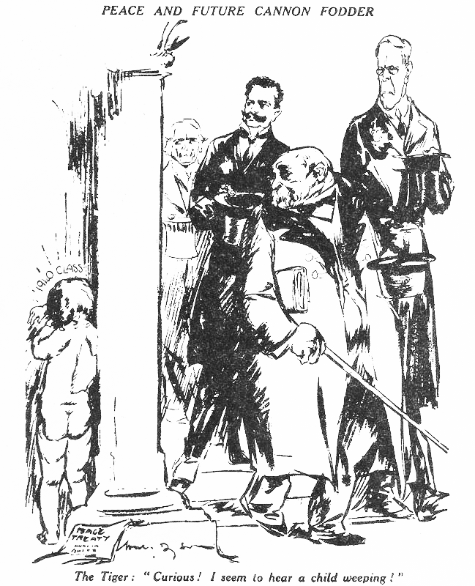
Study Source A
Source A is critical of the ‘Big Three’. How do you know?
Explain your answer using Source A and your contextual knowledge.
(4 marks)
This question is asking you to explain how a source supports or criticises a particular event. You need to refer to details in the source and explain them with your knowledge of what was happening at the time the source was created.
(See Appendix for more ideas about this source.)

Question checklist
Feature | Colour
Refer directly to details in the source by quoting from it or describing what is shown. You could refer to the source itself, its provenance, or both.
Explain what you can infer from the source – what message is being given?
Use detailed knowledge about what was happening at the time to explain whether the point of view given in the source is supportive or critical.

Example response
I know this source is critical of the Big Three because of the captions and the imagery used. Clemenceau (known at the time as ‘The Tiger’) seems heartless, saying ‘I seem to hear a child weeping’, suggesting he doesn’t care about Germany (represented by the child), which is presented as vulnerable and weak. Clemenceau was the keenest to see Germany punished at the Paris Peace Conference, because France had suffered badly in the war, so Clemenceau wanted reparations to help France rebuild.
The title of the source also shows that it is critical of the decision made by the Big Three. ‘Peace and Cannon Fodder’, suggests that the agreement made will only lead to a future war. This is also shown by the phrase ‘1940 Class’ above the child’s head – suggesting that by the time the child has grown, he will have to fight in another war. Some people at this time were critical of the peace negotiation, suggesting punishing Germany harshly would make it keen for revenge in the future. They called the Treaty of Versailles a ‘diktat’ and warned against making Germany accept all the war guilt. This source seems to agree with these people.

Task | Colour code the answer to show where each of the features in the checklist above is included.

Top tips!
Writing clearly and purposefully will really help examiners find the marks in your work. Use clear words or phrases that show the examiner you are analysing the source, referring to your own knowledge, and situating sources within their historical context.
Some useful phrases to include are:
- ‘The source shows that …’
- ‘This suggests that …’
- ‘I know the source is critical/supportive because …’
- ‘The writer/artist was trying to suggest that …’
- ‘At the particular time this was written/made (X) was happening’

Example question
Source B  This is an American cartoon from 1921. It shows a man being crushed by a large bag of money − the man is labelled ‘Germany’. ($55,000,000,000 was equal to £6.6 billion.). |  | 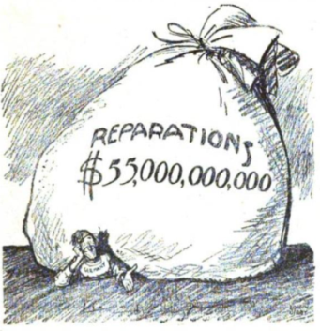
Study Source B
Source B is critical of the Treaty of Versailles. How do you know?
Explain your answer using Source B and your contextual knowledge.
(4 marks)

Task | Using the same checklist from above, have a go at this exam-style question about Source B. You should also try to include some of the useful phrases from the Top Tips section above.

Question type 2 | How useful are these sources for a historian studying X? (12 marks)

Example question
Source C  Source C is a German cartoon from 1924. It shows German soldiers in the First World War and the German politicians who negotiated the Treaty of Versailles. |  | 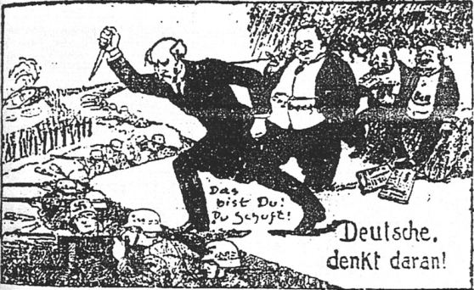
How useful are Sources B and C for a historian studying German reactions to the Treaty of Versailles?
Explain your answer using Sources B and C, and your contextual knowledge
(12 marks)

Question checklist
Feature | Colour
Evaluate the content of each source. What does it tell you? How would it help a historian trying to find out about the topic in the question?
Analyse the provenance of the sources. Where do they come from? What was their intended purpose?
Include contextual knowledge. What was happening at the time the source was written/made that helps you to understand it?
If you have time, you could include an optional extra paragraph on if there anything the sources don’t tell us and that a historian studying the topic would need to know? Use your own knowledge here.
Give a conclusion about the usefulness of the sources. This doesn’t mean saying one is more useful than the other, though. Focus on what they can and can’t tell us, as a pair. Do they reveal two different viewpoints on the same topic? Or is there a view that is missing?

Example response
Source B is useful to a historian studying the German reaction to the Treaty of Versailles because it reveals negative feelings about the reparations payments. Reparations of £6.6 billion were demanded from Germany as part of Article 232, which in turn was made possible by Germany taking all of the blame for the First World War, in the War Guilt Clause (Article 231). This frustration happened in 1921 because the final sum of reparations was not fixed at the signing of the Treaty of Versailles in 1919, but rather finalised in 1921 – this caused uproar at the time as it was much higher than Germany wanted, as suggested in the cartoon. As the cartoon was made in America, it might show that some Americans felt sympathy toward Germany, and thought they were being punished too harshly. The source cannot give us the German viewpoint on this topic. Whilst this cartoon is useful for teaching us that the reparations sum was fixed in 1921 at a high level, and how some Americans reacted to this, we cannot know exactly how Germany reacted just from this cartoon.

Task 1 | Colour code the first suggested paragraph for this answer, using the features above.
Task 2 | Using these sentence starters, complete the second paragraph of the answer, about Source C. Remember to use some specific examples to explain your answer.  - Source C is useful to a historian studying German reactions to the Treaty of Versailles because it reveals …  - In the cartoon we can see …  - This tells us that some Germans felt …

Task 3 | Now you also need to write a conclusion. This is not saying which source is more useful, but rather, how you can learn more from the sources together than apart. This only needs to be a few lines – think about how many viewpoints they reveal, or how many aspects of the topic they would give a historian insight into.

Example question
 | 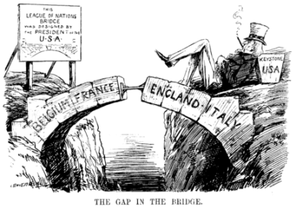 |  |  | 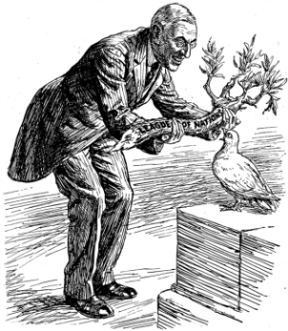
Source D  Source D is a British cartoon from satirical British magazine Punch, which liked to make fun of things.  The man lying down is ‘Uncle Sam’, a representation of America. |  |  | Source E is a British cartoon from satirical magazine Punch, in 1919. It shows Woodrow Wilson giving a dove a branch, labelled ‘League of Nations’.  The cartoon is entitled ‘Overweighted’, and the captions below it read:  President Wilson: ‘Here’s your olive branch. Now get busy.’  Dove of Peace. ‘Of course I want to please everybody; but isn't this a bit thick?’
How useful are Sources D and E for a historian studying how strong the League of Nations was?
Explain your answer using Sources D and E and your contextual knowledge.
(12 marks).

Things to think about
Source D
- What can we learn from this source about what some people thought about the League of Nations’ strength?
- What does the gap in the bridge represent? What will happen if any pressure is put on the bridge?
- Did America join the League in 1919? Why is this important, and can you link it to the cartoon?
Source E
- What can we learn from this source about views of the League?
- What does America expect the dove to do? Is it reasonable?
- What do the title and caption reveal to us?
Conclusion
Do the sources agree or disagree about the strength of the League?
- Is it helpful, or a limitation, that both sources come from the same magazine, country and time?
- Remember that you must always find and focus upon the positives of sources, even when acknowledging limitations – a good historian finds utility in every source!
- Finally, you are not trying to say which source is ‘more’ useful, unless the question explicitly tells you this – if it asks ‘how useful are these two sources?’ then you could look at them together – are two better than one?

Question type 3 | “Write an account of …’ (8 marks)

Example question
This question is based on the second-order concepts of cause, consequence, and change and/or continuity, along with detailed factual knowledge.
You will need to show your knowledge of the event itself, as well as an understanding of its causes or consequences and whether it led to change or continuity.
In blue, ‘events in Abyssinia’ is the event referred to – your answer must include detailed knowledge of what happened in this crisis | Question:  Write an account of how events in Abyssinia led to an international crisis. | In green, ‘led to an international crisis’ is asking you to explain the consequence of the event.

Task | Here are some more ‘write an account’ style questions. Practise highlighting the events and the second-order concept.  Decide if each is asking about causes, consequences, change/continuity.

1 | Write an account of how the aims of the peacemakers led to disagreements in 1919.
2 | Write an account of how the decisions at Versailles caused problems in Europe in the 1920s.
3 | Write an account of how the League of Nations improved its reputation through its actions in events in the 1920s.
4 | Write an account of how the Great Depression caused tension in Europe.
5 | Write an account of how the League Disarmament Conference caused international tension.
6 | Write an account of how events in Abyssinia became an international crisis.
7 | Write an account of how Appeasement enabled Hitler to expand Germany.
8 | Write an account of how events in the Sudetenland caused an international crisis.

Example response
Write an account of how the different aims of the peacemakers led to disagreements in 1919. (8 marks)
Differences between the aims of the peacemakers after WWI led to disagreements in 1919. One difference was about how to treat Germany after the war. On the one hand, Georges Clemenceau of France wanted to punish Germany and remove all of its military power. This was because France had suffered the most destruction during the First World War and had lost millions of men. On the other hand, Woodrow Wilson of the USA was worried that treating Germany too harshly would lead them to want revenge, and create problems in years to come. Britain was even more complicated, as in public Lloyd George had promised to ‘make the pips squeak’ and treat Germany harshly, yet in private he agreed with Wilson that treating Germany too harshly would create future problems. This all caused disagreements and problems in deciding the terms of the Treaty of Versailles as there were strong and contradictory stances taken by the different leaders, backed by strong public opinions. As a result, Germany was left whole, but burdened with high reparations and a military ‘no better than a police force’.
Another major area of disagreement between the peacemakers was over the new international system that each was aiming for. Away from Europe’s complicated history, the idealist Wilson proposed his Fourteen points including an end to secret treaties, the gradual ending of colonialism, freedom of the seas, and a League of Nations to promote international cooperation. Compared to this, Britain was unwilling to relinquish its international control and power – Lloyd George opposed reform to trade and naval laws, as these protected the British Empire. France joined Britain in objecting to any plans to end colonialism – indeed, Britain and France used the Treaty to absorb German colonies in Africa and break up the Ottoman Empire for their own gains in the Middle East. So, very different priorities for Wilson versus Lloyd George and Clemenceau led to the Fourteen Points being largely rejected, and little international reform actually occurring – of Wilson’s Fourteen Points, only the League of Nations was implemented and that without the United States as a member (because the US Congress was so horrified at how America’s demands had been brushed aside by Britain and France).
Task 1 | Read through the answer above and in different colours highlight the following:  - use of detailed knowledge that is relevant to the question  - explanation of a second-order concept (in this case, consequences)  - use of linking words and phrases (see the Top tips below).
Task 2 | Plan and write an answer to the following question:  Write an account of how events in Abyssinia became an international crisis.  (8 marks)

Top tips!
Your answer should:
- use phrases which help you to make connections − e.g., ‘this led to’, ‘this was because’, ‘as a result’, ‘a consequence of this was’
- be structured logically to show the sequence of events
- link events to results
- focus on the question asked and regularly refer back to it.

Question type 4 | ‘X was the main reason for Y.’ How far do you agree with this statement? (16 marks) + (4 SPaG marks)

Example question
This question asks you to analyse how different factors caused a trend/event.
‘The actions of Hitler were the most important cause of the Second World War.’ How far do you agree with this statement?
Explain your answer. (16 marks) + (4 SPaG marks)

Top tips!
- Make a quick plan, including a list of the points for and against the statement, and your judgment.
- You need to weigh up the evidence to come to a decision.
- First, give evidence that supports the statement.
- Then, do the same for any evidence that contradicts the statement.
- Reach an overall judgement about how far you agree with the statement.
- ‘Point, evidence, explanation’ is a good way to structure your paragraphs.

Example plan
Introduction: | Refer directly to the question and give your judgement.
Paragraph 1: | Evidence that suggests the actions of Hitler were the most important cause.
Paragraph 2: | Evidence that suggests that Appeasement was the most important cause.
Paragraph 3: | Evidence that the Treaty of Versailles was the most important cause.
Conclusion:

Task 1 | Use the grid below to add the evidence which you would use to support each of the main three paragraphs.
Task 2 | Now try to write a conclusion for this essay.

Example plan with evidence
Section | Evidence
Paragraph 1: Evidence that suggests the actions of Hitler were the most important cause.
Paragraph 2: Evidence that suggests that Appeasement was the most important cause.
Paragraph 3: Evidence that the Treaty of Versailles was the most important cause.
(For suggested examples, see Appendix.)
Task | Now try planning this question, using a similar structure.  ‘The anger felt by Germany was the most significant problem of the Treaty of Versailles.’  How far do you agree with this statement?  Explain your answer.(16 marks) + (4 SPaG marks)

Appendix

p.7 ‘Peace and Future Cannon Fodder’ – source notes
One way we can see that the source is critical of the Treaty of Versailles is that it predicts that the peace, created by the treaty, would not last. The title of the cartoon reveals this criticism. ‘Peace and Future Cannon Fodder’ tells us that the artist believed that the harsh terms of the treaty would lead to another war. At the time, it was felt by some people that the treaty terms would create conditions for Germany to hate the ‘Big Three’, and that it would want to seek revenge. This had been a particular concern for Wilson at the Paris Peace Conference and the actual terms of the treaty did cause great resentment − high reparations (£6.6bn), and military restrictions limiting the army to 100,000 men, damaged German pride and left many in the country feeling vulnerable.
The artist of the cartoon is also critical of the treaty because he puts forward the view that it would be those who were children at the time of the treaty’s signing who would later suffer the consequences of it. One detail of the source which shows this is the writing − ‘1940 Class’ − above the naked child’s head. This refers to the fact that children in 1919 would be adults by 1940 and would therefore be the soldiers of the war predicted by the artist.
Another criticism of the treaty shown by the source is that it suggests Georges Clemenceau to be the most responsible for its harshness. Although all members of the ‘Big Three’ are seen leaving the conference together, having completed their work, Clemenceau leads the way and is seen to be confused by the crying child who has thrown the treaty down at his feet in despair. ‘Curious! I seem to hear a child weeping!’, remarks Clemenceau. The artist is clearly criticising Clemenceau, who he refers to as 'The Tiger’, for seeking revenge on Germany without thought for the possible future consequences.

p.8 Clashes between the ‘Big Three’
Disagreement | Country 1 | Country 2 | Explanation
The seas  Who would have the strongest navies and control the seas? | Britain – Britain wanted the British navy to be the strongest and to control imperial trading routes. | America – America wanted freedom of the seas, with free-trade routes for all. | Britain and America disagreed because America thought Britain was being selfish, whereas Britain thought America’s idea threatened the security of the British Empire, and control of it through the British navy.
Germany’s military  How much of a military force should Germany have? | America – America wanted Germany to be treated fairly and thus be able to defend itself against future attacks. | France – France wanted to feel safe and therefore wanted Germany to have no military at all. | America and France disagreed because America thought France was trying to take advantage of Germany, whereas France thought America was helping Germany to remain a threat.
Revenge  What should be done with Germany to punish it for causing WWI? | America – America wanted Germany to be treated fairly because an unfair treaty would create another war. | Britain and France – both countries lost men and significant money during the war and thought Germany should pay for this. | America disagreed with Britain and France because America thought Britain and France were being short-sighted, whereas Britain and France thought America didn’t understand their pain.
Colonies  What should happen to German, British and French colonies? | Britain – Britain wanted to control the German colonies because this could help make its own Empire more secure and powerful. | America – America believed in ‘self-determination’ which meant there would be no colonies at all. It thought Germany’s colonies should be freed. | America disagreed with Britain because America thought Britain was being selfish, using the treaty to make itself stronger, whereas Britain thought America was interfering in matters that weren’t its business.
The German economy How much should Germany pay and how rich should it be allowed to become? | Britain – Britain wanted Germany to remain relatively well-off, as it was a major trading partner and Britain wanted to keep selling to Germany. | France – France wanted to cripple the German economy so Germany could never be a threat to France again. | France disagreed with Britain because France thought Britain was putting economic gain ahead of long-term safety, whereas Britain thought France was being overly aggressive and risked ruining European trade.

p.9 Terms of the Treaty of Versailles
Territorial terms
- Germany lost a strip of land that ran right through the middle of Eastern Germany. This left two parts of Germany disconnected. This land was given to Poland, to ensure it had access to the sea. This was called the ‘Polish Corridor’.
- Next to the Polish Corridor, Germany also lost a rich city called Danzig.
- Overall, Germany lost 10% of its land. This included Alsace−Lorraine, which was given back to France; Eupen and Malmedy, which were given to Belgium; and North Schleswig, which was given to Denmark.
- The Rhineland (bordering France) was demilitarised.
- Germany’s African colonies were taken by the League as Mandates.
Economic terms
- Germany had to pay £6.6 billion in reparations.
- The Saar was put under League control for 15 years, with the profits going to France.
Military terms
- The German military was limited to 100,000 men.
- Conscription was banned.
- The Germany navy was limited to six battleships, and zero submarines.
- Germany was not allowed to have an airforce.
Blame
- Germany had to sign Article 231, the War Guilt Clause. This meant that Germany had to take full responsibility for the First World War.
- Article 231 justified Article 232, which dealt with the reparations. This meant that Germany ‘accepted’ blame and so ‘accepted’ the fine.
International affairs
- The League of Nations would be created.
- Germany was not allowed to join the League.

p.13 German reactions to the treaty
Blame | - Germany felt (rightly) that it had not been solely responsible for causing tension before the First World War.  - This meant it was unfair that Germany took the entire blame.
Reparations | - The amount of reparations (£6.6 billion) was seen in Germany as too high.  - It was calculated that the debt would take nearly 100 years to repay.
Armed forces | - Germany was a proud military nation – making its army so small seemed like a deliberate blow to embarrass it.  - Having such a small army left Germany extremely vulnerable to an invasion by France (or indeed Poland).
Territory | - The Polish Corridor cut Germany into two separate parts – this separated German families.  - Germany was not allowed to claim other German-speaking lands under self-determination, despite having had land taken away.  - Demilitarising the Rhineland made Germany even more vulnerable to France.
The League of Nations | - Not being allowed to join the League meant that Germany did not get the protection of collective security.  - The League looked like a ‘winners’ club’, to which Germany wasn’t invited.

p.14 Cartoon notes
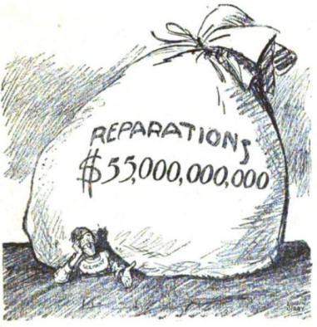 | This cartoon represents how heavy Germans felt the burden of reparations was going to be on them. The man being crushed by the bag of money represents how hard Germany thought it would be to repay the £6.6 billion.  The size of the bag in relation to the man (who represents Germany) makes a comment about the ‘disproportionate’ weight of the repayments. They are so heavy that Germany can’t even move – this symbolises how Germany complained it couldn’t afford to recover from the war, let alone pay the reparations.  The fact that this is an American cartoon is particularly useful because it reveals that some sympathy towards Germany spread internationally, or at least other countries were aware that Germany had been given such a heavy burden.
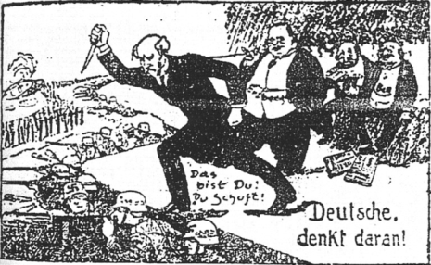 | This cartoon illustrates the ‘stab in the back’ myth that quickly spread following the signing of the Treaty of Versailles. This shows the anger at the German Weimar government which signed the armistice, and then the treaty.  The cartoon suggests that the armistice and treaty were signed by politicians, not the army (the army are still fighting in the cartoon). This shows that Germany ‘could still have won the war’. This was a crucial claim in Hitler’s rise to power.  This further reflects just how unpopular the treaty was within Germany – feeling was strong enough to turn some Germans against their new government.

p.18 Collective security definition
Collective security: This was the main way the League promised to keep peace in the world. All members promised to defend any other that came under attack. The League tried to persuade its member countries to disarm by arguing that you didn’t need a big army if you had lots of allies.

P.18 The aims of the League – cartoon notes
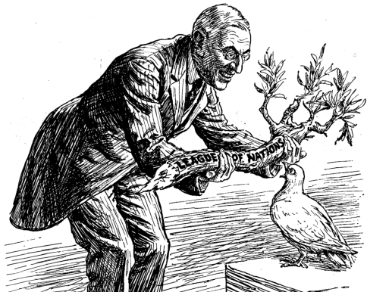
President Wilson: ‘Here’s your olive branch, now get busy.’ Dove of Peace: ‘Of course I want to please everybody; but isn’t this a bit thick?’ A cartoon (‘Overweighted’) published in Britain in March 1919.
What can you see in the source?  - A dove  - An olive branch  - President Wilson | What does the title reveal?  ‘Overweighted’ reveals the main message of the cartoon – that the burden of keeping peace is too great for this one dove (the League). | What does the caption reveal?  The caption directly reflects the title – by saying ‘isn’t this a bit thick’, the dove (League) reveals it cannot carry the branch of peace alone.  Having Wilson say ‘now get busy’ reflects how America set up the League then failed to join, not helping to keep the peace.
What can we learn from this source about feelings about the League?
We can learn that people were sceptical that the League could be successful, even early in the League’s life. It is particularly suggested that the League really doesn’t have a hope without the presence of America – as the League was America’s idea, and America was the most powerful country in the world. The promise of world peace seemed a little empty without America.

p.19 The gap in the bridge – source notes
In this cartoon the bridge represents the League of Nation and the man is Uncle Sam, representing America. He appears to not want to place the vital keystone into the bridge (America’s membership) that would make the bridge strong. The creator was trying to suggest that without American membership the League would not be strong
.

p.27 What was the impact of the Manchurian Crisis on the League?
causes
events
consequences

- The League asked Lord Lytton to go and investigate in Japan after the Mukden Incident. | - Not only did the Japanese stay in Manchuria, but in July 1937 they also invaded the rest of China. China appealed to the League and didn’t even get a meeting. | - The League tried to pass a resolution to order Japanese troops out of Mukden. Japan vetoed the resolution.
- In September 1931, the Japanese claimed that Chinese soldiers had sabotaged the Manchurian railway in Korea, which Japan controlled. This was called the Mukden Incident. | - Meanwhile, in January−March 1932, Japan attacked, bombed and captured the city of Shanghai in China itself. In March 1932, China appealed to the League of Nations again. | - A week after leaving the League in February 1933, Japan continued to invade more of China, taking the Jehol Province.
- In April 1932, a League delegation led by Lord Lytton arrived in Manchuria to see what was happening, and in October 1932 it finally reported. The report declared again that Japan should leave. | - The League also discussed banning arms sales to Japan, but the member countries could not even agree about that. They were worried that Japan would retaliate and the war would escalate. | - Japan attacked Manchuria. The official government in Japan told the Japanese army to withdraw, but its instructions were ignored.
- By February 1932, Japan had brutally conquered Manchuria. They renamed it Manchukuo and installed a puppet emperor. | - In February 1933, a special assembly of the League voted against Japan, so the Japanese walked out. | - As well as not backing economic sanctions, it was also clear that Britain and France were not prepared to send an army.
- The League, however, could not agree on sanctions. Without the USA, Japan’s main trading partner, they would be meaningless. Besides, Britain seemed more interested in keeping up good relations with Japan than in agreeing to sanctions. | - After the Mukden incident, China appealed to the League, claiming it was under threat of invasion. | - Japan claimed it was not invading as an aggressor, but simply settling a local difficulty. The Japanese argued that China was in such a state of anarchy that they had to invade in self-defence to keep peace in the area.
 | The League didn’t really take China seriously, as no invasion had happened yet, and China was so far away, and already in internal chaos.

p.48 Example plan with evidence
Section | Evidence
Paragraph 1: Evidence that suggests the actions of Hitler were the most important cause. | - Rearmament: leaving Disarmament Conference in 1933, Nuremberg Rally in 1935  - Invasions in Europe: Rhineland 1936, Austria 1938, Sudetenland 1938  - Trigger for war: Czechoslovakia 1939, Poland 1939  - These caused war because other countries started rearming too and decided to go to war with Hitler in order to prevent him from getting even stronger.
Paragraph 2: Evidence that suggests that Appeasement was the most important cause. | - Anglo-German Naval Agreement 1935 – Britain let Germany increase its navy.  - Rhineland 1936 – German soldiers would have retreated.  - Munich Crisis 1938 – Czechoslovakia could have fought Germany with British and French support.  - Appeasement caused the Second World War because it allowed Hitler to grow continuously stronger from 1935 to 1939, even driving Stalin into the Nazi−Soviet Pact.
Paragraph 3: Evidence that the Treaty of Versailles was the most important cause. | - The terms were unfair and made the League of Nations look like a ‘winners’ club’, so it lost legitimacy and the support of the US, eventually leading to collapse.  - Germany sought revenge, just as predicted – much of the tension in the mid-1930s was over aspects of the treaty that Germany was undoing.  - The treaty gave Hitler a huge platform, and is arguably one of the main reasons he was elected in 1933, promising to destroy it.  - The Treaty of Versailles therefore caused WWII because it put Germany on a path to revenge as early as 1919.
A possible conclusion | All the factors played a part. In the long term, the Treaty of Versailles set the conditions for a war to happen and brought Hitler to power. However, in the short term, it was Hitler’s actions which led to war. Appeasement has been criticised with hindsight, but was arguably reasonable in the conditions of the late 1930s and did give Britain time to properly prepare for war. Therefore, the actions of Hitler were indeed the main cause of the Second World War.

Image attributions
© By Bundesarchiv, Bild 183-H27337 / CC-BY-SA 3.0, CC BY-SA 3.0 de, https://commons.wikimedia.org/w/index.php?curid=5434059
©By Bundesarchiv, Bild 146-1976-063-32 / CC-BY-SA 3.0, CC BY-SA 3.0 de, https://commons.wikimedia.org/w/index.php?curid=5419014
© By Bundesarchiv, Bild 183-R69173 / CC-BY-SA 3.0, CC BY-SA 3.0 de, https://commons.wikimedia.org/w/index.php?curid=5368502

