Y10 exam prep Foundation Writing– How to approach Qu 1 – describe a picture and give opinion
(12 marks) (refer to speaking picture prep sheet to help)

Module 1 P25 Les Amis
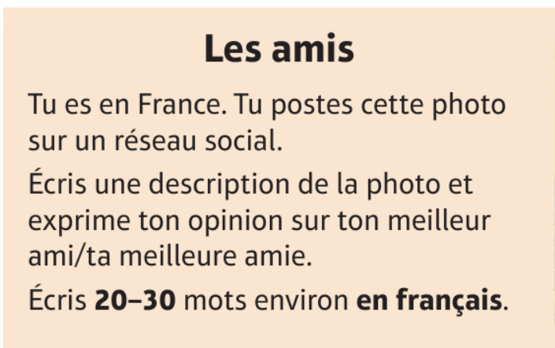

Module 3 Manger en famille (P12 Revision workbook)

Tu postes cette photo sur des medias sociaux pour tes amis.

Écris une description de la photo et exprime une opinion sur le petit-déjeuner chez toi.

Écris 20-30 mots environ en français

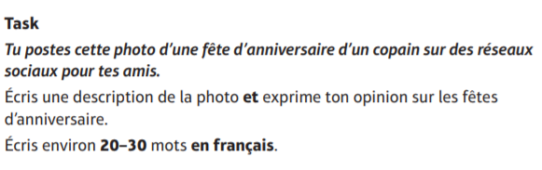
Module 3 –Les fêtes

Y10 exam prep Foundation Writing– How to approach Qu 1 – describe a picture and give opinion
(12 marks) (refer to speaking picture prep sheet to help)

Module 1 P25 Les Amis

Module 3 Manger en famille (P12 Revision workbook)

Tu postes cette photo sur des medias sociaux pour tes amis.

Écris une description de la photo et exprime une opinion sur le petit-déjeuner chez toi.

Écris 20-30 mots environ en français

Module 3 –Les fêtes

