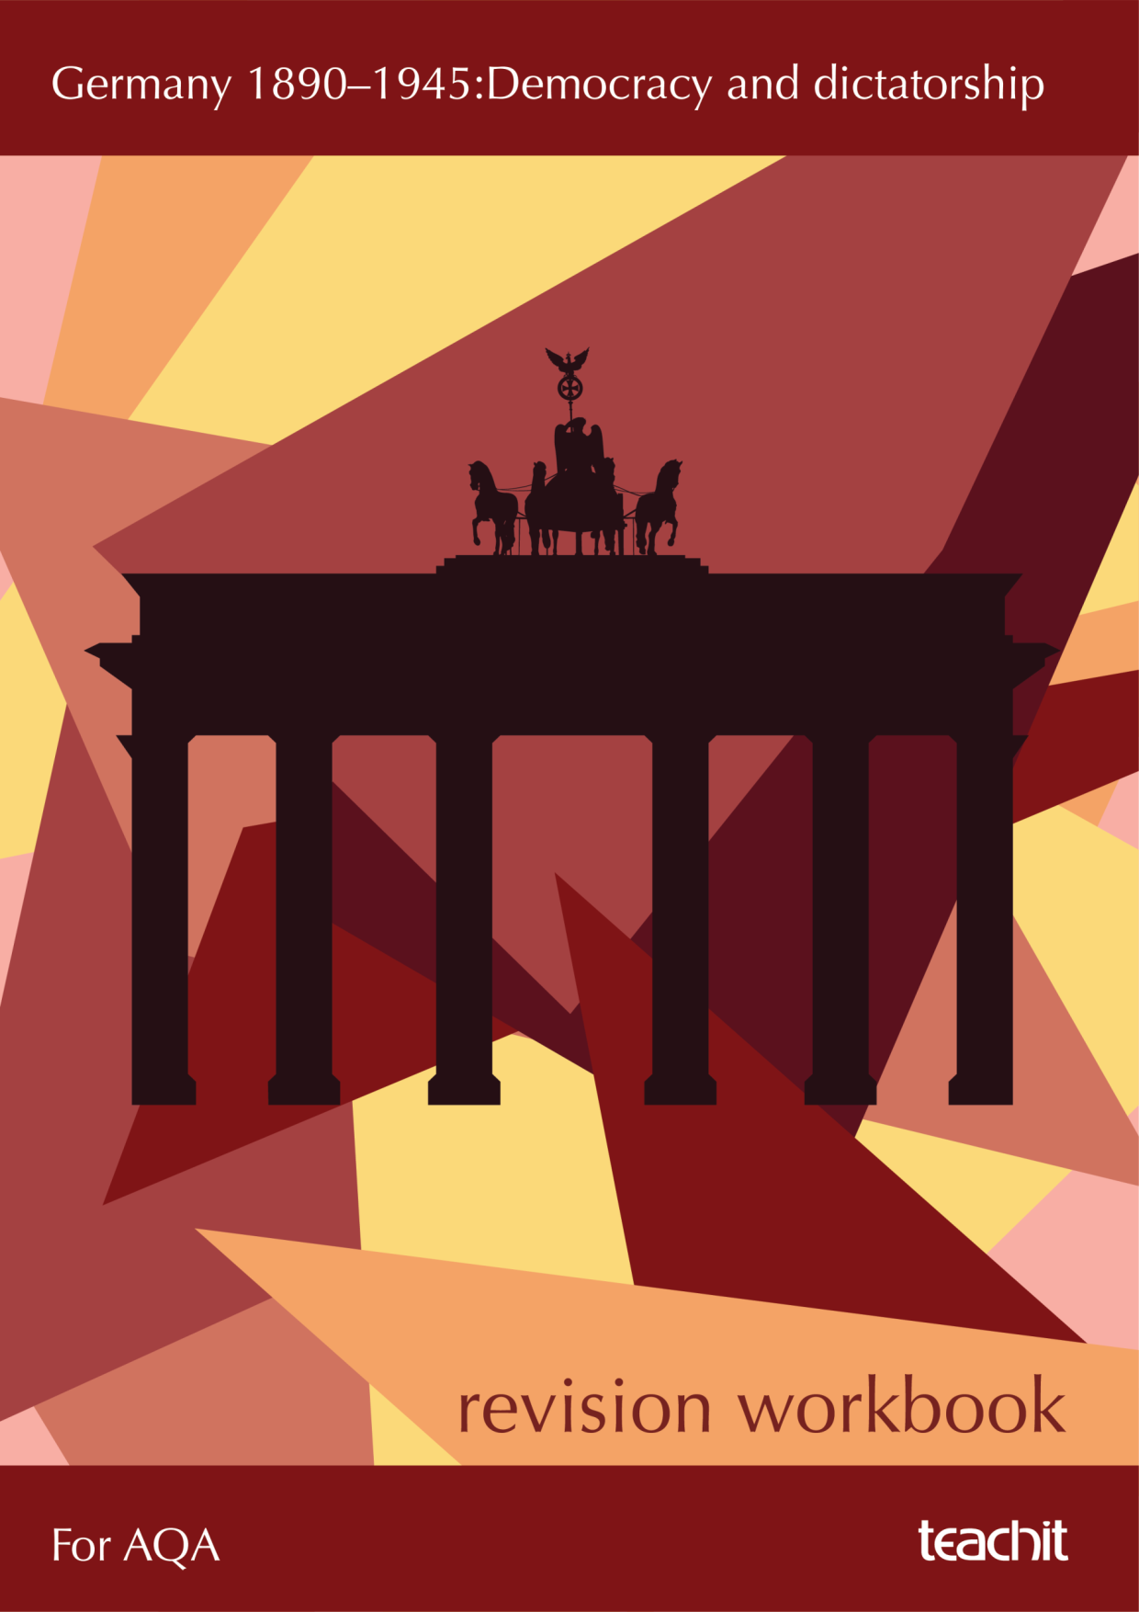

Contents
4 | Introduction to this workbook
6 | Topic 1: Germany and the growth of democracy |  |  | Revise | Practise | Refresh
6 |  |  | Overview of Germany 1890−1918
7 |  |  | Who held power in the Second Reich?
8 |  |  | The growth of economic and social tensions 1900−1914
11 |  |  | The Naval Laws
12 |  |  | What impact did World War One have upon Germany?
15 |  |  | How did the Treaty of Versailles impact upon Germany?
20 |  |  | What economic problems did the Weimar government face?
24 |  |  | How far did Germany recover under Stresemann?
28 |  | Topic 2: Germany and the Depression
28 |  |  | The growth of the Nazi Party 1928−32
30 |  |  | How far did the Great Depression lead to an increase in support for the Nazis in the period 1928−32?
31 |  |  | Why did Hitler become chancellor?
34 |  |  | How did Hitler become Führer?

36 | Topic 3: The experience of Germans under the Nazis |  | Revise | Practise | Refresh
36 |  | Economic changes in Nazi Germany
42 |  | Women in Nazi Germany
44 |  | How did the Nazis change the position of young people?
47 |  | The police state
48 |  | How did Hitler control the Church?
49 |  | Persecution of minorities
52 |  | Propaganda, censorship and culture
56 |  | Opposition to the Nazis
58 | Exam skills
58 |  | Question 1
60 |  | Question 2
61 |  | Question 3
63 |  | Question 4
66 |  | Question 5
68 |  | Question 6
72 | Image and extract attributions

Introduction

Overview of the exam
Section A of Paper 1 explores Germany’s history over a 55-year period, 1890−1945. This includes a variety of developments and changes such as:
- social and cultural
- economic
- political
- the role of individuals and groups, such as Stresemann and the NDSAP.

There are three key topics that you will need to study:
Topic 1 | Germany and the growth of democracy
Topic 2 | Germany and the Depression
Topic 3 | The experience of Germans under the Nazis

Assessment objectives
The exam will assess your knowledge of the key events in this period as well as your understanding of historical concepts such as continuity, change, cause, consequence, significance, similarity and difference.
Assessment objective |  | What does it mean?
AO1 | Demonstrate knowledge and understanding | - Knowledge and understanding of Germany in the period 1890−1945.  - Your ability to recall and apply a range and depth of factual knowledge of Germany’s history during this period.  - Tip: Try to use two or three pieces of knowledge each time you approach a question with an AO1 focus.
AO2 | Explain and analyse historical events | - This is your ability to communicate and explain Germany’s history using various second-order concepts such as description, causation, change, continuity and consequence.
AO4 | Interpretations | - Interpretations are historians’ views and the evidence they select to support them.  - They will often differ, despite exploring the same event, person or development.  - You will be given two interpretations, between 50 and 100 words each.  - You will need to know how they differ, why they differ and if they are ‘convincing’.

Which questions assess which objectives?
The first six questions of Paper 1 will cover Germany (the last four will be on your ‘Conflict and tension’ topic).
You will be given a separate Interpretations Booklet containing the two interpretations that you will use to answer the first three questions.
Overall, Section A is worth 40 marks and consists of 6 compulsory questions.
Questions 1−3 focus on AO4
Q1 | How do the interpretations differ? | - Identify how one interpretation argues something different from the other.  - Make sure you refer to both interpretations and thoroughly explain at least one difference.  - 4 marks (about 5 minutes).

Q2 | Why do the interpretations differ? | - Explain why the two interpretations are different.  - Use the captions (provenance) that come with the interpretations, and your own knowledge of the period, to explain how the different circumstances in which they were written resulted in different views.  - 4 marks (about 5 minutes).
Q3 | Which interpretation gives the more convincing opinion about … ? | - This question requires you to use your own knowledge of the period.  - Take one interpretation at a time. Summarise what each argues in a sentence or two, then explain how convincing you find this historian’s argument, by using two or three pieces of your own knowledge to support or challenge the interpretation.  - Conclude by judging which interpretation you think is the more convincing of the two and why, using what it says in the interpretations and your knowledge.  - 8 marks (about 10 minutes).
Question 4 focuses on AO1
Q4 | Describe … | - Describe two key features of the topic in question. Each feature should be two or three lines long.  - You need to make sure that your own knowledge is specific and that you have a range of knowledge (two or three pieces of your own knowledge).  - 4 marks (about 5 minutes).
Question 5 and 6 focus on AO1 and AO2
Q5 | In what ways … Explain your answer | - Explain two or three changes.  - Use two ‘point−evidence−explanation’ chains which are three or four lines each.  - 4 marks will be awarded for the quality of your AO1 knowledge and understanding.  - 4 marks will be awarded for the quality of your explanation of how a group or development was changed/affected by the event/development given in the question.  - 8 marks (about 10 minutes)
Q6 | Essay question with bullet points | - This essay question will give you two bullet points to compare.  - You need to explain how each bullet point affected a particular event/ development and support this with evidence.  - You should then give an overall judgement (decision) about which was the more important.  - 6 marks will be awarded for the quality of your AO1 knowledge and understanding.  - 6 marks will be awarded for the quality of your explanation of how a group or development was changed/affected by the event/development given in the question.  - 12 marks (about 15 minutes)

How to use this workbook
The first part of this guide will help you to refresh your knowledge of the three key topics you have studied on this period and to apply your knowledge using a variety of tasks.
The second part will guide you through how to answer each of the six types of question with lots of tips and advice.
Disclaimer: The suggested approaches and sample questions in this exam skills pack have been written to complement the teaching of the specification. AQA have not endorsed the sample questions or approved the content.
The suggested answers and source notes provided are for exemplification. There are many ways of answering most history questions (for example structuring essay questions). You should draw on your own knowledge and understanding as much as possible to find approaches that suit you. This guide is a good starting point.

Germany and the growth of democracy
Topic 1
 | Overview of Germany1890−1918 | Key terms
 | - Germany was ruled as a monarchy by Kaiser Wilhelm II.  - There was also an elected Reichstag (parliament) organised into political parties.  - The German government was generally right-wing; it favoured tradition and order.  - Germany was a relatively new country. It had formed in 1871. Prussia had been the most dominant state when it united, so it held quite a lot of influence in the government.  - In 1871, Germany defeated the French in the Franco-Prussian War despite it being a new country. They served the French harsh treaty terms – including taking Alsace and Lorraine from France. This helps us to understand why the French formed a defensive alliance against Germany, and why Germany sought a defensive alliance to protect against a revenge attack from France. This also explains the importance of Alsace and Lorraine in the context of the Treaty of Versailles. | Kaiser | king
 |  | autocrat | ruler with absolute control
 |  | Prussia | the largest state in Germany (it had 17/58 representatives in the Bundesrat)
 |  | Reichstag | elected parliament

The rule of Kaiser Wilhelm II
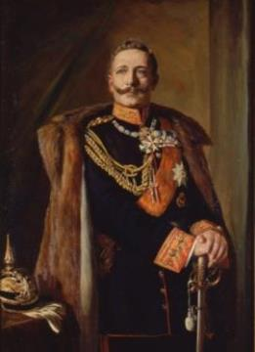 |  | - The Kaiser was an autocratic ruler.  - He created Weltpolitik – world politics – which focused on:  Glory He wanted Germany to be a strong, powerful nation.  Army He wanted a large army.  Navy He wanted a large navy.  Empire He wanted Germany to have its ‘place in the sun’.  - There were growing tensions in Germany, which was rapidly industrialising.  - As cities began to swell (urbanise), living and working conditions worsened.  - The Kaiser’s strong focus on foreign policy meant that he did not focus on solving these issues, which led to tensions in the cities.
Kaiser Wilhelm II

Timeline
1848 – rapid industrialisation starts
1888 – Wilhelm II’s reign begins
1914 – outbreak of WW1
1900 – von Bülow becomes Chancellor
1908 – Daily Telegraph affair
1871 – unification of Germany
1894 – Chancellor Caprivi resigns
1906 – budgetary crisis
1913 – The Zabern Affair

How was the government organised during this time?
Kaiser Wilhelm II  - In charge of foreign policy and the army.  - Chose the Chancellor from the Bundestag.  Chancellor  - In charge of the ‘day to day’ running of the government.  - Had power over the Bundesrat.  Bundesrat  - Council of the 25 states – 58 representatives.  - Introduced and could approve laws – laws to be sent to the Bundestag for approval.  Bundestag  - Parliament – 397 deputies.  - Voted on and approved laws introduced by the Bundesrat.  - 14 votes could veto a law. | As the chancellor was chosen by the Kaiser, he could appoint and dismiss who he wanted, giving him influence and control. If they didn’t do as he wanted, they could be sacked or made to resign – like von Bülow.

Who held power in the Second Reich?
The budgetary crisis  1906  The SPD and the Centre Party united to vote against the government’s 1906 budget. The Kaiser was angry at this and used his constitutional power to dissolve the Reichstag and call a new election in 1907. | The Daily Telegraph Affair  1908  The Kaiser made anti-British comments which were then reported in the Daily Telegraph, causing tension between Germany and Britain. The Kaiser had to go before the Reichstag and agree that he would not act in this way again, showing how the Reichstag was able to influence his actions. However, the Kaiser sacked Chancellor von Bülow shortly after this as he was upset that Bülow was too supportive of the Reichsta.g. | Conservative elite  The conservative elite were very dominant in German politics. They pushed for the growth of the army, navy and empire and quite often succeeded in pressuring the chancellor into putting forward policies like the Navy Bill in 1906. | The Zabern Affair and the vote of no-confidence in Bethmann 1913  In 1913, there was a vote of no-confidence actioned against Bethmann due to the Zabern Affair. Despite Bethmann losing the vote of no-confidence, the Reichstag did not have the power to force him to resign. He therefore stayed as chancellor, highlighting the limited power of the Reichstag.
Growth of the trade union movement  Due to urbanisation there was a growth in left-wing political groups such as the SPD. The SPD became the largest party in the Reichstag (28% of the vote by 1912) as their support grew massively. This growth was a political challenge to the more conservative parties and ministers in the government and to the Kaiser’s views. | Chancellor von Bülow  From 1900, von Bülow was chancellor. He challenged the Kaiser on issues such as the Tariff Law and managed to form the ‘Bulow Bloc’ (a voting bloc) in the Reichstag. However, he was forced to resign after the Hottentot election and the loss of the Kaiser’s support. The Kaiser replaced him with Bethmann. | Kaiser Wilhelm’s personal ruling style  1888−1918  Wilhelm II had what has been described as an ‘autocratic personal rule’. He purposely tried to control the government by selecting ministers who supported his views (e.g. von Tirpitz), attempting to control the chancellor (e.g. Hohenlohe) and using his power of patronage to remove liberal ministers who pushed for alternative reforms. | Chancellor Caprivi  Caprivi was chancellor until 1894. He had tried to resign five times before this as he grew tired of the Kaiser’s interfering. The Kaiser refused to let him resign until the final time he asked, showing the power the Kaiser had over the chancellor.
The Kaiser  He was the sovereign (king) of Germany. The constitution gave him powers; he was the Commander-in-Chief of the army, he could dismiss the chancellor and government ministers, he could dismiss the Reichstag. However, he could not introduce laws − only the chancellor could do this. | The army  The Kaiser was the Commander-in-Chief of the army and the army swore an oath of loyalty to him. Germany was dominated by conservatives, such as the army. The army was answerable only to the Kaiser, as was shown by them ignoring the Reichstag’s criticisms of them during the Zabern affair. | The chancellor and his ministers  The chancellor was selected by the Kaiser and could be sacked by him. The Kaiser quite often selected supporters from the aristocracy to this position. The chancellor would present ideas and laws to the Reichstag and he was also in charge of putting them into law once approved by the Reichstag. | The Reichstag  This was an elected parliament in Germany, voted for by men aged 25+ with the right to vote. The Reichstag voted on ideas and legislation put forward by the chancellor. They could either approve, change or veto them, an example being the colonial policy in 1906.

Task | Who really had the greater power in Germany by 1914? For each individual/group, provide three pieces of evidence to show they had power in Germany.

Kaiser | Chancellor | Reichstag | Conservative elite

The growth of economic and social tensions 1900−1914
Task | Define the following key terms:

Industrialists
Socialism
Conservative
SDP
Urbanisation
Trade union
GNP

Task | How far do you agree that increased industrialisation caused significant social unrest in Germany by 1914?  Read the information and find evidence to support and challenge the view. |  | Key
 |  |  |  | Supports the view
 |  |  |  | Challenges the view

Industrialists’ concerns about socialism  Industrialists were really worried about the growth of socialism, which came as a result of rapid industrialisation and urbanisation. This caused social tension as industry owners and workers clashed over pay and conditions in the factories. | Conservative elite concerns about socialism  The conservative elite worried about the growth of socialist parties in politics, which came as a result of rapid industrialisation and urbanisation. Political parties such as the SPD grew in support and began to dominate the Reichstag (they had 110 seats by 1912), threatening the traditional power of the conservative elite.
Global trade increased  Small business owners and farmers faced increasing hardship due to global trade increasing during this period of industrialisation. Competition from other countries such as the USA threatened their profits. | Living conditions in the cities  As the cities grew and more workers left the countryside, living conditions declined. There was limited housing and sanitation was poor, so disease spread quickly.
New industries  Germany began to lead the world in industries such as chemicals and engineering. They began producing new dyes and mechanical goods. This led to more jobs in the towns and cities as more factories sprang up. | Left-wing party growth  Left-wing parties began to increase in size and support, as a result of industrialisation. By 1912 the SPD had 28% of the seats in the Reichstag and they had challenged the government’s 1906 budget, causing political tension with the conservative, right-wing parties.
Transport  To support the transport and export of goods, the German government invested in creating more railways. This meant they could export more goods quicker, and also that people were able to move from the countryside to the towns for work. | Rapid urbanisation  With more factories emerging in towns and cities, more people migrated from the countryside in search of jobs. The growth of the urban population was so fast that Berlin’s population had doubled to two million by 1910. This created pressure and tension as there was only limited housing in these cities.
The growth of trade union membership  During this period, trade union membership grew by three million (the largest in the world in 1900) as people turned to the trade unions to challenge the poor working and living conditions they faced. | Growth in the Germany economy  Germany became a great power by 1900, challenging countries such as Great Britain in areas such as coal and steel. Thanks to industrialisation, the GNP of Germany grew by 9%.

Task | Complete the essay grid.  Which of the following was the more important reason why there was economic and social unrest in Germany by 1914?  - Concerns about socialism  - Living conditions in the cities and rapid urbanisation | Exam tip!  This is a question 6-style task, worth 12 marks. In the exam you should aim to spend 15 minutes answering this queston.  A couple of minutes spent planning your answer can be extremely useful.

 | Describe the event/development with two or three facts | Explain how it caused economic and social unrest |  | Assess how significant it was in causing unrest – compare to the other bullet point as well as other events/developments that it contributed to
Concerns about socialism
Living conditions in the cities and rapid urbanisation
Overall judgement

The Naval Laws
Weltpolitik – the context  The Kaiser pursued a policy known as ‘Weltpolitik’ – world politics – which can be summarised as GANE: |  |  |  |  | The Naval Laws | Amendments
 |  |  |  | 1898 | First Naval Law | seven battleships to be built
Glory | He wanted Germany to be a strong, powerful nation. |  |  | 1900 | Second Naval Law | doubled the navy from 19 battleships to 38 battleships
Army | He wanted a large army. |  |  | 1906 | Third Naval Law/Amendment | six extra cruisers to be built
Navy | H wanted a large navy. |  |  | 1908 | Fourth Naval Law/Amendment | new vessels to replace old cruisers would be battleships
Empire | He wanted Germany to have its ‘place in the sun’, so he persued territory in Africa, supported by the German Colonial League. |  |  | 1912 | Fifth Naval Law/Amendment | three additional battleships
The growth of the navy |  | Arguments for Arguments against  - Naval position. Germany became the second-largest naval power in the world by 1914. - Support in the Reichstag. The Second Naval Law was passed with very little opposition. Von Tirpitz used the Second Boer War to rally support for the German navy. - Colonial expansion. Growth in the navy gave Germany a greater chance of developing an empire in Africa. Colonies would create access to resources and labour. - Fairness. Britain had a large navy, so why should Germany not be permitted to have an equal-sized navy? - Unification and patriotism. Growing the navy helped to further unify the country. - Protection – encirclement. Germany had defeated France in the Franco-Prussian War in 1871 and knew France was eager for revenge and the return of Alsace and Lorraine. France had formed an alliance with Russia. The navy was another form of protection. - Competition and tension with Britain. Britain feared German naval growth. A naval race began, with each trying to outdo the other in size and power. - Risk theory. Even von Tirpitz himself knew that Germany could not expand the navy enough to outgrow the British navy. - Opposition in the Reichstag. The Conservatives and the SDP opposed the introduction of the First Naval Law due to the cost. - Debt. Germany amassed 490 billion marks worth of debt by pursuing the Naval Laws. This put a strain on government finances. - Social tensions. Growing industrialisation and urbanisation was causing social tension between the working class and the conservative elite; the government would have been wiser to focus on these issues.
As part of Weltpolitik, the Kaiser knew that the expansion of the navy would be vital. To succeed as a colonial power, you needed a strong to provide protection for territories and to challenge the rule of existing colonial powers such as France.
- Hollmann thought that Germany should invest in cruiser ships. They were more affordable and more widely used in the German navy.
- Von Tirpitz thought that Germany should invest in battleships to rival Great Britain’s fleet.
- The Navy League, started by von Tirpitz (Secretary of the Navy) grew to a million members. They campaigned for reforms and were very influential.

Task | Read and highlight the information.  Summarise three reasons why the Germans introduced the Naval Laws.

What impact did World War One have upon Germany?
Tasks | - Read the evidence below.  - For each factor, explain the impact on Germany.  - Determine which factor had the greatest impact.

Factor | Evidence | Questions 5 and 6 AO2 explanation skills  How did this impact upon Germany? | Question 6 AO2 judgement skills  Which is the most important consequence and why? Judge most to least important and explain your judgement.
Political | - In October 1918, some crews in the German navy mutinied at Kiel and Hamburg.  - On 9 November 1918 the Kaiser abdicated (gave up his throne) and fled Germany.  - Germany became a democratic republic, led by a president and chancellor. Chancellor Ebert was the first. There were 28 political parties in the Reichstag. The Social Democrats were the main party.  - The German people felt ‘stabbed in the back’ by the politicians who had signed the armistice. They called them the ‘November criminals’.  - Many ex-soldiers, civilians and right-wing judges and civil servants hated the new democratic leaders and some wanted the Kaiser to return.  - This led to challenges to power from left and right wing, e.g. the Sparticist uprising (1919) and the Kapp Putsch (1920).
Economic | - Workers rebelled against their leaders and went on strike, e.g. in Stuttgart and Hanover.  - Germany was almost bankrupt after the war. Government debts trebled between 1914 and 1918, from 50 billion to 150 billion marks.  - The German economy was massively damaged by the war. Industrial production was two-thirds of the 1913 level.  - The new government had to pay war widow pensions for 600,000 women.
Social | - Over 750,000 Germans died because of food shortages during the war. The British navy had blockaded ports so food couldn’t be imported. Many poor people survived on bread and turnips.  - As Germans were weakened by starvation, they were vulnerable to sickness. Many died during the flu epidemic of 1918.  - Two million German troops died and 55% of all German troops were casualties. Two million children were left without fathers.

Task | Try to make links between the different factors and add explanations about how they connect. Create as many connections as possible. An example has been added for you.
Political impact
Economic impact
Social impact
E.g. The amount of soldier deaths led to 600,000 widows, which added an extra economic burden on the government, which had to pay war widow pensions on top of facing 150 billion marks worth of debt.

What agreements did the government make to stay in power?
When the Kaiser abdicated on 9 November 1918, there was a ‘political revolution’ in Germany. The moderate politicians were concerned that left-wing rioters might try to seize power or that Germany would fall into chaos.
Following the announcement of the new German Republic, with Ebert as the first chancellor, it was decided that a Council of Representatives would be set up to rule until a government could be created. In order to create a stable government quickly, they had to agree on the following:
World War One | Ending it was essential. The war was devastating Germany, causing shortages and mutinies.
Army | The government would need support from the army to survive and keep order.
Civil servants | To survive, the government would need their expertise and support.
Industry | Many business owners were concerned by the left-wing, pro-communist rebellions which were taking place in Bavaria. The government needed to reassure them and also get their support.
Trade unions | To prevent strikes the government needed to get the trade unions on side.

Task 1 | Read each of the actions that the new government took. Draw an image in the dual coding box to show your understanding of the action taken. Dual coding is using an image to represent a key term and is one of the best ways to memorise information.
Task 2 | Explain why you think they took this action and what impact you think it would have had upon political stability in Germany.

Dual coding | What the new government did | Why did they do this? |  | What impact would it have had upon stability in Germany?
WWI
Matthias Erzberger signed an armistice with the allies on 11 November 1918, ending WWI.
Army
They reassured Groener that the army would not be reformed. Officers kept their ranks. In return Groener agreed to use the army to help the new Republic keep order.
Civil servants
The civil servants stayed in office and were told to work alongside soldiers’ and workers’ councils.
Industry
The government reassured leaders of industry, e.g. Hugo Stinnes (coal and shipping), that they would not nationalise industries or confiscate land or factories.
Trade unions
It promised Carl Legien that they would try to achieve an eight-hour working day.

How did the Treaty of Versailles impact upon Germany?
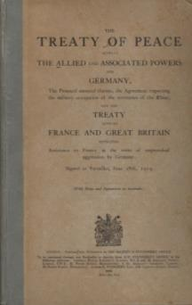 |  | The German people expected a fair treaty, but:  - The German government was not allowed to be involved in the creation of the Treaty and Germany was forced to sign it.  - The terms were harsher than those which had been discussed in earlier negotiations.  Key details of the Treaty – signed 28 June 1919  - The armistice was signed on 11 November 1918 by Matthias Erzberger. He had little alternative but to sign, due to the social and political unrest. Germany was running out of money and troops.  - It was seen as a ‘diktat’ – Germany had no say in negotiations. The government was given 15 days to raise objections. All objections raised by Germany were refused. The Treaty became known as a ‘dictated peace’.  - Allied leaders decided the terms:
The cover of the English version

Britain | Lloyd George wanted some form of punishment – especially as elections were coming soon. But he wanted Germany to recover enough to trade with.
France | Clemenceau wanted the harshest possible terms to punish Germany.
USA | Wilson wanted to create a more peaceful world order, based upon his 14 Points.

The terms of the Treaty of Versailles − TRAWL
T | Territory  - 13% of Germany’s territory was lost, including Alsace and Lorraine to France and Posen and West Prussia to Poland, leaving 10 million Germans living outside of Germany.  - Germany lost all its colonies.
R | Reparations  - These were set in 1921 at £6.6 billion, to be repaid over 42 years.
A | Armed forces  - The army could be no larger than 100,000 men. Conscription was not allowed.  - The navy could have no more than six battleships and no submarines. No air force was allowed.  - The Rhineland was demilitarised as a buffer zone for France.
W | War guilt clause  - Germany accepted total blame for the war.
L | League of Nations  - Germany was not allowed to join.  - It was seen by many in Germany as a club of victorious powers.

German reactions to the Treaty of Versailles
- Some Germans thought that Germany should have fought on, and that they were ‘stabbed in back’ by Weimar politicians who became known as the November Criminals.
- Many linked the new Weimar government with a sense of humiliation.
Task 1 | Read, highlight and annotate the information. Use dual coding if you find this helpful.
Task 2 | Summarise the key details of the Treaty.
Exam-style question | Describe the territorial losses faced by Germany. (4 marks)

Task 1 | Sort the impact of the Treaty of Versailles into social, political and economic consequences using the Venn circles
Task 2 | Judge which you believe was the most important to least important consequence and explain your decision for each.
Task 3 | Link the different circles, e.g. how do the political consequences link to the economic consequences?
Social
Political
Economic

A | B | C | D
‘November criminals’ – the government was always associated with defeat. | Social divides increased and the divide between the rich and poor grew bigger. | Reparations contributed to economic depression in an already weakened Germany. | The Weimar Republic was always linked to surrender. Some have argued that this made them politically weak from the start.
E | F | G | H
Territory loss impacted on industrial production and government finances. It caused unemployment to grow. | The Weimar government faced political opposition from the right, e.g. the Kapp Putsch. It faced criticism from start. Matthias was later assassinated. | ‘Stab in the back’ – Some Germans believed that Germany could have won the war and that they were betrayed by the Weimar politicians. | There were feelings of depression, anxiety and shame in Germany. They felt like a defeated nation.
I | J | K | L
This led to feelings of vengeance. | The loss of overseas colonies also meant a loss of resources, trade and international standing. | People were more willing to vote for extremist parties in later years, e.g. the Nazis who promised to end the treaty. | Some had a sense of vulnerability and anger at the military restrictions. They felt that they would not be able to defend themselves if they were attacked by another power.

What was the impact of the framework of the new German constitution?

Key features
Chancellor
- elected every four years
- led the government
- chose ministers
- proposed laws to be passed by the Reichstag.

Reichstag
- elected parliament
- members were elected by proportional representation every four years
- passed laws
- controlled taxation
- Chancellor had to have a two-thirds majority in the Reichstag.
Reichsrat
- elected every four years
- represented Germany’s regions
- could delay laws being passed unless a two-thirds majority of the Reichstag overruled it.

President
- elected every seven years
- head of state
- could rule without the Reichstag in an emergency (Article 48)
- could call new elections
- appointed judges, controlled the army, and chose the chancellor.

Proportional representation was used to elect politicians. This meant that lots of different parties were able to gain seats in the Reichstag. In fact, there were 28 different parties which had to form coalitions in order to pass laws. The process of making laws was therefore very slow.

What were the strengths and weaknesses of the Weimar system?
Task | Highlight the strengths of the framework in one colour and the weaknesses in another.

Democracy and power to the people  Article 1 of the constitution confirmed Germany was a democracy. German people had more control. | More political participation  All men and women over 21 could vote using a secret ballot. | Taxation  The Reichstag had control over taxation. | Reichstag  Members were elected every four years using proportional representation. All views were included. | Respect  Democracy gained international respect – a key reason why Germany’s international position improved in the 1920s.
President  Electing the president aimed to avoid dictatorship. If a president was incompetent they could be removed after a short period. | Article 48  The president could suspend the constitution and pass laws by decree if there was an emergency. It meant he could dismiss the Reichstag, call new elections and assume control of the army. | Checks and balances  Power was shared between the local governments, Reichstag, Reichsrat, chancellor and president to avoid dictatorship. | Reichsrat  Members of the Reichsrat were chosen by each local region. They could delay new laws introduced by the Reichstag unless there was a two-thirds majority in the Reichstag. | Chancellor  He decided which laws should be passed, though under normal circumstances these only became law if the majority of the Reichstag and Reichsrat voted for them.
Criticism from the right  The right-wing members of the army, judiciary, civil service and industry did not support the new government. These were influential people whom it was dangerous to have in opposition. | Proportional Representation  Every party was allocated one representative for each 60,000 votes it gained. This meant no party ever had a majority. Coalitions often fall apart; between 1919 and 1923 there were nine coalition governments. | Local government  There were 18 local governments (e.g. Bavaria, Prussia) who could introduce laws that worked best for their individual areas. They held on to some traditional powers. Each had their own Land (plural Länder) which controlled key services such as police, courts and schools. | President could appoint and dismiss the chancellor  The president was usually the leader of the largest party. It also meant he might not pick the best person for Germany but rather the best person for himself. | Slow decision-making in times of crisis  The balancing of powers made it difficult for the chancellor to make decisions. In a crisis, if the chancellor could not get the biggest parties’ support, he would have to ask the president to use Article 48. By 1930, the chancellor regularly relied on the president to pass laws.

What political threats did the new government face?
Sparticist Uprising, 1919  Who were they and why did they challenge the government?  - They were a left-wing, communist group.  - They wanted to overthrow the government and set up a communist government.  - They were led by Rosa Luxemburg and Karl Liebknecht.  What happened during the uprising?  - In January 1919, 100,000 people demonstrated in Berlin. They took over key buildings, e.g. newspaper offices.  - Chancellor Ebert and defence minister Noske needed help to stop the uprising; the army wasn’t enough. |  | 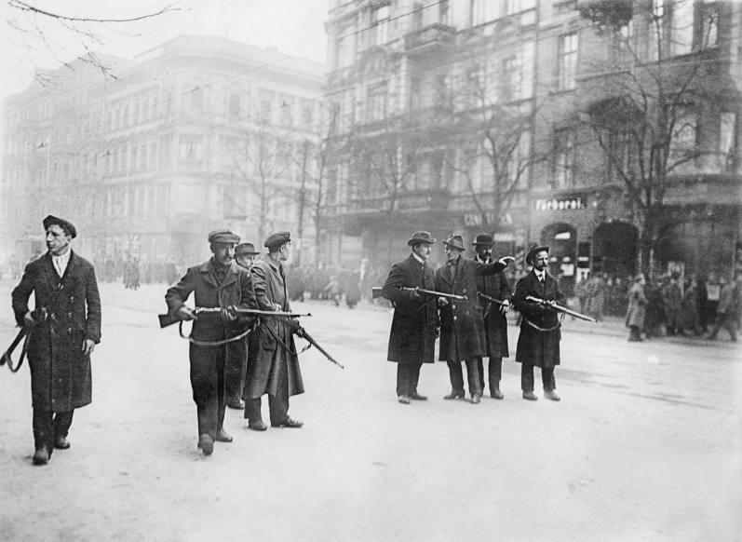
 |  | Sparticists hold a street in Berlin
- The government used the Freikorps to end the uprising.
- Several thousand communists, including Luxemburg and Liebknecht, were arrested or killed.

What was the impact?
The Freikorps had saved the government from a communist revolution. The government survived.
People lost faith in the Weimar Republic when they saw their government having to use force.

Kapp Putsch, 1920

Who were they and why did they challenge the government?
- The Papp Putsch was a right-wing uprising.
- They wanted to overthrow the government, bring back the Kaiser and destroy the Treaty of Versailles.
- They were angry at army cuts.

What happened during the uprising?
- 5,000 right-wing supporters of Dr Kapp marched on Berlin to overthrow the Weimar government and bring back the Kaiser.
- The army refused to fight against Kapp. Rebels controlled the city.
- The government was forced to move to Dresden.
- The government ended the uprising by asking workers in Berlin to go on strike. Essential services (gas, electricity, water) stopped and the capital ground to a halt.
- Kapp ran away. He was arrested and put into prison.

What impact did it have on the government?
The Weimar government had survived another political threat.
They had asked the people of Berlin to stand by them, and they did.
The unrest had made them look weak, with the army refusing to fire on the marchers.
Right-wing unrest continued, as shown by the Munich Putsch 1923 …

Munich Putsch, 1923

Who were they and why did they challenge the government?
- The right-wing NDSAP (National Socialist German Workers’ Party) – led by Hitler.
- Wanted to overthrow the government and lead the country using nationalist principles and to destroy the Treaty of Versailles.

What happened during the uprising?
- On 8 November 1923, Hitler and 600 members of the SA (Stormtroopers) tried to take control of the Bavarian government.
- On 9 November Hitler, Ludendorff and 3,000 supporters marched through Munich trying to win public support. They only had 2,000 rifles.
- State troops fired, 14 marchers died and Hitler fled. He was later captured, and Ludendorff was arrested.

What impact did it have on the government?
Government had survived another political threat and the people of Munich had not joined in the putsch.
Hitler was arrested and put into jail and the Nazi Party was banned (for a while …).
In the long term, the Nazi Party benefited from this event. Hitler was able to use his court appearance to raise the party’s profile. His court sentence reflected the judge’s sympathy with his views. He used his time in jail to write Mein Kampf. He also devised his new strategy – to take power legally and democratically, before then destroying democracy.

Task 1 | Read, highlight and annotate the information.
Task 2 | Complete these exam-style questions.  - Describe the Sparticist Uprising. (4 marks)  - Describe the Kapp Putsch. (4 marks)  - Describe the Munich Putsch. (4 marks)

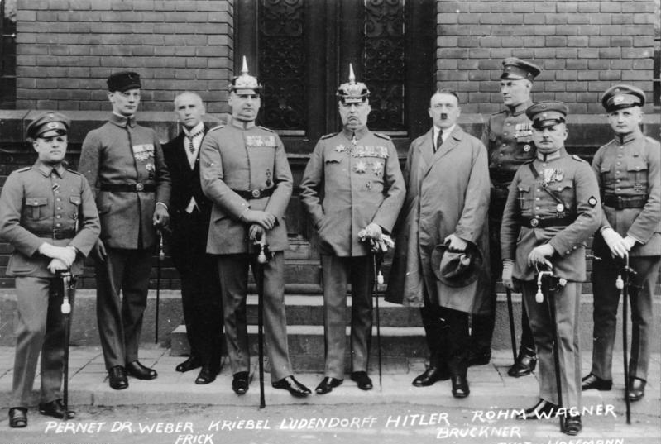
The defendants in the trial that followed the Munich Putsch

What economic problems did the Weimar government face?
 | 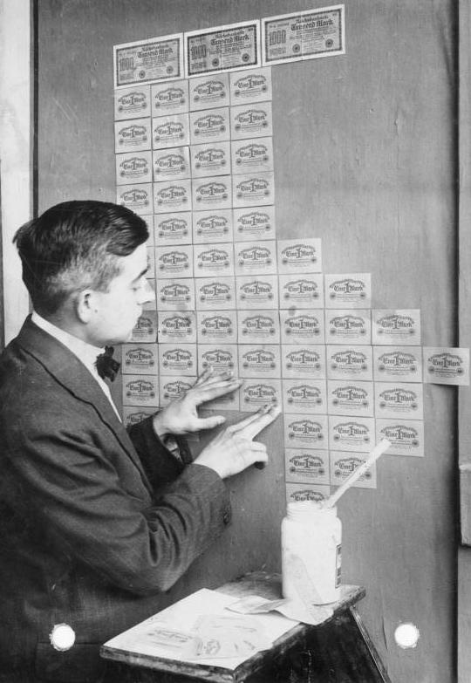 | - Germany was virtually bankrupt after the war.  - Many people were facing starvation and shortages – many were so poor that they were surviving on bread and turnips.  - The war left 600,000 widows and two million children without fathers. By 1925 the state was spending a third of its budget on war pensions.  Problem 1: War debts  - Reparation payments accounted for 3% of German annual input.  - The Saar coalfields had been lost, which meant less coal and iron to trade. This damaged German industry and also meant Germany was weighed down by a debt it could not afford to pay.  Problem 2: Treaty of Versailles
 | Banknotes being used as wallpaper
- Germany paid its first instalment of reparations in 1921, but by 1922 Germany said that it did not have enough money to continue paying. France lost patience.
- On 9 January 1923 French troops marched into the German industrial region of the Ruhr and took control.
- They took raw materials (coal and iron) in place of the payments.

Impact of occupation
- The German army could not stop the French so the government called for the workers in the Ruhr to carry out passive resistance. This meant refusing to work for the French.
- The government continued to pay the German workers who were on strike, which led to a fourth problem …

Problem 3: French invasion of the Ruhr, 1923
- The government printed money to pay the workers who were on strike in the Ruhr. As more and more money was printed, it became worth less and less. Wages had to be paid weekly not monthly and people used wheelbarrows to take home their money.
- As prices and wages rocketed, people soon realised that money was worthless.
- Foreign countries refused to accept German currency so imports were stopped.
- There were food shortages and queues for food. By 1923 a loaf of bread cost 201 billion marks.

Problem 4: Hyperinflation

Losers − who suffered as a result? | Winners – who benefitted as a result?
- Everyone suffered from shortages and found it difficult to buy what they needed. People burned bundles of money as it was cheaper to do that than buy coal. Shops began to refuse to take money, so people were forced to ‘pay in kind’ (trade items like their piano or jewellery). There was violence and looting.  - Many pensioners and those with savings found the money in their accounts was now worthless.  - The Weimar government decreased in popularity. It was blamed for accepting reparations in the first place and being slow to solve the crisis. | - People with debts found that these were wiped out.  - Industrialists and landowners who owed money on mortgages found it easy to pay debt.  - Entrepreneurs and speculators saw opportunities to make money or hoard goods.  - Foreign currency was good value to visitors from other countries.  - Extreme parties on the right and the left found that more people were willing to vote for them.

Task | Create a flow chart which summarises the economic problems the German government faced, 1919−23.

Economic problems due to WWI
1918−19
Treaty of Versailles
1919−22
French invasion of the Ruhr
1923
Hyperinflation
1923

Task | Knowledge check. Explain each of the following terms in no more than one sentence.

Armistice
November criminals
Article 231 of the Treaty of Versailles
Sparticist uprising
Kapp Putsch
Munich Putsch
Proportional representation
Article 48
French invasion of the Ruhr
Hyperinflation

Task | Weimar Germany pie chart  - Which development or event do you think had the greater impact on the Weimar government?  - Each event/development needs to be given a segment of the pie.  - The bigger the size of the slice of the pie chart, the greater impact the event/development had upon the government.
 | Step 1: | Give each event/development a slice of the pie.
 | Step 2: | Explain your judgement in deciding the biggest slice of the pie.

Events to give a slice:
Impact of WW1
Treaty of Versailles
Framework of the new government
Political threats from the left
Political threats from the right
Economic problems, 1918−23

Task | Revision hexagons – threats to the Weimar government  - Summarise each event in no more than 25 words. Ensure you include key names, terms and statistics.  - Once completed, try to make as many links as you can between the different events; draw arrows and annotate the links with your understanding.

e.g. The economic, social and political impact of WWI already damaged the reputation of the new government. When land and resources were lost due to the Treaty of Versailles and they agreed to reparations, this meant the government struggled more economically and their reputation was damaged further – the ‘November Criminals’.
Threats to the Weimar government 1918−23
Start
Impact of WWI
Treaty of Versailles
End
Economic problems
1918-23
Political threats from the right
Framework of the new government
Political threats from the left

How far did Germany recover under Stresemann?

Economy
Policy | Evidence | Explain how this policy helped the Weimar economy to recover | Explain how this policy did not help the Weimar economy to recover
Ended passive resistance | - All workers in the Ruhr were ordered to end passive resistance and return to work.
Introduced the Rentenmark  November 1923 | - A new currency – the Rentenmark – was established. Its value was tied to the price of gold and backed by German industrial plants and agricultural land.  - The Reichsbank was a new, independent national bank that was given control of the currency.
Dawes Plan  1924 | - $25 billion of loans were borrowed from the USA between 1924 and 1930. They were used to fund factories, buy new machinery and help restart production.
The Young Plan  1929 | - £6.6 billon reparations were reduced to £2 billion, with 59 years to pay. This meant payments were reduced to £50 million per year.

Foreign relations
Policy | Evidence | Explain how this policy helped the Weimar economy to recover | Explain how this policy did not help the Weimar economy to recover
The Locarno Pact  October 1925 | - Germany accepted the borders of the Treaty of Versailles and France promised peace with Germany.  - Germany and the Allies agreed that the Rhineland would be permanently demilitarised.  - The five signatory powers (Belgium, France, Great Britain and Italy, as well as Germany itself)’agreed to open talks about German membership of the League of Nations.
Joined the League  of Nations  1926 | - Germany joined in September 1926 and was given a seat on the council.
The Kellogg-Briand Pact 1928 | - 61 nations promised not to go to war to resolve disputes.

Politics
Policy | Evidence | Explain how this policy helped the Weimar economy to recover | Explain how this policy did not help the Weimar economy to recover
Extreme parties | - Votes for extremist parties fell. In 1924, 40% of votes were cast for extreme parties. This fell to 28% by 1928.  - The Nazi Party gained only 12 seats in 1928.
Moderate parties  (SPD, DDP, ZP) | - Votes for moderate parties increased.  - The SDP gained more votes.
New president | - When Ebert died he was replaced by Hindenburg, a former field marshal of the Kaiser’s army.

Culture – The ‘Golden Age’
Policy | Evidence | Explain how this policy helped  the Weimar economy to recover | Explain how this policy did not help the Weimar economy to recover
Art and architecture | - The Bauhaus movement emerged as an international centre of design.  - Its members rejected traditional design principles and created radically new buildings and objects.
Cinema | - Marlene Dietrich was a glamorous international filmstar.  - Innovative movies challenged people’s ideas, famous examples being The Cabinet of Dr Caligari and Metropolis.  - For the first time, some films were funded by central government.
Music | - Nine hundred jazz and cabaret clubs emerged in this time.  - Swing dancing, which would have shocked earlier generations, became very popular.
Art | - Artists like Otto Dix rejected traditional styles of painting in favour of brutal, often shocking portrayals of war and German society.  - Abstract art emerged as a new form.  - Censorship was dropped, allowing greater freedom of expression.

Germany and the Depression
Topic 2

The growth of the Nazi Party 1928−32
- The Nazi Party started as the DAP (Deutsches Arbeiter Partei) in 1919. It was led by Anton Drexler and had just 40 members.
- Hitler joined the party in 1919 and within two years had become its leader.
- In 1923 Hitler tried, unsuccessfully, to seize power during the Munich Putsch. The party was banned (it would remain so until 1925) and Hitler was put into jail (although he only served nine months).
- Once Hitler was released, the party was relaunched.

Why did support for the Nazis grow during 1928−32?
Factor | Supporting evidence
Hitler’s personal appeal | - He was a powerful orator (speaker).  - He was a WWI Iron Cross hero.  - He was a strong leader who promised to unite the country, restore order and scrap the Treaty of Versailles.
Strength of the SA | - In 1930, there were 400,000 members.  - They were used to attack communists, disrupt their meetings, tear down posters and intimidate voters.  - They gave an impression of discipline through their uniforms, parades, rallies and marches.
Propaganda | - The newspapers Der Stürmer and Völkischer Beobachter were used to promote the Nazi message.  - New technology was used, including radio broadcasts, plane tours and cinema news reels.  - Propaganda posters promised ‘Work and bread’ and the destruction of the Treaty of Versailles.
Working class support | - This group were promised jobs. This was very appealing because unemployment was high; 40% of factory workers were unemployed.  - The Nazis presented themselves as the party of workers.
Middle class support | - Teachers, lawyers and professionals deserted moderate parties and turned to extremist parties due to Great Depression (many had lost their companies and pensions).  - They saw the Nazis as protection against the Communist Party.  - The Nazis stood for traditional values, criticising the hated ‘moral decline’ of 1923−29.
Farmers’ support | - Farmers made up 40% of voters.  - They feared communists, who wanted to ban private ownership of land.  - The Nazi Party promised to help struggling farmers pay their debts and also to take land from the Jews.  - The ‘Blood and soil’ motto was used to tell farmers that they were Aryans. Farmers became a strong section of Nazi support.
Big business support | - The Nazi Party promised protection from communists.  - Big businesses such as Benz and Krupps donated money to the party.
Support from young people | - Hitler’s passionate speeches and exciting rallies appealed to some young people.  - The Nazis promised jobs during a time of high youth unemployment.
Support from women | - The Nazis promised to prioritise families. Some women were drawn to propaganda posters which demonstrated strong, traditional values.  - They had not been targeted by other parties as voters.

Diamond nine: Why did support for the Nazis grow?
Task 1 | Using the factors and supporting evidence on the last page, prioritise the reasons why support grew. State the factor in the box and provide two or three pieces of your own knowledge to summarise the factor.
Task 2 | Explain your overall judgement (box 1) and see if you can link the factors by drawing arrows between the boxes and annotating them.

1.
2.
3.
5.
6.
4.
9.
7.
8.
Task 3 | What was the main reason why support grew? Explain your judgement.

How far did the Great Depression lead to an increase in support for the Nazis in the period 1928−32?
- In 1928, despite key changes to the Nazi Party, it achieved only 12 seats in the Reichstag elections.
- By 1930, this had grown to 107 seats.
- The Wall Street Crash of 1929 led to a global economic depression, one which impacted massively upon Germany.
Task 1 | Using the key, identify the social, economic and political impact of the Great Depression upon Germany. |  |  | Social
 |  |  |  | Economic
 |  |  |  | Political

Homelessness  Many could no longer afford their rent. Shanty towns sprang up. Unemployed people wandered the streets and fighting often broke out. There was a 24% increase in theft arrests. | Unemployment rose  Forty percent of all factory workers, 50% of all 16−30-year-old Germans and 60% of all graduates were unemployed. | Chancellor Brüning’s reforms  The government was unable to pay unemployment benefits. Taxes were raised and benefits cut. This caused more problems for the unemployed. | The workers  The economic collapse also affected wages. Taxes went up and employers cut wages to save money. People had less money to spend.
Right-wing parties  The right-wing parties, middle class and wealthy all opposed Brüning’s idea of raising taxes. This meant the Weimar Republic faced a threat from the right-wing parties and their supporters. Nazi votes grew by 1930 to 107 seats. | Banks recalled loans  American banks urgently needed the return of money they had lent to Germany (in the Dawes Plan and Young Plan). German banks also asked for their money back from German businesses. However, these businesses could not afford to return the loans as their survival depended on them. They had to either downsize or close. | High level of unemployment  Unemployment rose from 1.3 million in 1929 to 6.1 million in 1933. This was because companies had to pay back loans to the American and German banks and because sales fell at home and abroad. | Chancellor Brüning’s proposals turned people against the Weimar system  People demanded political action to solve the problems but the Weimar government failed them. From 1930 to 1932, Chancellor Brüning proposed raising taxes to pay for the cost of unemployment benefit and reducing unemployment benefit to make the payments more affordable.  This meant that people faced higher taxes whilst suffering from the Depression, and the unemployed did not receive as much help.
The middle class and savers  The economic collapse led to many in the middle class losing their savings, their companies or their homes. People who had invested their savings in shares saw them lose their value as markets fell. If unemployed too, this meant many people had a much weaker safety net. | Coalition Party collapse  The coalition of parties that Brüning’s government depended on collapsed in 1930. Brüning could only rule by Article 48. There had been only five presidential decrees in 1930. There were 66 in 1932. Ruling by decree meant that people lost faith in democracy. | Left-wing parties  The left-wing parties (e.g. the KPD Party) and many of the working class opposed Brüning’s proposal to make benefits lower for the unemployed. This meant the Weimar Republic faced a threat from the left-wing parties and their supporters. Communist Party seats rose in the Reichstag. | German companies struggled to sell their goods  German companies struggled because there was less demand for the goods they sold both at home and abroad. The worldwide Depression was a disaster for export industries but high unemployment meant that domestic demand for goods fell too. This meant companies lost money and had to sack people, adding to unemployment. Production fell by 40% by 1932.

Task 2 | Summarise the social, economic and political impact upon Germany.
Task 3 | Explain in 50 words why the Great Depression led to an increase in support for the Nazi Party.

Why did Hitler become chancellor?

 | March 1932: Presidential elections  - Hindenburg stood for re-election in March 1932.  - Germany was in the grip of the Depression.  - Result: no candidate got the 50% required to win. | Results  - Thälmann (KPD): 5 million votes (14%)  - Hindenburg: 18 million (49.6%)  - Hitler (NDSAP): 11 million (30%)
 | April 1932: Presidential elections  - The presidential election was held again.  - Hitler campaigned a great deal; plane tours, SA parades, etc.  - Hindenburg won. | Results  - Thälmann (KPD): 4 million (11%)  - Hindenburg: 19 million (53%)  - Hitler (NDSAP): 13 million votes (36%)

May 1932: Chancellor Brüning resigns
- Hindenburg’s re-election as president did not bring stability. Chancellor Brüning tried to introduce reforms to improve things.
- He banned the SA and SS, which upset the Nazi Party.
- A scheme to buy land from large landowners and use it to house the unemployed. Landowners and Hindenburg were upset by this.
- Brüning angered the right wing with these reforms and lost the support of the Reichstag and President Hindenburg.

May 1932: von Papen becomes chancellor
- Brüning resigned in May 1932.
- Hindenburg made von Papen chancellor, thinking he would be able to control the Reichstag and bring stability.

July 1932: Reichstag elections
- Von Papen struggled to control the Reichstag.
- Reichstag elections took place and the campaigning was violent.
- The Nazis won 230 seats – a bigger share of the seats − and was now the largest party in the Reichstag.
- Hitler demanded that Hindenburg make him chancellor. Hindenburg refused and kept von Papen.

November 1932: von Papen is sacked
- Von Papen called new Reichstag elections, hoping that Nazi Party support would lessen. It did not lessen enough.
- Von Papen was told to resign and he still refused to make Hitler the chancellor.

December 1932: von Schleicher becomes chancellor
- Hindenburg made von Schleicher the chancellor but he struggled to gain support in the Reichstag.

January 1933: Hitler becomes chancellor
- Von Papen proposed a solution to Hindenburg to try and stabilise the Reichstag and control the Nazi Party by making Hitler the chancellor and von Papen the vice chancellor.
- Hindenburg and von Papen thought they could make all of the decisions themselves and control Hitler; von Papen said he had Hitler ‘in his pocket’.
- Hitler was made chancellor in January 1933.

Task 1 | Create a flow chart of the steps to Hitler becoming chancellor.  Summarise the information as you create the flow chart.

Task 2 | Explain the impact of each of these developments during the Great Depression, in 25 words or fewer.

Ending of the Dawes Plan
Use of Article 48
Shortages and homelessness
Role of Brüning

Task 3 | Describe the role of Hindenburg and von Papen in Hitler’s rise to power.
Task 4 | Create a word-cloud of 25 words to summarise the reasons why the Nazi Party grew during 1928−32. The larger the word, the more significant it is.

How did Hitler become Führer?
Elections to the Reichstag were coming. Hitler was concerned that he might not get the two-thirds majority he needed to control the Reichstag because the left-wing KPD had been growing in support.

Reichstag fire: February 1933
- A week before the election, the Reichstag was burned down.
- Dutch communist Marinus van der Lubbe was arrested and found guilty.
- Hitler used this as an opportunity to accuse the KPD of plotting to take over the government.
- Hitler was able to persuade Hindenburg to pass an emergency decree giving the police the powers to search houses, close communist newspapers, confiscate property and detain people without trial. Four thousand communists were arrested.

Election: March 1933
- The Nazis won more seats but still had less than 50% of the total.
- To change the constitution, Hitler needed a two-thirds majority.

The Enabling Act: 24 March 1933
- To get the two-thirds majority he needed to change the constitution and pass the Enabling Act, Hitler formed a coalition with the National Party and the Centre Party.
- The Enabling Act was passed by 444 votes to 91.
- Hitler now had the power to make laws without the consent of the Reichstag for four years.
- He used the Enabling Act to pass further laws to remove other political threats like other political parties and trade unions.

The removal of political power groups
- State parliaments (Länder): The Nazis closed down all 18 state parliaments. All state governments had to obey central government.
- New political parties: There was a ban on the formation of these.
- Trade unions: The Nazi Party broke into trade union offices and arrested the officials. All of the trade unions were then forced to become one single trade union run by the Nazi Party, the ‘German Labour Front’ (DAF).
Night of the Long Knives: June 1934  - Röhm was the leader of the SA. Hitler saw Röhm as a threat to his position because he commanded two million men.  - The German army were also concerned about Röhm and the SA as they were worried they might either try to merge with the army, or take them over. Hitler knew that if he could get rid of the threat of the SA, then the German army would support him.  - Hitler arranged to meet the SA leaders in a hotel where they were shot. Röhm, Strasser, Streicher and 400 prominent SA members were killed in total.  - In 1934 the army swore a personal oath of allegiance to Hitler. This gave him control of the military.  The Death of Hindenburg: August 1934 |  | 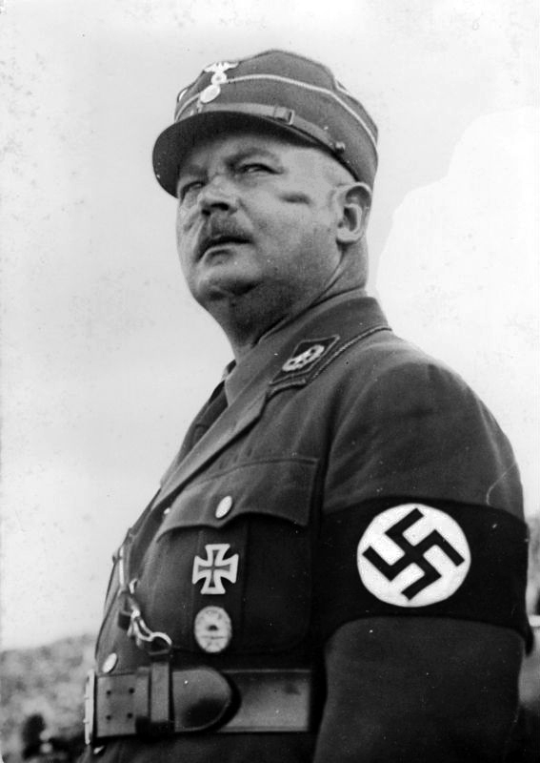
 |  | Ernst Röhm
- Hindenburg died in August 1934.
- With the president dead, the other political parties banned and Hitler in control of the army, he was able to take power unopposed.
- Hitler controlled the Nazi Party, police, army, media, church, education, law and industry.
- He was now the Führer (total leader) of Germany.

How was Hitler able to become dictator of Germany?
Task 1 | Summarise why each step was important to enabling Hitler’s rise to power in three bullet points per step.
Task 2 | Dual code (draw an image) for each of the steps.
Task 3 | Fill in the boxea to explain how each step led to the next.

Night of the Long Knives
June 1934

Dual Code
The death of Hindenburg
August 1934

Dual Code
Reichstag fire
February 1933

Dual Code
The removal of political power groups

Dual Code
The Enabling Act
24 March 1933

Dual Code

The experience of Germans under the Nazis
Topic 3

Economic changes in Nazi Germany
Hitler came to power when there were six million people unemployed. He had promised to solve this and wanted to achieve full employment.

Policy 1: Reich Labour Service (RAD)
This provided short-term employment for unemployed men.
- Unemployed 18−25-year-old men given manual labour for six months.
- Became compulsory from 1935 onwards.
- Men were paid very low wages and discipline was strict.
- Jobs included repairing roads, planting trees and draining marshes.

Policy 2: Public works schemes
These were government funded schemes to provide jobs.
- Autobahns (motorways).
  - 7,000-mile network planned.
  - First stretch opened in 1935.
  - By 1935, 125,000 men were employed and 500 km of road were finished.
  - Other public works included bridges, coastal walks and sports facilities.
  - Public works spending rose from 18 billion marks in 1933 to 38 billion marks in 1938.

Policy 3: Rearmament
This would help reduce unemployment and prepare Germany for war.
  - Labour Service Corps (Conscription)
- Conscription was introduced in 1935.
- The army grew from 100,000 in 1933 to 1.4 million in 1939.
  - Rearmament
- Spending on coal, iron and armament factories (tanks and planes) increased from 3.5 billion marks in 1933 to 26 billion in 1939.
  - Four-Year Plan
- The Nazi Party aimed for ’autarky’ (self-sufficiency).
- Spending on weapons was increased to establish a ‘war economy’, led by Göring.
- Production of iron and steel trebled and production of plastic increased by 460%.
- However, this led to shortages of consumer goods (e.g. food, clothing) and ‘guns versus butter’ criticisms.
  - ‘Invisible employment’
By 1938, 0.3 million people were unemployed.
While the figures make it look as though unemployment dropped massively, some people were not counted on the unemployment figures – they were ‘hidden’ from the numbers. They included:
- RAD workers.
- Men conscripted into the army.
- Jews and women who had been removed from their jobs and replaced.

- Task | Summarise the key unemployment policies that Hitler introduced and how they helped to reduce unemployment.

Policy | Provide three key facts about this policy | How did this change/reduce unemployment?  Summarise in 25 words.
RAD
Public work schemes
Rearmament

- Task | True or false?

Statement | True | False
Unemployment was 6 million in 1933.
The RAD was not compulsory.
The RAD workers had to work for free, with no payment.
The autobahn-building project employed 125,000 men.
Government spending on public works schemes rose to 48 million marks.
The person in charge of the Four-Year Plan was Göring.
Conscription meant that men were forced to be in the armed forces.
Government spending on rearmament rose to 26 million marks by 1939.
Jews and women were removed from jobs and replaced by non-Jewish German men.
RAD workers did not appear in the unemployment figures.

Improving working conditions for workers – benefits of working
German Labour Front (DAF)  Trade Union | Strength Through Joy (KDF) | Beauty of Labour (SDA)
- Trade unions were banned in 1933.  - The DAF set out the rights of workers, the maximum length of the working week and minimum pay levels. | This introduced:  - Leisure activities including sports events, foreign travel and cultural activities such as films and theatre showings .  - The Volkswagen scheme helped families to save for a car. | - This tried to improve conditions in the workplace by providing:  - canteens  - toilets  - showers  - sports facilities

- Task | Explain how each policy improved conditions for German workers in 25 words each.

Policy | Explain how this changed working conditions in Germany
DAF
KDF
SDA

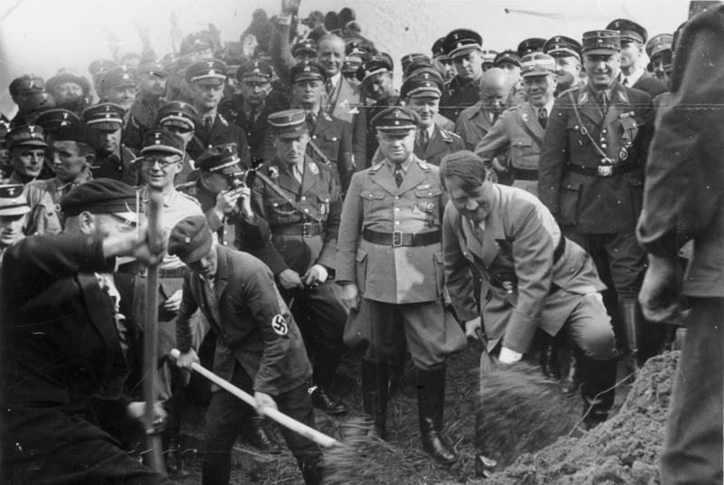
Hitler visiting the start of a new section of the autobahn

Did ordinary Germans benefit from Nazi policies?
- Task | Choose evidence from the boxes to weigh up the benefits and limitations for ordinary Germans on the scales below. Which are the ‘heaviest’ (most important) benefits and disadvantages? Who gained/lost the most?

Employment dropped to 0.3 million by 1939. It had previously been 6 million. | Thanks to the National Labour Service, from 1933 onwards there was a whole new network of autobahns (motorways) which improved transport across Germany and helped businesses to trade more.
Wages improved. By 1939 there had been a 20% increase. | Rearmament from 1936 onwards meant government money was diverted to the war economy. This led to the ‘guns versus butter’ argument.
From 1933 to 1939, unemployment figures did not include invisible unemployment – Jews, women, National Labour Front member or prisoners. | Despite the promise, no Volkswagen Beetles were ever given to workers (they weren’t produced until after WWII).
From 1933 to 1939, real wages did not increase. Rising food prices cancelled out higher wages. | Rearmament meant more jobs in other industries. The need for uniforms and weapons meant that jobs were created in armament factories and it helped to provide more work for coal mines, steel factories and construction workers.
Strength Through Joy – This was a scheme to provide leisure and luxuries for workers (e.g. films, events, sports, cruises). Workers could save up for a Volkswagen Beetle. | The Four-Year Plan was introduced in 1935. This aimed to make Germany ‘self-sufficient’ in food and raw materials, to save importing them from other countries. Germans tried to substitute materials for others such as fabric made from wood pulp. However, they could not find substitutes for all items and this led to a shortage of items such as butter.
Beauty of Labour – This was a scheme to improve working conditions (e.g. safety, cleanliness, nice canteens!) | During WWII, Germans had to take in evacuees, further adding to shortages that people experienced as bombing already caused damage to housing.
Trade unions were banned in 1933. This meant that workers’ freedom was restricted. The DAF lessened their rights (they couldn’t negotiate pay or the working week and those who disrupted production were punished). | Factory owners and industrialists made profits during 1933−39. The banning of trade unions and the creation of the DAF meant that that their workers were disciplined, further adding to stability and profits.
Working hours increased. They rose to 49 hours a week. | In the long term, employment policies would have failed. The German economy could not sustain it due to rearmament – after 1939 they would have run out of money

- Task |  | Write an overall judgement of 25 words explaining your final decision.

- Task | Revision quilt.  - Give each of the categories a different colour: unemployment policies, working conditions, benefits, WWII and limitations.  - Match the policy or event to the category by colouring in the box that colour. *Some might need two or more colours.  - Give each of the dates a symbol.  - Match the policy or event to the correct date by putting a symbol in the box.

Beauty of Labour | Invisible unemployment | Volkswagen Beetle | Butter shortages | ‘Guns versus butter’
Conscription | Trade unions banned | Rearmament | Black market | Real wages
RAD | Increased working hours | Strength Through Joy | Entertainment closed down 1944 | Rising food prices
Evacuees | Four-Year Plan | Inflation during WW2 | DAF | Public works schemes
Bombing | Government spending increases | Wage increases | Autobahn | Jews and women sacked

Unemployment policies | Working conditions | Benefits | WWII | Limitations

1933 | 1934 | 1935 | 1936 | 1937 | 1938 | 1939 | 1940 | 1941 | 1942 | 1943 | 1944

Women in Nazi Germany

Why did the Nazis introduce policies to change the position of women?
- To encourage more women to have children in order to address the falling birth rate.
- To reduce male unemployment. Removing women from the workplace would provide jobs for men.
- The Nazis wanted to return to traditional values and morals, including a strong family.

Nazi views on women suggested that they should:
- Aim for the ‘three K’s’: Kinder, Küche, Kirche (children, kitchen, Reich church).
- Stay healthy.
- Play the traditional role of mother and housewife; learn how to look after a home and a husband.
- Marry and have lots of children who were needed to fill Germany’s conquered lands.
- Maintain a traditional appearance, natural look, no make-up, long skirts, plaited/tied-back hair.
- Not work − they should stay in the home. They disliked women in professions (medicine, law).
The role of women was communicated in propaganda, with Goebbels at the helm.
Nazi policies on women  - Gertrud Scholtz-Klink was appointed as Reich Women’s Leader (1934). She oversaw policies towards women.  - All women’s organisations were forced to merge with the German Women’s Enterprise (DFW). If an organisation refused to join it was banned. It gained six million members and by 1939 1.7 million had attended motherhood courses.  - The Law for the Encouragement of Marriage (1933) encouraged people to marry. Newly married couples received a 1,000 mark loan if the wife stopped working. They could keep the money permanently if they had children (a quarter of the loan for each of their first four children).  - The Divorce Law (1938) encouraged childbirth. If a wife could/would not have children, her husband could divorce her.  - Lebensborn (1935) encouraged childbirth. Nurseries and financial aid were provided for women who had children with SS men.  - There were no women in the legal system by 1936. They could not be judges, lawyers or do jury service. |  | 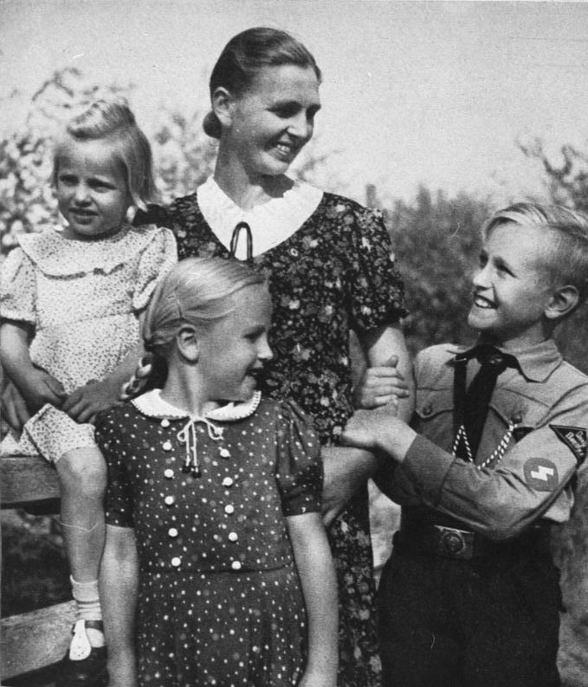
 |  | A nazi propaganda photo showing an Aryan family - the young boy is wearing a Hitler Youth uniform
- The Mother’s Cross encouraged childbirth. It was an award for the number of children a woman gave birth to: bronze for four or five, silver for six or seven and gold for eight or more. Mothers who gave birth to 10 children were expected to name Hitler as the godfather!
- The Law for the Protection of German Blood and German Honour (1935) meant women were banned from relationships with or marrying Jews or other ‘undesirables’.
- Women were banned from professional posts, including teaching and being doctors or civil servants, in 1933.
- Women were dismissed from work so that they could focus on being wives and mothers. By 1934, 360,000 had left work.

- Task | Summarise the key changes in the role of women using the following sections:

Women at work
Marriage and family
Clothing and appearance

- Task | Using specific vocabulary, explain what each of the following terms mean:

Kinder, Küche, Kirche
Law for the Encouragement of Marriage
Motherhood Cross
Lebensborn programme
Aryan woman

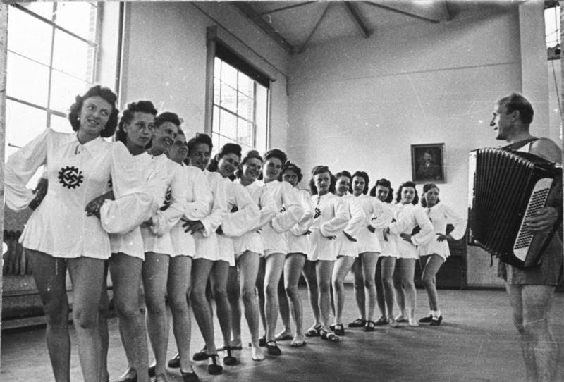
Women dancing at a Strength through Joy event

How did the Nazis change the position of young people?

Why did the Nazi Party want to change the position of young people?
- They wanted to bring them up to be proud Germans who supported a strong country and Nazi policies.
- They wanted all boys to be strong and healthy to form part of productive work and to fight in the armed forces.
- They wanted all girls to become wives and healthy, fertile mothers.

Control of schools and teachers
- A law was passed giving the Nazi Party the power to sack teachers and head teachers they did not approve of.
- All teachers had to belong to the Nazi Teachers’ League, promising to teach Nazism in school and swear an oath of loyalty to Hitler.
- The League ran political education courses for teachers.
- 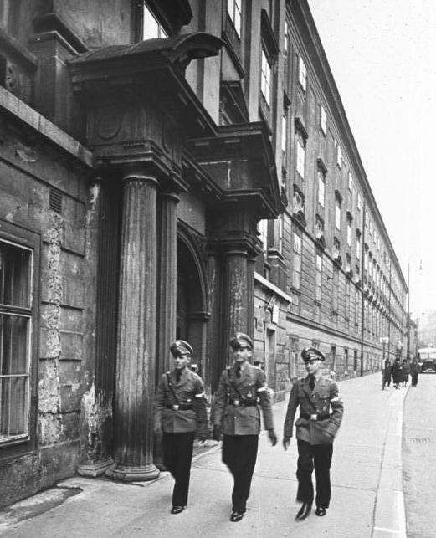 |  | - The curriculum  - All lessons were to prepare students for their future roles in the Nazi state.  - ‘Eugenics’ Taught students that the Aryan Germans were the ‘master race’ (superiority) and that other races were inferior.  - Biology confirmed Aryan beliefs and that Jews and Slavs were ‘Untermenschen’ (sub-humans).  - History taught about the ‘stab in the back’ by weak politicians and hardships of 1920s before the Nazis saved Germany.  - Mathematics questions served to indoctrinate children into Nazi beliefs.  - PE became 15% of a school's weekly timetable. Boxing became compulsory for boys. Those who failed fitness tests could be expelled from their schools.  - Boys were taught to be soldiers.  - Girls were taught lessons to be good mothers and wives.  - All had to read Hitler’s Mein Kampf.
  - The National Political Education Institute
  - Napolas
- These were boarding schools intended to train future leaders of Germany.
- They selected only the most intelligent, aggressive, competitive and ‘racially pure’.
Students attending a physics lesson in a Napola school

Youth groups
Hitler wanted to make sure Nazi ideas were indoctrinated into children outside of school too – their first loyalty was to be to Hitler.
The following groups were set up from 1925:
Age | Boys | Girls
6−10 | Little Fellows (Pimpfe)
10−14 | German Young People (Deutsches Jungvolk) | Young Maidens (Jungmädel)
14−18 | Hitler Youth (Hitler Jugend)  - Swore an oath of loyalty to the Führer.  - Had to report anyone who was disloyal to the Nazis.  - Gained military skills like map-reading, signalling and shooting. | League of German Maidens (BDM)  - Swore an oath of loyalty to the Führer.  - Physical and character-building activities included camping and marching.  - Trained to cook, iron, make beds, sew and prepare to be a housewife.  - Taught ‘racial hygiene’; to marry only Aryan men.

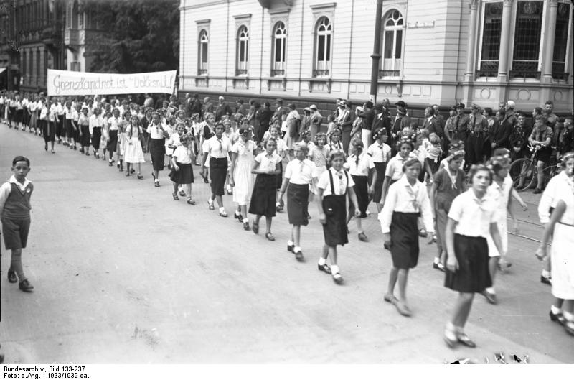
Members of the Young Maidens marching in 1933

Successes | Failures
- Some members were enthusiastic and keen.  - There were eight million members by 1939.  - Many parents encouraged their children to join for fear of being threatened by the Nazi Party. | - Some did not enjoy the activities.  - Some parents felt they were being undermined by it.  - Many children joined not because they wanted to be ‘good Nazis’ but rather because they wanted to enjoy the activities.  - Membership had to be made compulsory in 1939.

- Task | Complete the fishbone diagram to summarise Nazi policies on children and how they changed the position of women.  - Information gathering. For each of the policies targeted towards young people, add at least two key facts to the bone. Two examples have been completed for you.  - Effects. Add at least three effects that each of the policies had upon young people. An example has been completed for you.

Curriculum: eugenics, race science, sport 1/6 timetable
The Nazis sacked teachers they did not approve of. They had to swear an oath of loyalty.
Youth groups
Teaching in schools
Effect 3
Effect 2
Effect 1
League of German Maidens
Teachers had to be part of the Nazi Teacher’s League.
Teachers had to only teach what the Nazis said they could and carried out such acts as singling out Jews in classes.
Information
Effects

The police state
When Hitler became chancellor, Germany already had a police force, but it was run by local authorities. Fearing that his control over the police would be weak, he set up his own police and security forces which would be loyal to him directly. The police came under the control of the Nazi Party, not the government. They became politicised.
The three main organisations created were:

SS (Protection squad)
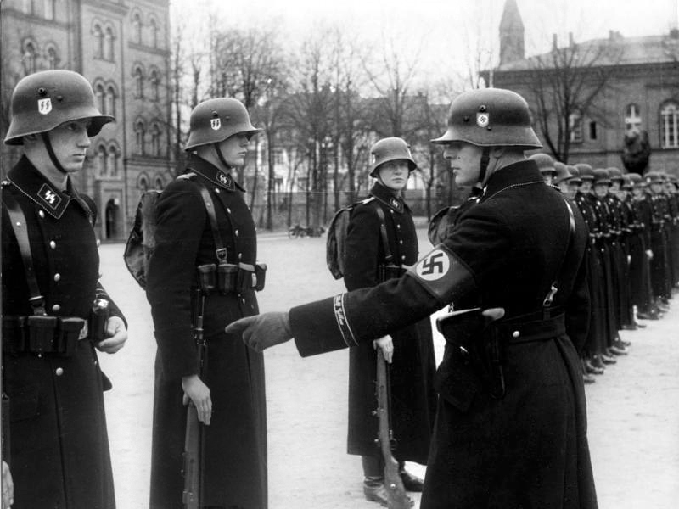 |  | - Formed in 1925, they were led by Himmler.  - They were formed after Hitler’s release from prison when he realised he needed his own private police force as protection.  - They swore an oath of loyalty to him personally.  - They wore black uniforms, which created a sense of fear.  - They started as a group of 240 men but grew to 240,000.  - In 1934, they helped to destroy the SA in the Night of the Long Knives. After this, they were put in control of all the police forces and carried out additional roles:  - to destroy opponents  - to carry out racial policies (e.g. persecute Jews)  - to search houses, arrest people and confiscate property.
Members of the SS on parade

SD
- Formed in 1931, they were led by Heydrich.
- They wore uniforms and were a security force.
- They spied on opponents. They kept a card index of everyone suspected of opposing the Nazi Party or government.

Gestapo
- This was the secret state police force.  - It was formed in 1933 and led by Himmler.  - Approximately 30,000 in size.  - They did not wear a uniform; this caused a huge amount of fear amongst the Germans as it meant that they could not identify who was or was not a member of the Gestapo – your own neighbour could even be a member of the force!  - They were there to identify and spy upon anyone who criticised or opposed the Nazi Party or German government and act upon suspicions they had, using a web of informants to help them to do this. |  | 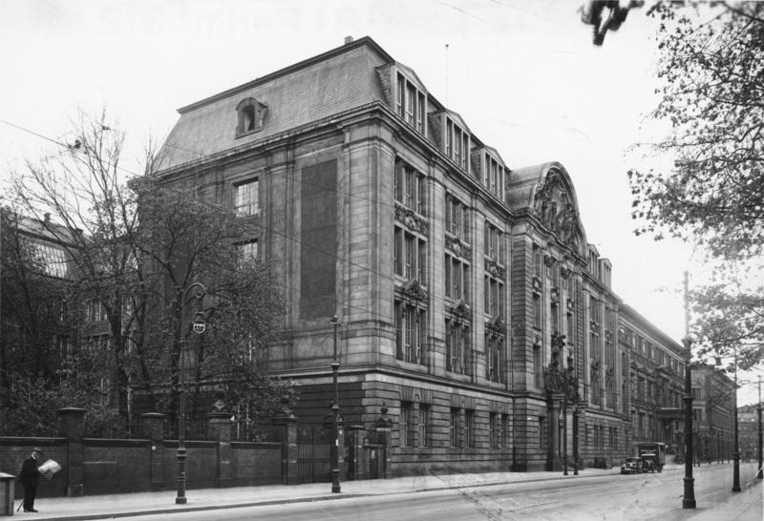
 |  | The Gestapo headquarters
- They had such powers as the ability to tap phones, use torture when questioning suspects and imprison people without trial.
- By 1939, approximately 160,000 people had been arrested for political crimes.

- Task | - Summarise each of the sections of the police state into five bullet points. Highlight the specific evidence and dual code the different sections.  - In a different colour, annotate the boxes with the similarities and differences between the sections.  - Which do you think was the most feared and why? Consider their methods and powers.

SS | SD | Gestapo

How did Hitler control the Church?

Catholic Church
Hitler reached a concordat (agreement) with the Pope in 1933. He agreed to allow freedom of worship and not to interfere in Catholic schools, in return for priests staying out of politics and swearing an oath of loyalty.
Later in the 1930s he betrayed the agreement:
- Catholic priests were harassed and 400 were arrested, with many sent to concentration camps.
- Catholic schools were closed or brought into line with Nazi state schools.
- The Catholic Youth League was banned.
- Pope Pius XI realised in 1937 that the concordat was worthless. He issued Mit Brennender Sorge (With Burning Anxiety) which criticised the regime. In 1941 the Catholic Archbishop Galen began to openly criticise the regime.

Protestant Church
German Protestants disagreed over their response to the Nazis and broke into two groups:
Some German Protestants approved of the Nazi regime. Ludwig Müller became the first Reich Bishop and led the Reich Church who wore Nazi uniforms and displayed the swastika in their churches.
Others opposed the Nazis. The Confessional Church was set up 1934 by Pastor Martin Niemöller. Six thousand people joined (compared to 2,000 remaining in the Reich Church). Some pastors spoke out against Nazi policies. Eight hundred were arrested and sent to concentration camps.
- Task 1 | Add as many key facts as you can to each of the rectangles.

Policies towards the Churches
Confessional Church
Reich Church
Catholic Church

Persecution of minorities

Political opponents
- These included communists, social democrats and other critics.
- They were the first group to be systematically arrested and sent to concentration camps, from July 1933.

Slavs
- Propaganda and school lessons suggested Slavs were among what the Nazis termed ‘Untermenschen’ (inferior races), different in origin from Aryan Germans.
- Hitler threatened to invade Slavic countries in Eastern Europe for ‘Lebensraum’ (‘living space’).

Gypsies (Roma people)
- 26,000 Gypsies lived in Germany. The Nazis believed that they did not work or contribute enough taxes and that they were a threat to ‘racial purity’.
- The Nazis began removing their civil rights from 1933. Many faced internment in camps from 1936 onwards.
- Himmler ordered the deportation of all Gypsies in 1942.

Homosexuals
- Many gay men were arrested – 8,000 arrests had occurred by 1938.
- Many were sent to concentration camps where an unknown number died.
- The Nazis encouraged voluntary castration.

‘Asocials’
- This Nazi category included alcoholics, prostitutes, criminals, beggars and homeless people.
- About half a million were arrested and sent to concentration camps, where an unknown number were killed.

Disabled people
- The Nazis believed people with physical and mental disabilities were a burden on society and would weaken ‘racial purity’.
- The Law for the Prevention of Hereditary Diseased Offspring of 1933 began compulsory sterilisation of certain groups, including those with mental illness, learning disabilities, deafness and epilepsy. By 1939, 400,000 people had been sterilised.
- The T4 Programme euthanised babies and children with severe mental and physical disabilities.
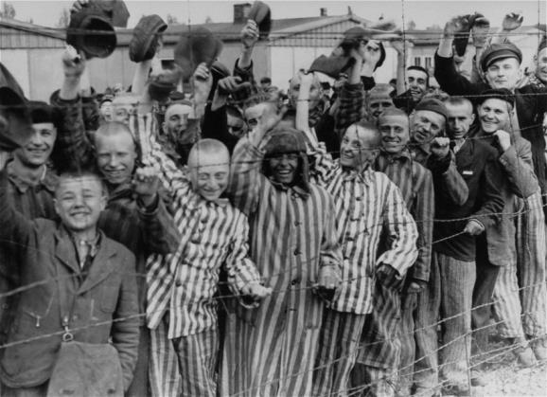 |  | Persecution of Jews and other minorities  - Hitler’s view of Jewish people:  - The Aryan race was a superior ‘Herrenvolk’ (master race) that was blonde, fair-skinned and physically fit.  - Lesser races included the ‘Untermenschen’ (Slavs of Eastern Europe and ‘sub-human’ people in Africa) and those classed as ‘Lebensunwert’ (unworthy of life), e.g. Jews and Gypsies.
Dachau survivors cheer the approaching US troops, 1945

1933  Increased anti-Semitic propaganda  - This included images of stereotypical facial features and reasons to hate Jews. They were shown as ‘vermin’ and ‘filth’.  - These were included in newspapers (especially Der Stürmer), posters, films (e.g. The Eternal Jew) and through schools. | 1939  Forced emigration  - Jews were evicted from their homes and collected for deportation.  - This was overseen by the Reich Office for Emigration, led by Heydrich.  - Not many Jewish people could afford to emigrate, and many had nowhere to go, so progress was slow. | Start of 1938  - Jews had to register all possessions. This made it easier for the government to confiscate them.  - Jews had to carry identity cards and use the name ‘Israel’ or ‘Sarah’. A red ‘J’ (for ‘Jude’ – ‘Jew’) was placed on passports and identity documents.
1939  Ghettos  - Jews were rounded up and put into ghettos. These were sections of cities with walls built around them where conditions were extremely harsh. | September 1935  Nuremberg Laws  - The Reich Law on Citizenship meant Jews were no longer German citizens.  - They could no longer be assisted by the police, vote, or hold a German passport. They had to wear a yellow Star of David.  - The Reich Law for the Protection of German Blood and Honour forbade marriage between Jews and non-Jewish Germans. | 1933  - Jews were banned from government jobs, inheriting land and serving in the army. Jewish civil servants and teachers were sacked.  - The Nazis encouraged people to boycott Jewish businesses.
1938  9−10 November: Kristallnacht  - Gangs smashed and burned Jewish property and attacked Jews.  - 814 shops, 171 homes and 191 synagogues were destroyed. Goebbels said Jews had ‘brought it on themselves’.  - Jews were fined one billion marks to pay for the damages.  - By 12 November 1938, 20,000 Jews had been sent to concentration camps. | 1934  Laws discriminating against Jews  - Jews were not allowed to be doctors or lawyers.  - Jews were not allowed to sit on some park benches or use some swimming pools.  - Young people were encouraged to hate Jews in school textbooks. | 1939  Einsatzgruppen  - The Einsatzgruppen were murder groups. These squads followed the advancing German armies and rounded up all the Jews.  - They were taken into the countryside and woods where they were forced to dig their own graves before being shot.
1941
The Final Solution
- Death camps were created to carry out the systematic murder of Jewish people.
- They were sent to these camps to be killed. Some were worked to death, others were shot or gassed.

- Task 1 | Create a timeline of the Jewish persecution in the period 1933−45.

- Task 2 | Match the keywords to their definitions.

Euthanasia |  | hatred of or policies against the Jews
Anti-Semitism |  | tall, blonde hair, blue eyes, North European looks
Aryan |  | members of what the Nazis thought of as an ‘underclass’ such as Jews or Slavs
Subhuman/Untermenschen |  | act of killing someone to relieve suffering

- Task 3 | Give evidence and examples of Hitler’s persecution of the following groups.

 | Evidence | Explanation
Jews
Disabled people
‘Asocials’

Propaganda, censorship and culture
Repression and persecution were a large part of how the Nazis kept control of Germany.
Equally important, however, was their success in persuading people to support the regime. They did this through propaganda and censorship.

Propaganda
The Minister of People’s Enlightenment and Propaganda from 1933 was Joseph Goebbels. He was in charge of spreading key Nazi beliefs, such as anti-Semitism and hatred of the Treaty of Versailles, by using the following strategies:

- Press  Why: High readership levels  Propaganda:  - Goebbels organised daily press briefings to ensure all articles were pro-Nazi.  - Nazi newspapers, e.g. Der Stürmer.  Censorship:  - An Editor’s Law meant all articles published were the responsibility of the editor.  - There was no free press.  - Anti-Nazi newspapers were closed down – 1,600 in 1935 alone. | Sum it up in five words/pictures
- Radio  Why: Mass audience, national  Propaganda:  - In all public places, as well as homes, offices, factories, schools, and street corners through loudspeakers.  - Nazi speeches broadcast daily.  - ‘People’s receivers’ – cheap radios all people could afford to buy. By 1939, 70% of German homes had a radio.  Censorship:  - All radio stations were put under Nazi control.  - All radios were designed to have a limited range, so they could not pick up foreign stations. | Sum it up in five words/pictures
- Mass rallies  Why: Created an almost religious atmosphere − exciting, colourful  Propaganda:  - Made the Nazis and Germany look strong and created a feeling of unity.  - Rallies were often led by SA and Hitler Youth groups.  - E.g. at the Nuremberg rally of 1934, swastikas, a giant eagle, 130 anti-aircraft searchlights, 20,000 flags and 200,000 waving party supporters were all on display. | Sum it up in five words/pictures

- Sport  Why: To ‘nazify’ sport  Propaganda:  - Sports stadiums displayed swastikas.  - Nazi salute during national anthem.  - Victories seen as evidence of Germany’s strength and superiority.  - E.g., at the 1936 Berlin Olympic Games, 49 visiting countries watched the German showcase. It was the biggest Olympic stadium ever, seating 110,000 people and was covered in swastikas and Nazi symbols. Germany won 33 gold medals.  Censorship:  - The Reich Press Chamber did not allow the press to publish anything that wasn’t approved. | Sum it up in five words/pictures
- Posters  Why: Visual, communicates key messages and ideas, easy to distribute.  Propaganda:  - Displayed all across Germany – streets, cafes, libraries, schools.  - Included anti-Semitic and anti-communist messages.  - Advertised and raised the profile of various Nazi initiatives, e.g. Hitler Youth, 1936 Berlin Olympics. | Sum it up in five words/pictures

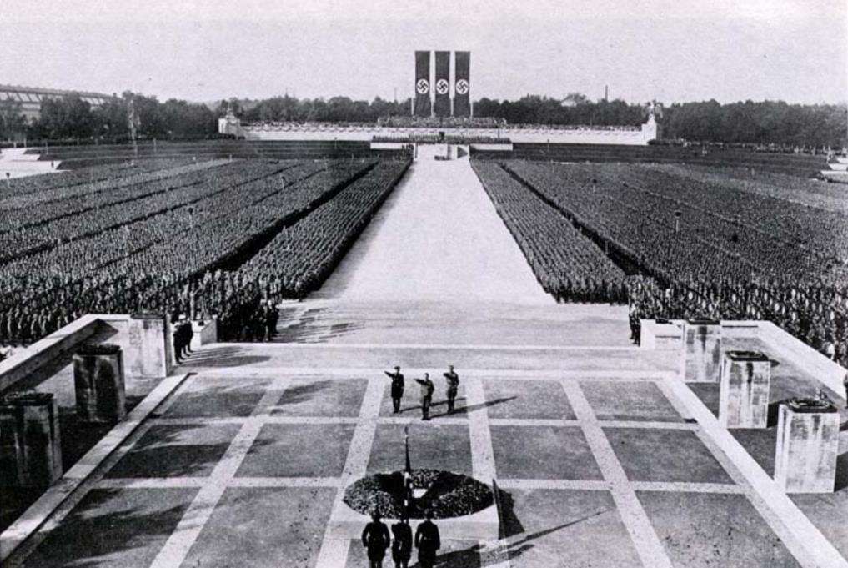

A Nazi party rally, 1934

Nazi culture
The Reich Ministry of Culture was set up in 1933. It was in charge of art, architecture, literature, music, theatre and film. It promoted culture which benefitted the Nazis.
- Task | Read and annotate the boxes with further examples from your studies.

- Literature  The party wanted to prevent the spread of anti-Nazi beliefs and promote Nazi ideals instead.  Censorship:  - No new books could be published without approval from the Chamber of Culture.  - Existing books were censored and controlled.  - In 1933 there was a book-burning of Jewish and communist books (around 20,000 books were destroyed.) This was highly symbolic. |  |  |  |  | 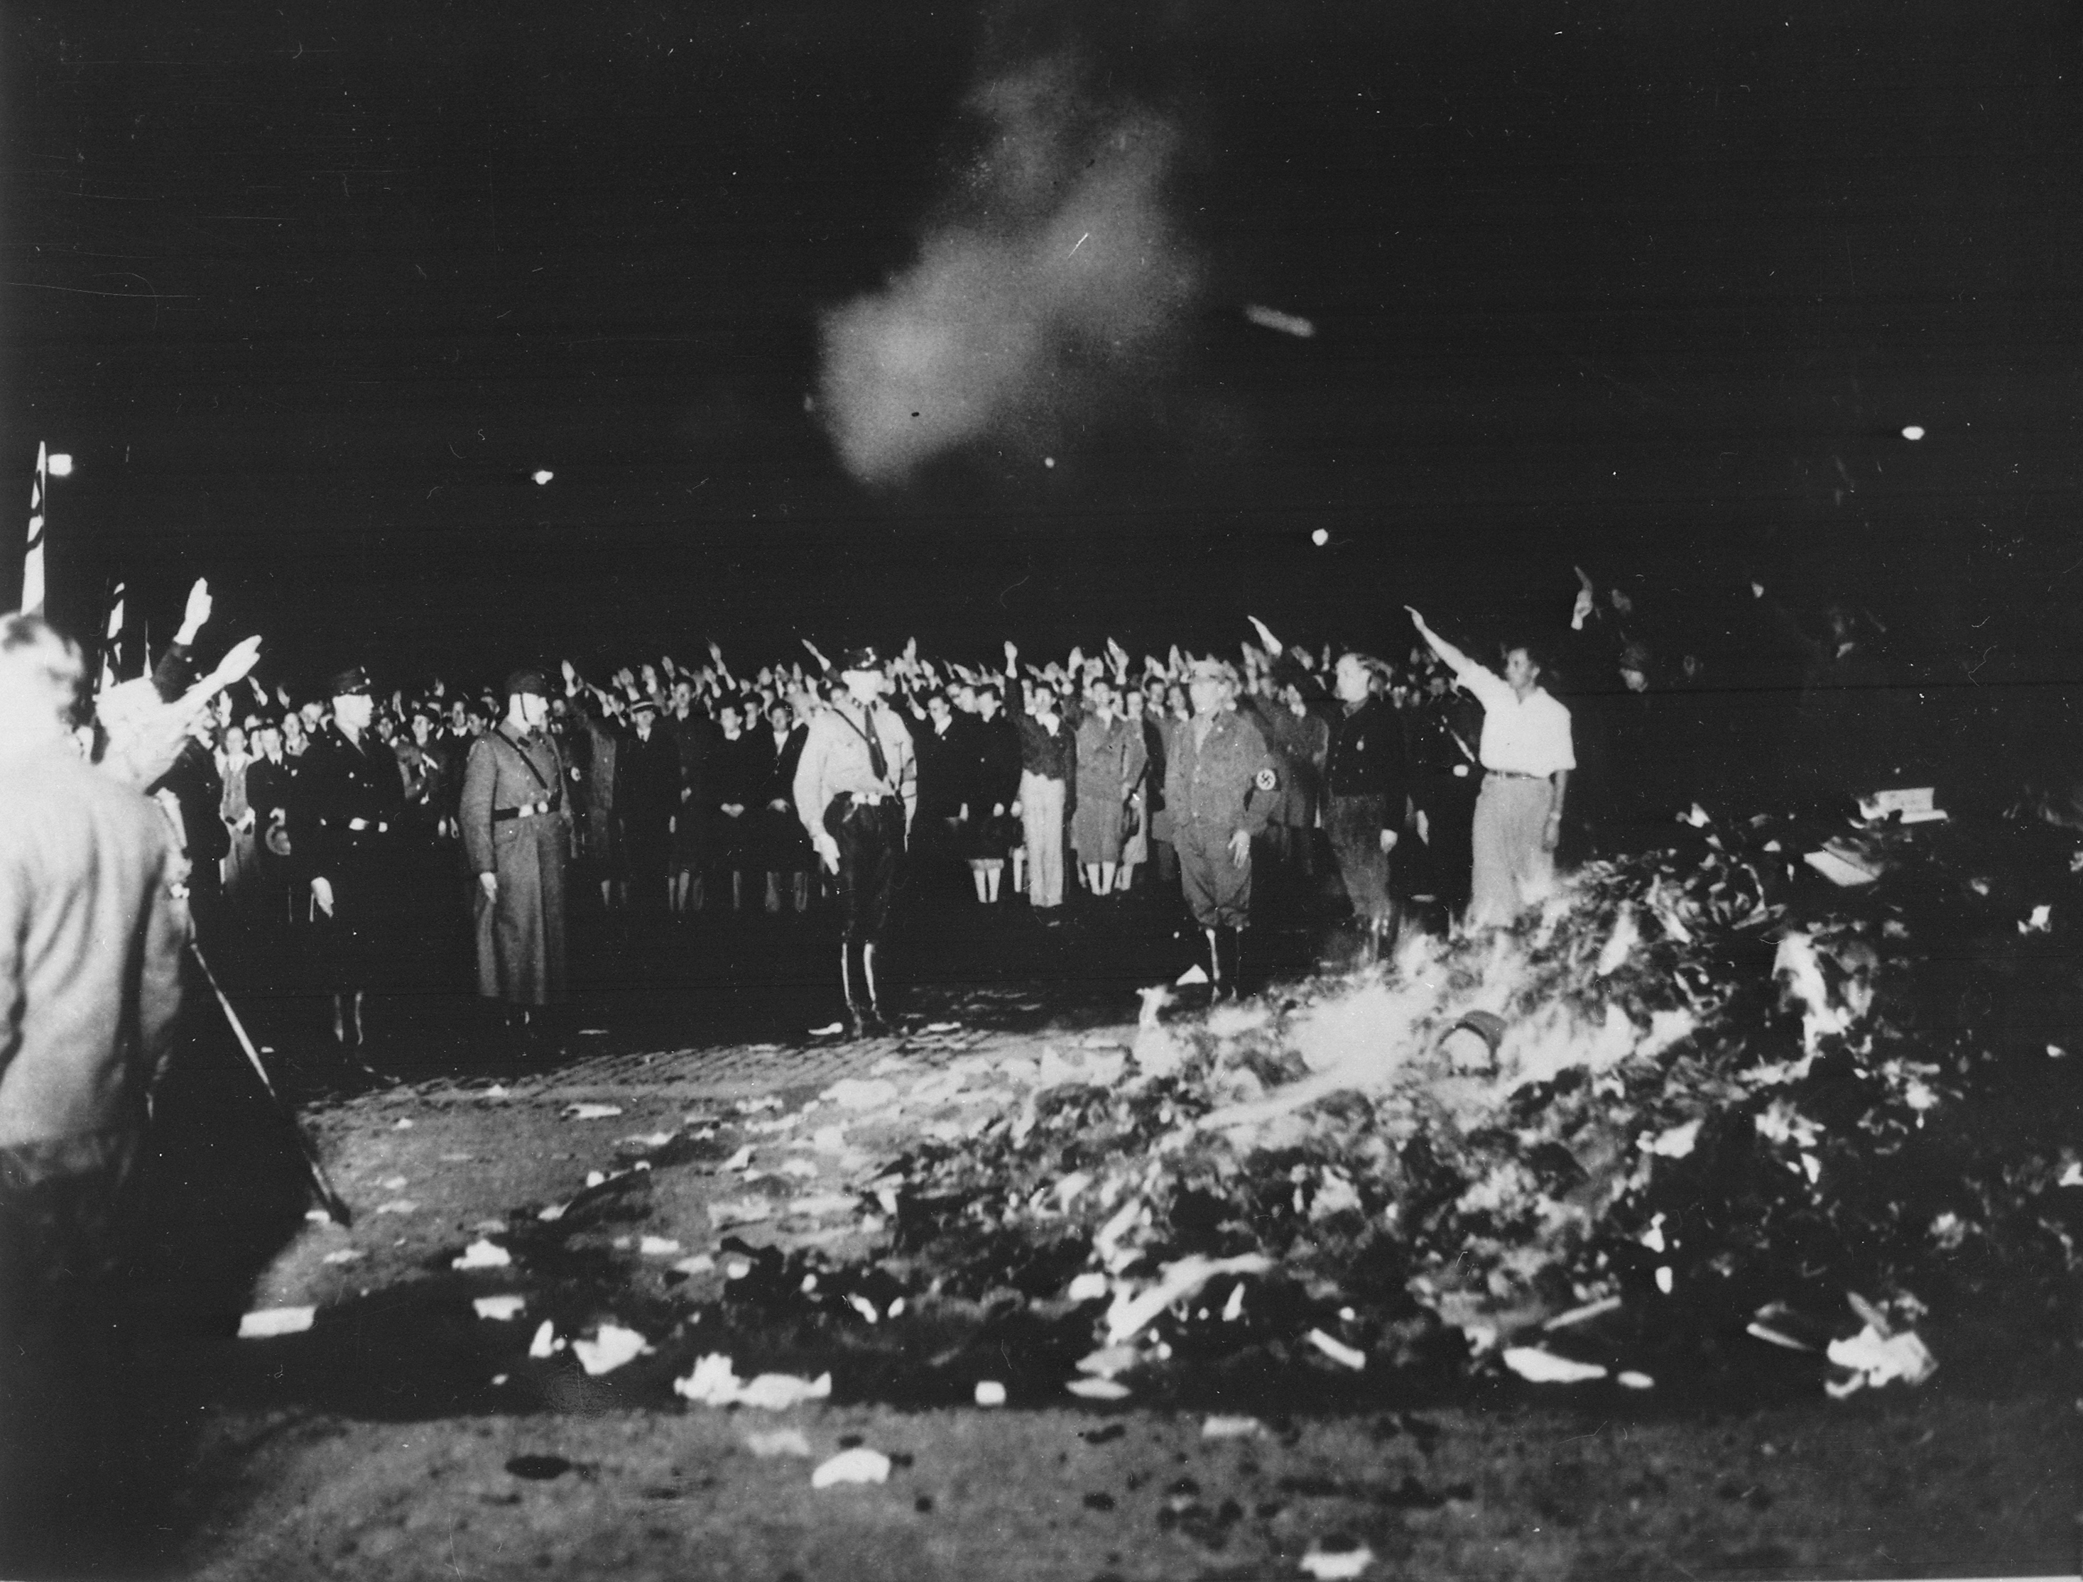
 |  |  |  |  | ‘Non-German’ books being burned in Berlin, May 1933
Culture
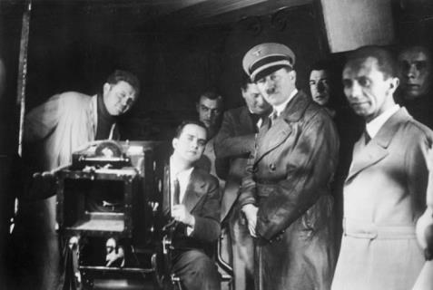 |  |  | - Cinema  The Nazis capitalised on a very popular pastime – audiences could reach 250 million in 1933.  Propaganda:  - Each film would begin with an official newsreel.  - Films had political messages (e.g. The Eternal Jew was anti-Semitic).  - 100 films were made each year.  Censorship:  - Anti-Nazi films were banned.
Hitler and Goebbels visiting film studios in 1935

- Music  The Nazi Party wanted to control the performance and composition of music.  Propaganda:  - Classical music by composers like Wagner and Beethoven, and traditional folk music, were favoured. Jewish composers like Medelssohn were condemned by the Nazis.  Censorship:  - Jazz music was not allowed. | - Art  All artists and writers were only allowed to produce pro-Nazi art.  Modern, Weimar-era culture and art were removed from galleries and traditional art pieces such as landscapes of the countryside and conventional portraits were restored.  Censorship:  - All painters and sculptors had to submit their work for approval by the Reich Chamber of Art. If you were not approved, you could not produce art (e.g. Jewish artists were banned from working).  - Artists they disapproved of had their work removed, e.g. Picasso’s paintings.
Culture
- Architecture  The Nazis wanted classical buildings and to remove modern architecture such as the Weimar-era Bauhaus designs.  Propaganda:  - Albert Speer (architect) designed the parade ground for Nazi rallies in Nuremberg. |  |  | 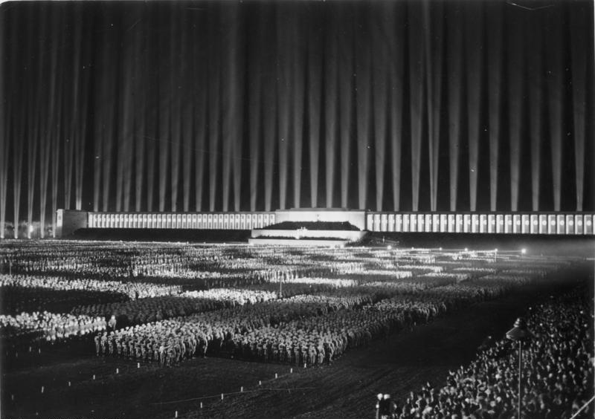
 |  |  | ‘Cathedral of Light’ used at Nazi party rallies

Opposition to the Nazis
- The White Rose group were Munich University students who secretly distributed anti-Nazi pamphlets. Their leaders, siblings Sophie and Hans Scholl, were captured and executed in 1943.  - Edelweiss Pirates were young people who rejected Nazi values and discipline, drank alcohol and danced to jazz. They wrote anti-Nazi songs and slogans and would attack Hitler Youth.  - Swing Youth groups admired American culture, clothing, music and leisure pursuits. They listened to swing bands and jazz. They drank alcohol and smoked.  Opposition from young people  - The July Bomb Plot of 1944 was an attempt by senior army officer Colonel Claus von Stauffenberg to kill Hitler using a hidden bomb. The bomb exploded and four people were killed, though Hitler suffered only minor injuries. Around 5,000 people were arrested on suspicion of involvement in the plot.  - The Kreisau Circle was made up of right-wing academics, officers and wealthy landowners. They met in secret and were highly critical of the Nazi regime.  Resistance from conservatives and the military | - The Protestant Confessional Church was led by Martin Niemöller. He encouraged other Protestant pastors to reject the Reich Church. Niemöller was held in a concentration camp during the period 1937–45.  Religious opposition
 |  | 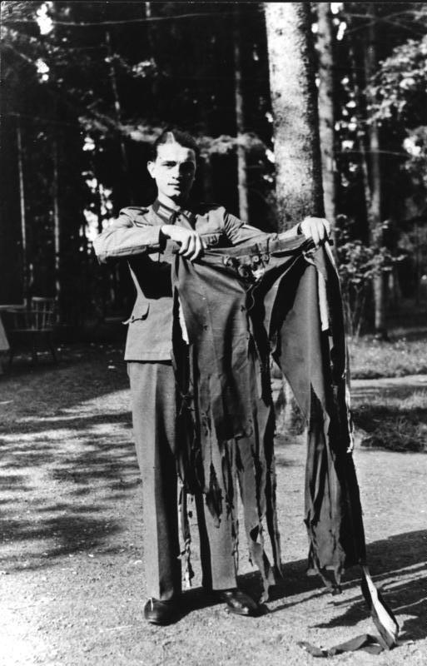
 |  | Hitlers trowsers after the assassination attempt known as the July Bomb plot

- Task | Place each of these groups on the axes below.

Non-violent
Violent
Active
Passive

How did WWII impact upon Germany?
- From 1939, Germans experienced rationing due to food and clothing shortages during WWII (due in part to self-sufficiency measures). A week’s rations for one person included just 2 kg bread, 250 g of meat and 60 g cheese. | - In 1944, a greater focus was put on the war effort. All ‘additional’ services, including entertainment, were closed.
- Self-sufficiency (autarky) meant that imports were cut, which caused shortages. | - In the first few years of war (1939−41), the Germans benefitted from gaining luxury goods from occupied countries such as France and Holland.
- Steel was rationed. This affected the amount of consumer goods available such as tinned food and razor blades. | - The British RAF carried out bombing raids in Germany. In 1942, they began to bomb towns and cities (civilian attacks). Places such as Dresden experienced heavy bombing, causing damage to buildings and loss of life.
- During WWII, Germans had to take in evacuees, further adding to shortages that people experienced as bombing already caused damage to housing. | - Rearmament meant more jobs in other industries. The need for uniforms and weapons meant that jobs were created in armament factories and it helped to provide more work for coal mines, steel factories and construction workers.
- By the end of WWII, a black market had emerged due to shortages and inflation. | - After 1941, Germans experienced increased hardship due to the war. This included working longer hours.
- Rationing was introduced in 1939. This meant that two out of five Germans were healthier than they had been before. | - When Germany invaded countries such as Czechoslovakia and Poland, they were able to take goods from those countries and distribute them amongst the German population.

- Task | Decide whether each of the effects of the war described above was positive or negative and arrange them into the table below.

Positive impact | Negative impact
Overall: How did WWII impact upon Germans?

Exam skills
In the exam, you will be asked six questions, worth 40 marks in total. They will look similar to this:
Question | Marks | Assessment objective | Approx. time to spend on this question
How do the interpretations differ …? | 4 marks | AO4 | 5 minutes
Why do the interpretations differ? | 4 marks | AO4 | 5 minutes
How convincing are the interpretations? | 8 marks | A04 | 10 minutes
Describe … | 4 marks | AO1 | 5 minutes
In what ways … Explain your answer | 8 marks | AO1 and 2 | 10 minutes
Essay question with bullet points | 12 marks | AO1 and 2 | 15 minutes

Example questions
Question type 1 | How do the interpretations differ …? (4 marks, 5 minutes)

Interpretation A  Henrik Metelmann in his book called ‘Through Hell for Hitler’, published in 1970.  Metelmann was a member of the Hitler Youth in the 1930s and he is referring to his experiences in this extract. | Interpretation B  Inge Scholl in her book called ‘Students Against Tyranny’ published in 1952.  Inge Scholl’s brother Hans and her sister Sophie were members of the White Rose group. They were arrested and executed by the Nazi police state in 1943. Inge is referring to what happened when Hans returned from a Hitler Youth rally in the 1930s.
At the time, it was smashing. When we went on our marches the police stopped the traffic and passers-by had to give the Nazi salute. We were poor and suddenly had fine uniforms. I’d never been on holiday; now they were taking us to camp by lakes and mountains.  I am ashamed to say now that, to us, Hitler was the greatest human being in the world. At rallies we couldn’t hear what he was saying – but we all screamed anyway. When war came I was so excited. I thought, ‘Now, I can show the Fuhrer what I’m made of’. | We could not believe it. I remember that the leaders had told Hans that his songs were not allowed. Why should he be forbidden to sing those songs just because they had been created by other races? Then came the racial legislation and our Jewish classmates had to leave school.  We were living in a society then, where hate and lies had become normal. No one was safe from arrest for the slightest unguarded remark, and some disappeared forever for no good reason. Unseen ears seemed to be listening to everything that was spoken in Germany.

- Spotlight | AO4 Interpretations  - Interpretations are a person’s view of something, at least five years after the event.  - They will often differ, despite exploring the same event, person or development. This is because they will have a different focus, emphasis or will have consulted different sources.  - You will be given two interpretations, between 50 and 100 words each

Question 1 tips!
- You only need to give one difference, but you must refer to what both of the sources say in order to explain your answer.
- You will need to say how they differ, why they differ and if they are ‘convincing’.
Ways that interpretations can differ:
- Information that they choose to include about an event.
- Tone/view that the interpretations have, e.g. positive or negative.

Tasks | Read interpretations 1 and 2 and highlight parts of the interpretations where you spot a difference.  Then have a go at answering this question:  How does Interpretation B differ from Interpretation A about life for young people in Nazi Germany?  Explain your answer based on what it says in Interpretations A and B.

Q1 success criteria | Completed?
State the difference that you can spot between them.
Quote the parts of the interpretations that contrast with each other.

Question type 2 | Why might the authors have a different interpretation about …? (4 marks, 5 minutes)

Question 2 tips!
Reasons that interpretations can differ:
- The motivations of the author – why do you think they wrote this account?
- When, where and in what circumstances was the author writing? How might this have affected their view?
- Intended audience – who might they have been writing for?

Tasks | Complete the table below then have a go at answering this question:  Why might the authors of Interpretations A and B have a different interpretation about life for young people in Nazi Germany?  Explain your answer using Interpretations A and B and your contextual knowledge.  (4 marks)

 | Interpretation 1 | Interpretation 2
Who wrote it?
What do you know about the author?
When was is written? What circumstances/experiences affected the author?
Who was the intended audience/ reader?

Q2 success criteria | Completed?
Consider who the author is, when they were writing/speaking and their intended reader/audience.
There is no need to repeat what is different about the interpretations. Focus on why.
Its good to speculate! You might not be certain why the authors differ, but you can suggest possible reasons using phrases such as ‘may have’, ‘perhaps’ and ‘might be’.

Question type 3 | Which interpretation gives the more convincing opinion about … ? (8 marks, 10 minutes)

Question 3 tips!
- This time, you need to address the events/issues that are given in the question and decide which interpretation you think fits best with what you know about the history of the event/issue
- Which do you find the most convincing in light of what you know?
- Take one interpretation at a time to assess. Summarise what the interpretation is arguing then explain how convincing you find the argument, using two to three pieces of evidence.

Tasks | Read interpretations 1 and 2 and highlight parts of the interpretations that you consider to be either convincing or not convincing. Complete the grid below then answer the following question:  Which interpretation gives the more convincing opinion about life for young people in Nazi Germany?  Explain your answer based on your contextual knowledge and what is says in Interpretations A and B. (8 marks)

Summarise interpretation A | Interpretation quote | Own knowledge to support or challenge the interpretation | Explanation

Summarise interpretation B | Interpretation quote | Own knowledge to support or challenge the interpretation | Explanation

Which of the two is the more convincing?

Q3 success criteria | Completed?
Summarise what the interpretation is arguing.
Quote the part of interpretation that you want to explore.
Support or challenge what the interpretation is arguing, using specific own knowledge.
Explain how convincing you find it as a result.
Repeat for the second interpretation.
Judge which of the two is the more convincing and why. Your judgement could be based on:
- the emphasis or focus of the interpretations
- their typicality (do they support/contradict other views you may have studied )
- their range/comprehensiveness (how well do they cover the issue in the question),
- their accuracy about the issue in the question.

Question type 4 | Describe … (4 marks, 5 minutes)

Tips!
- Describe two key features of the topic topic in question.
- Each feature should be two or three lines long.
- You need to make sure that your own knowledge is specific and that you have a range of knowledge (two or three pieces of precise and detailed own knowledge)

- Spotlight | AO1 Knowledge and understanding  - This is your ability to recall and apply a range and depth of factual knowledge of Germany’s history during this period.  - Try to use two or three pieces of your own knowledge each time you approach a question with AO1 tested in it.
AO2 Explanation and analysis
- This is your ability to communicate and explain Germany’s history using different second-order concepts such as description, causation, consequence, and change and continuity.

Q4 Example response
Describe two terms of the Treaty of Versailles. (4 marks)
States the feature being described | One key feature of the terms of the Treaty of Versailles was the territorial losses. For example, Germany lost Alsace and Lorraine to France, they lost the Saar coalfields for 15 years to France, and East Prussia was cut off from Germany due to the Polish corridor. Therefore, they lost a significant amount of land.  A second key feature of the Treaty of Versailles were the military restrictions. For example, the German army was limited to 100,000 men, the navy to 15,000 men and they weren’t allowed an air force. Therefore their armed forces were restricted and they felt vulnerable. | Briefly explains the feature
Provides three pieces of specific evidence – it has names and numbers |  | States the feature being described
Provides three pieces of specific evidence – it has names and numbers |  | Briefly explains the feature

Task | What is good about this response and why?  Can you improve the response using the success criteria below?

Q4 success criteria | Completed?
You have read the question carefully and identified the event or development that you need to describe.
You have stated the feature you are describing in the first sentence.
You have supported this with two or three pieces of evidence.
You have made sure that this evidence is specific – e.g. key terms, dates, statistics and names.
You have concluded the description with a short (one-line) explanation of the development or event.
Repeat for a second aspect of the development or event.

More Q4 practice questions
Describe two political threats that the Weimar government faced during 1919−23. (4 marks)

Example response
One of the political threats that the Weimar government faced was the Sparticist Uprising. For example, Luxemburg and Liebknecht led 100,000 demonstrators and took over key buildings like newspapers, so the government used the Freikorps to end it. Therefore, this was a left-wing communist threat to the government.
A second key political threat that the Weimar government faced was the Kapp Putsch. For example, there were demonstrators and they rebelled and wanted change. Therefore, this was a threat.
Task 1 | Annotate the first paragraph of the answer above, like the example on p. 63. Where does the answer meet the success criteria?
Task 2 | Annotate the second paragraph. What is missing?
Task 3 | Rewrite an improved version of the second paragraph.
Describe two weaknesses of the Weimar government constitution. (4 marks)

Example response
One weakness of the Weimar government was Article 48. For example, in times of emergency the president could bypass the Reichstag to pass laws, rule directly and use the army to do this. Therefore, many lost faith in democracy.
Task 1 | Where does the answer hit the success criteria on the previous page? Can you improve it?
Task 2 | Write about the second feature.
Task 3 | Annotate it with where you are meeting the criteria.
Describe two ways the Nazis persecuted Jewish people. (4 marks)
Feature to describe |  | Own knowledge to support point | Brief explanation

Describe two economic and social problems of the period 1900−1914. (4 marks)
Feature to describe | Own knowledge to support point | Brief explanation
Describe two features of Hitler’s rise to power. (4 marks)

Feature to describe | Own knowledge to support point | Brief explanation

Describe two economic threats that the Weimar government faced during 1919−23. (4 marks)
Describe two measures that Stresemann introduced to reform Germany during 1923−29. (4 marks)

Question type 5 | In what ways … (8 marks, 10 minutes)

Question 5 tips!
- Explain change and/or continuity in two or three ‘Point, evidence, explain’ chains.
- 4 marks will be awarded for the quality of your AO1 knowledge and understanding.
- 4 marks will be awarded for the quality of your explanation of how a group or development was changed/affected by the event/development given in the question.

Example plan and response
In what ways were the lives of German people affected by World War One? Explain your answer. (8 marks)
Plan
- Economic impact – nearly bankrupted
- Social/political impact – divisions emerged
Response
WWI had a huge impact on Germany, affecting people’s lives in many different ways. Firstly, the German economy was nearly bankrupted. Industrial production fell to two-thirds of the 1913 level and German factories were exhausted by the war. They had been focused on producing military goods rather than products that could be used in peacetime. This meant that there were terrible shortanges of food, medicine and clothing which affected the poorest members of society most significantly.
The economic hardship caused by the war led to social divisions.Whilst a few factory owners had made massive profits during the war, workers now found themselves in a desperate situation, many surviving on only bread and turnips. Germany before the war had been wealthy and stable – now, many workers began to turn to the political extremes. There was a navy mutiny in Kiel and the threat of revolution at home. Overall, by the end of the war, Germany was politically and economically unstable.
Task | Highlight the response to show how it meets the success criteria below. Can you improve it?
Q5 success criteria |  | Completed?
This question focuses on change. Read the question carefully and identify the change that you need to explain.
Before you start, bullet-point two ways that people’s lives were affected by the issue in the question.
State each impact that you are explaining clearly in a new paragraph.
Explain each change using two or three pieces of evidence. Make sure the evidence is specific – key terms, dates, statistics and names.
Repeat! Explain a second change, supporting it with specific evidence.
Remember that changes affect people differently. To show that you understand this complexity you could explain how the impact varied (e.g. on men/women, younger/older, richer/poorer, people in different locations and at different times across the period in focus).

More Q5 practice questions

In what ways were the lives of children and young people affected by Nazi policies? Explain your answer. (8 marks)
Task | Complete the table below to plan an answer to this question.
Change |  | Own knowledge to support point | Explanation of the change. Did it affect different groups in different ways?

In what ways were the lives of Germanys affected by the Depression? Explain your answer. (8marks)
Task | Complete the table below to plan an answer to this question.
Change |  | Own knowledge to support point | Explanation of the change. Did it affect different groups in different ways?

In what ways were the lives of women in Germany affected by Nazi social policies?
Task | Complete the table below to plan an answer to this question.
Change |  | Own knowledge to support point | Explanation of the change. Did it affect different groups in different ways?

Question type 6 | The ‘bullet-point’ question. (12 marks, 15 minutes)

Tips!
- Your answer will look at cause, consequence or change and continuity. Two bullet points will be given for you to assess. You need to explain each bullet point in a paragraph and follow this with an overall judgement.
- 6 marks will be awarded for the quality of your AO1 knowledge and understanding.
- 6 marks will be awarded for the quality of your explanation of how a group or development was changed/affected by the event/development given in the question.

Q6 Example response
Which of the following was the more important reason Germany recovered under Stresemann?
- Economic reforms
- Foreign relations
Explain your answer with reference to both reasons. (12 marks)

States the bullet point being explained in a clear point | The most important reason why Germany recovered under Stresemann was economic reforms he introduced from 1923. For example, he ended passive resistance and introduced a new currency the Reichsmark, he secured the Dawes Plan which led to $25 billion worth of loans from the US banks to German industries and the Young Plan which reduced reparations to $2 billion. This therefore helped Germany to recover as foreign countries were now willing to trade with Germany as the new currency was more stable, the Dawes Plan loans were used to fund factories, buy new machinery and help production restart which trebled during this time and the lower reparations amount also helped them to focus on their industry. This is the most important reason why the economy recovered as it reduced unemployment and improved German trade, an impact that was felt by more people than foreign relations policies. As a result of the economy improving, this led to culture flourishing such as jazz clubs.  The less important reason why Germany recovered under Stresemann was due to the foreign policies that he introduced. For example, he ended passive resistance in the Ruhr to improve relations with France, signed the Locarno Treaty which agreed the 1919 borders and it joined the League of Nations in 1926. This therefore led to German recovery as not only was conflict ended with France in the Ruhr, which allowed factories to start producing goods again, but also it helped to repair Germany’s international relations and be seen as an equal rather than a defeated power. This is the less important reason as whilst it meant that Germany was involved in international agreements, it did directly improve things like culture and the film industry. However, as a result of improved relations, it did mean other countries were willing to make agreements such as the Dawes Plan and the Young Plan.  Overall, the main reason why Germany recovered was due to the economic reforms introduced as it kick-started Germany industry and trade with foreign countries increased, reducing unemployment. Linked to this, the improvement in foreign relations helped to secure those loans which funded the development of culture in areas such as film. | Provides three pieces of specific evidence
Explains in a developed way
 |  | Assesses importance and role in later events
States the bullet point being explained in a clear point |  | Provides three pieces of specific evidence
Explains in a developed way |  | Assesses importance and role in later events
Judges main reason and explains this |  | Assesses the contribution of the other reasons

Mark:
What went well (WWW):
Even better if (EBI):

Q6 Conclusion practice
Task | Which of the following was the more important reason Hitler was able to control society?  - The police state  - Policies towards the Churches  Explain your answer with reference to both reasons. (12 marks)
Task | Read the conclusions below and use the success criteria to explain which is better and why.

Answer A | Answer B
Overall, the main reason why Hitler was able to control society was due to the police state as it created a climate of fear which made people obey Nazi orders and laws, and it also allowed them to identify and arrest opponents. Linked to this, the policies towards the Church also led to control as he was able to reduce the influence of the Church in education and the Concordat meant he could buy time to grow his police state, before using it to arrest priests. | Overall, the main reason why Hitler was able to control society was due to the police state as he controlled people. Controlling people is good as it helps to make sure they are listening and doing what you want and that’s good for control. I personally think that it is wrong and it was bad.
What is good about this conclusion? | What are the problems with this conclusion?

Q6 Improve the paragraph
Which of the following was the more important reason support for the Nazis grew during 1928−32?
- Farmers
- Propaganda
Explain your answer with reference to both reasons. (12 marks)

Paragraph structure
Point – factor stated and first line of argument using words from question
Evidence − specific
Explanation – linked to question
Assess its importance and role in later events
Overall judgement

Task 1 | Fill in the gaps to improve the answer
The most important reason why support grew for the Nazis was due to the growth in support from the farmers. For example, the farmers made up of the voters so Hitler promised them
(living space) and introduced the idea of ‘ ‘ where
he told the farmers they were Aryans and the master race, giving them a sense of importance. This therefore led to greater support as the farmers had suffered during 1923−29 and felt that the
hadn’t supported them, so were attracted to a party promising to improve agriculture and protect them from the threat of . This is the most important reason because
. As a result

Task 2 | Why is the paragraph better now that you have filled the gaps?

Q6 planning practice
Which of the following was the more important reason Hitler was able to become chancellor in 1932?
- Hitler’s oratorical skills
- Scheming of von Papen and Hindenburg
Explain your answer with reference to both reasons. (12 marks)

Event or development (bullet points) | Point | Evidence to support point | Explanation | Judge and link to other factors
Hitler’s oratorical skills
Scheming of von Papen and Hindenburg
Conclusion

Q6 checklist
Q6 success criteria | Completed?
You have read the question carefully and identified the event or development that you need to assess.
Before you start, you have jotted down two or three pieces of evidence that you will use for each factor.
You have stated the factor/bullet point that you are explaining in the first sentence of a paragraph.
You have supported your explanation of each bullet point with two or three pieces of specific evidence.
You have concluded the paragraph with a judgement of the factor’s importance and how it connected to other factors/events.
You have repeated the process for the second bullet point. Top answers must consider both factors.
You have reached an overall judgement about which is the most important bullet point, for the issue in the question. You could do this by looking at the connection or relationship between the two bullet points.
You have checked your answer for accuracy.

Image and extract attributions
© By Bundesarchiv, Bild 102-00344A / Heinrich Hoffmann / CC-BY-SA 3.0, CC BY-SA 3.0 de, https://commons.wikimedia.org/w/index.php?curid=5478829

© By Bundesarchiv, Bild 102-00104 / Pahl, Georg / CC-BY-SA 3.0, CC BY-SA 3.0 de, https://commons.wikimedia.org/w/index.php?curid=5414025

© By Bundesarchiv, Bild 102-15282A / Georg Pahl / CC-BY-SA 3.0, CC BY-SA 3.0 de, https://commons.wikimedia.org/w/index.php?curid=12685396

©By Bundesarchiv, Bild 183-R27373 / CC-BY-SA 3.0, CC BY-SA 3.0 de, https://commons.wikimedia.org/w/index.php?curid=5436396

© By Bundesarchiv, Bild 146-1973-010-31 / CC-BY-SA 3.0, CC BY-SA 3.0 de, https://commons.wikimedia.org/w/index.php?curid=5418949

© By Bundesarchiv, Bild 146-1974-121-28A / CC-BY-SA 3.0, CC BY-SA 3.0 de, https://commons.wikimedia.org/w/index.php?curid=5418980

© By Bundesarchiv, Bild 146-1978-013-10 / CC-BY-SA 3.0, CC BY-SA 3.0 de, https://commons.wikimedia.org/w/index.php?curid=58322805

©By Bundesarchiv, Bild 146-1978-013-07 / CC-BY-SA 3.0, CC BY-SA 3.0 de, https://commons.wikimedia.org/w/index.php?curid=58322753

© By Bundesarchiv, Bild 133-237 / CC-BY-SA 3.0, CC BY-SA 3.0 de, https://commons.wikimedia.org/w/index.php?curid=5416624

©By Bundesarchiv, Bild 183-H15390 / CC-BY-SA 3.0, CC BY-SA 3.0 de, https://commons.wikimedia.org/w/index.php?curid=5364011

©By Bundesarchiv, Bild 183-R97512 / Unknown / CC-BY-SA 3.0, CC BY-SA 3.0 de, https://commons.wikimedia.org/w/index.php?curid=5368800

©By Bundesarchiv, Bild 102-14597 / Georg Pahl / CC-BY-SA 3.0, CC BY-SA 3.0 de, https://commons.wikimedia.org/w/index.php?curid=5415527

©By Bundesarchiv, Bild 183-1990-1002-500 / CC-BY-SA 3.0, CC BY-SA 3.0 de, https://commons.wikimedia.org/w/index.php?curid=6138875

© By Bundesarchiv, Bild 183-1982-1130-502 / CC-BY-SA 3.0, CC BY-SA 3.0 de, https://commons.wikimedia.org/w/index.php?curid=5342072

©By Bundesarchiv, Bild 146-1972-025-64 / CC-BY-SA 3.0, CC BY-SA 3.0 de, https://commons.wikimedia.org/w/index.php?curid=5482663

©Through Hell for Hitler© Henrik Metelmann 1990, Reproduced with permission from The History Press

©Excerpt (less than one page) from Students Against Tyranny: The Resistance of the White
Rose, Munich, 1942-1943 by Inge Scholl, trans. Arthur Schultz, © 1970 by Inge Aicher-Scholl.
Reprinted by permission of Wesleyan University Press.

