School name
Drama workbook

Name:_____________________________________________
Class:_____________________________________________

In this workbook, you will find different exercises and tasks to help support your learning.
Some of the booklet will require you to read information and answer questions, whereas some will ask you to create images and diagrams.
Please answer all questions and complete all written tasks in pen and any diagrams and drawings in pencil.

You have been given this booklet as you are not able to participate in the practical work. Although you are not in the lesson, you will need to learn some of the information ready for your return to lessons.

Help can be found on insert school vle here

Please return to the drama department at the end of the lesson.
Date: ___________________
Drama rights and expectations.
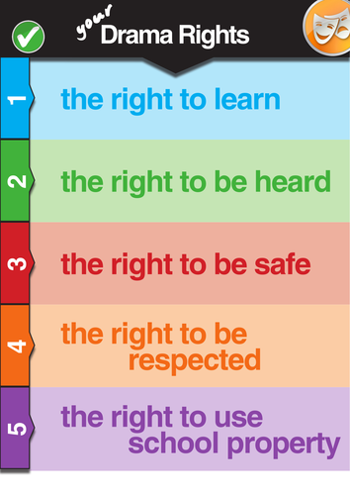
Not only are these your drama rights, but they are also the rights of everyone else in your group.

Task:
In the space below, write out a set of class expectations you could see in a drama classroom.

Eg – Sit quiet when the teacher is giving you information.

1_____________________________________________________________________________________________________
2_____________________________________________________________________________________________________
3_____________________________________________________________________________________________________
4_____________________________________________________________________________________________________
Date: _________________________
Becoming a character
In drama you are expected to think about other people’s feelings and at times you may pretend / act as they would. In order to progress in your skills, you need to ‘become’ the character. This means changing things about yourself to be the other character.

Task: - in the space below – create a spider diagram of all the things you can change about yourself in order to try and become a different character on the stage. (These usually need to be things that people can see)

Date:_______________________
Understanding your character.
In order to complete the next task, you will need to read the information below. It is all about how to create a character.
When creating a character, you will usually have given circumstances. These are pieces of information that you already know about the character. For example – Charlie Bucket is a poor child who does not have much money. This information can help you to create a character, it is also information which you cannot change.
In a scene, you can pause the action and allow your character to say their thoughts out aloud so that the audience knows what they are thinking. Thought tracking is a great way to add information to a scene, as well as allowing comedy to be inputted.
When developing your character, to help understand them further, you may use a thought tunnel. This allows others to stand on either side of you whilst you walk down the line in role. The others in the group will help you consider what your character might do in different situations.
Another way to explore your character is to hot seat them. Hot seating allows others to question your character and you then think about what your character might do or say. Another way to explore your character and get more of an understanding, is to do some writing in role. This is where you explore your role further but complete some writing as if you were them.

Task: - underline the key drama words in the above passage.
Date:_____________________
Checking your understanding.
Task: complete the word search and questions below.

Character cards improvisation role play Thought tracking voices in the head writing in role
thought tunnel hot seating

Q- What is thought tracking?
…………………………………………………………………………………………………………………………………………………………………………………………………………………………………………………………
Q – What is improvisation?
……………………………………………………………………………………………………………………………………………………………………………………………………………………………………………………….
Date:___________________
The performance space.
In the drama studio, there is a flexible performance space. Below are some diagrams of the most common performance spaces.
Task: having looked at the diagrams, consider where the audience is sat and where the actors enter and exit. Think about what people can see when they are in the audience.
Then complete the table on the next page, stating the positives and the negatives of each type of staging.

The performance space continued.
 | POSITIVES | NEGATIVES | Where you may see this stage.
Thrust stage
In the round

Traverse stage

Arena stage
Proscenium stage
Date:__________________
Different areas of the stage.
Traditionally, stages are ‘raked’. This means that they tend to be a bit higher at the back of the stage so that the audience can see everything happening, even at the back. The stage goes up, almost like a bunch of leaves being ‘raked’.
The front of the stage goes down to the audience. So the front of the stage is down and the back of the stage is up. Using the diagram below, label the different areas of the stage. Some have been done to help you get started.
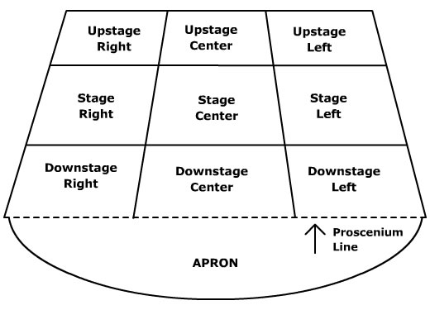

Upstage centre Stage left
Downstairs right Downstage centre
Upstage centre Upstage left

Date:______________________
Developing character.
When developing and creating a character, you can create a role on the wall. This gingerbread shape allows you to put information inside the diagram as well as around the outside.
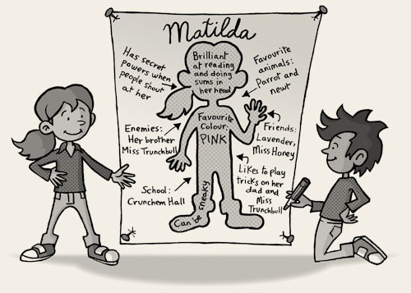
Here is a role on the wall for the character of Matilda from the Roald Dahl book.
Task: on the next page, create a role on the wall for a character of your own. It could be a character from a film, novel, or even a character you have made up.
On the outside write about how others view them – how do they come across to other people?
On the inside – write their feelings and information about them.

ROLE ON THE WALL.

Date:______________________
Character fact file.
To help you to know your character more, it is important to create a character fact file. Here you can put information about your character, which in turn helps you to show that you are thinking and behaving like a different person. Below is a character fact file.
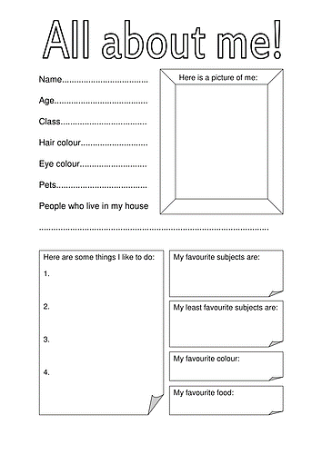
Task: try to create a character fact file for a character of your choosing. You could do one for a teenager, or even a celebrity, but whichever you choose, you need to think about it being made up.

Date:___________________
Searching for new words.

Character Traits
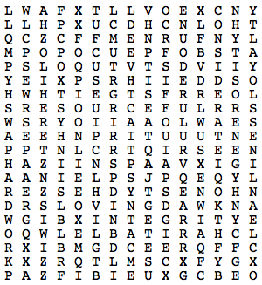

integrity discipline  honesty hardwork  respect cleanliness  charitable friendliness  persistence fairness | patriotism resourceful  generosity loyalty  cooperative considerate  thoughtful courteous  loving helpful

Date:______________________
Melodrama
Melodrama is a genre of drama and involves an over the top exaggerated performance style. The story lines are simple and involve good fighting evil (with no deaths or serious injuries) and the rescue of a damsel.
Task: thinking about the characters you are given, try to come up with the five stock characters of melodrama.

character | clue
H _ _ _ | Usually the character who rescues everyone or saves the day.
_ _ _ _ AI_ | The evil character who comes up with a plan to take over the town / rob the bank.
D_ _ _ _ _ in D_ _ _ _ _ _ _ | This character is usually a female who is kidnapped and needs to be rescued.
S_ _ _ _ _ _ _ | This person works with the evil leader and helps carry out their plans.
G_ _ D O _ _ P_RS_ _ | This person usually sees the evil person commit their crime and then reports it to the person who saves the day.

Key words:
Villain, sidekick, damsel in distress, good old person, hero.

Date:_________________________
Symbolism and costume.
In performances, often it is not possible to spend lots of money on costume, so to help with this, there is use of symbolism. Symbolism, comes from the word ‘symbol’, meaning a sign or image which is easily recognisable as something else. For example; a red light – usually means danger, a green light usually means go.
Task: complete the table below. Think about what the images shown could represent.
Image | What it could represent
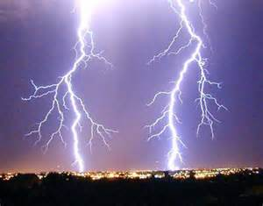
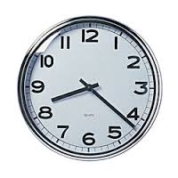

The colour blue?
The colour black?
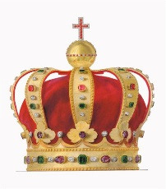

Date:__________________
Designing a costume using symbolic clothing.
Task: Using the outline below, draw on a costume and label it. If you can colour it then do so, but if you have no colours, label it stating what colour items would be and why. Make sure you label the drawing saying why you have given your character a particular clothing item. (Why not design a costume for a melodrama character?)
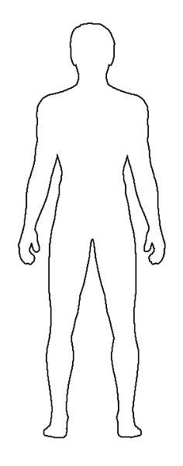
Remember to label the drawing saying why you have chosen a certain item and / or colour.

Date:___________________
Designing a story line / plot.
In Melodrama, the plot lines are usually very similar. They involve a villain plotting to commit a crime; usually bank robbery, or kidnap for ransom. When the terrible event takes place, then a witness or good old person sees this and shouts for help or goes to find the hero.
The hero is introduced to the audience and he then goes to confront the evil villain in his lair. The villain is usually shocked to see the hero and a fight occurs. In Melodrama, no-one dies, or losing limbs and there are no guns or violent injuries. The villain is usually beaten in some way, or runs away.
The hero then rescues the damsel, or retrieves the money which has been stolen and either leaves with the damsel, or returns the money to its rightful owner.
The stories are all very similar, but the villain’s names and evil plans may change. They may kidnap the hero’s sidekick instead etc.
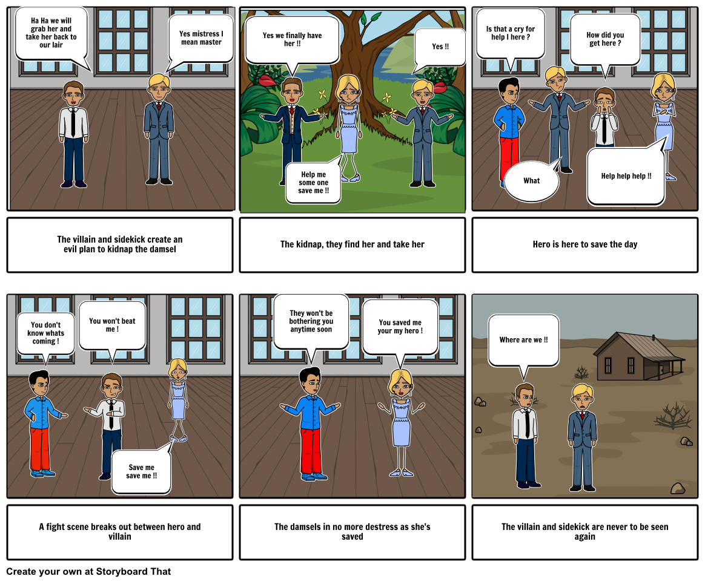
The story must follow a clear plot line and have a distinct start and end. Often, storyboards are used to help plan what the performance will be like.

Date: _____________________
Creating a storyboard.
Task: using the storyboard outline below, create your own short melodrama story. Include the information in each little box telling the performers what is happening. Draw the pictures and use the small box for wirtten information.

Date:__________________________
Exploring a script.
Task: - Read the story line below. Highlight the names of the characters. Highlight any adjectives which describe the product ‘Wacky Soap’.

Date:____________________
Selling soap!
Task: in the space below, design a poster selling Wacky Soap. Remember that it needs to include the benefits of this wonder product and encourage people to buy it. Make sure you sell the soap in a positive way rather than mentioning that it washed away parts of your body.

Date: ________________________
Tackling problems and keeping secrets.
Task: write a short script below of a scene where a parent has found some Wacky Soap hidden in their child’s bedroom. This Soap is now an illegal product and possession can result in prison, but worse than that, too much use could make body parts disappear.
Things to consider; what might the parent say? How will they say it? Will the child blame someone else? Will the parent allow the child to use the soap at all? Perhaps under supervision? What if a body part disappears? (try to add stage directions so that the performer would know how to say the lines)
_______________________________________________________________________________________________________________________________________________________________________________________________________________________________________________________________________________________________________________________________________________________________________________________________________________________________________________________________________________________________________________________________________________________________________________________________________________________________________________________________________________________________________________________________________________________________________________________________________________________________________________________________________________________________________________________________________________________________________________________________________________________________________________________________________________________________________________________________________________________________________________________________________________________________________________________________________________________________________________________________________________________________________________________________________________________________________________________________________________________________________________________________________________________________________________________________________________________________________________________________________________________________________________________________________________________________________________________________________________________________________________________________________________________________________________________________________________________________________________________________________________________________________________________________________________________________________________________________________________________________________________________________________________________________________________________________________________________________________________________________________________________________________________________________________________________________________________________________________________________________________________________________________________________________________________________________________________________________________________________________________________________________________________________________________________________________________________________________________________
Date:______________________
Designing a set.
Sets are used to help create a more believable space for the performers as well as the audience. They can come in different forms, but the most commonly used one in schools and small venues is called a composite set. The composite set, is usually a large backdrop which then is used to show lots of different areas / representations of scenes in one go. Depending upon where the actors stand, this helps to set the scene. It is usually a fixed set and as our school stage shows, it can be added to with smaller pieces of movable set.
Task: in the space below, create a design for a composite set for a performance of Wacky Soap. Think about what you want to show, there are homes, town squares, palaces, shops and many other areas you may wish to try and represent. Colour your image as well.

Front of stage.
Date:_______________________
Read all about it!
Task: Imagine that a student at school has been secretly using Wacky Soap and it has begun to wash away parts of their body! In the space below, write a short newspaper article reporting the story. Remember to use normal English writing skills when creating your work.
Use the following as a checklist to help ensure your work is a good standard.
Include | It’s there | Include | It’s there
Paragraphs throughout the work. |  | Catchy headline
Quotations from friends or relatives |  | Quotations from local police / medial officials
Commas |  | Semicolons
Statistics about the number of cases reported. ( you can make this up) |  | Quotation from King Huff about how the Soap destroyed his family.
Interesting vocabulary – adjectives and verbs |  | Adverbs
Written in past tense throughout. (he was, they were, it was) |  | Written in third person throughout. ( he/ she / they)

If you are unsure, this is all work you will have covered in English in year 7 and 8. Or you can use FROG to help you out.

Date:_________________
Voice / language.
Task: read through the passage and underline the key words. Then have a go at completing the word search about Language and Voice.
When speaking lines, often, we are told “it’s not what you say, it’s the way that you say it!” (Usually this is when we are getting told off at home! you know, when you say sorry and then get told off again?) If you put emphasis on certain words, this is known as intonation. It means that in a sentence, you might say
“Sit down and be quiet” but you place emphasis on the quiet. It helps to put stress on the word “quiet” and keep people’s focus on this.
Another thing to consider with speech, is your pace, a bit like running, it refers to how fast you say the lines. So for example, someone may say “I’m fine!” quickly which may make you think they are not, but also if they say it slowly, it may give you an idea that they are a bit fed up or tired.
Articulation is important when performing or even presenting, as this allows people to hear your speech more clearly, which aids understanding.
Some people from different areas may have an accent. This helps to set a performance in a particular area / location. Not all pays do this, but some are clearly mean to be in a certain location. (e.g East Enders) They may have a natural register to allow the words to flow freely, but still maintain an accent.

ACCENT CLARITY FLUENCY
INTONATION ARTICULATION PACE
REGISTER PAUSE EMPHASIS TONE VOLUME PITCH

Q – Which element of your voice do you think you use the most and why?
_________________________________________________________________________________________________________________________________________________________
Date:___________
Making a movie!

In drama you often concentrate on making work for sharing to an audience. Did you know that often the same skills used in making a movie or adverts are used when putting a performance on stage?
Your challenge is to come up with an idea for a zombie movie…
In the space below, put down all your ideas about how a virus / zombie outbreak could have occurred at your school.
INITIAL IDEAS.

Planning your movie!
Having thought about the plot line to your movie, there are various decisions which need to be made for your movie, these include;
Locations
Scene order
Shooting angles
Music to use in the scene

TASKS TO COMPLETE PRIOR TO FILMING:
1—Create a detailed storyboard of your movie –this should include colour—detail about location, which characters are involved and also thought about the music or sound affects you may wish to use. (Whoever does this has to produce something which can be handed to your project manager (teacher) and they can understand exactly what is happening in each scene / location)

2—A formal letter requesting filming permission for your locations. This has to be formally written and include the dates of filming; locations required, duration required and a brief outline of what you will be filming there. Remember that this needs to be formal and written in Standard English. Failure to present a formal letter will result in no filming permits being awarded.

3—A risk assessment for filming ( this is a formal document which outlines potential risks to those involved and around you along with what you will do to alleviate the risks)

4— Make up designs for at least 2 different characters (full colour and labelled)

5— Costume designs for at least 2 different characters (Full colour and labelled)

6— A proposed DVD case cover for your film, including logo, blurb, design on front and tag line.
8— set design for the main locations—design your space for filming.

Storyboard (what happens and where)

Formal letter.
………………………………………………………………………………………………………………………………………………………………………………………………………………………………………………………………………………………………………………………………………………………………………………………………………………………………………………………………………………………………………………………………………………………………………………………………………………………………………………………………………………………………………………………………………………………………………………………………………………………………………………………………………………………………………………………………………………………………………………………………………………………………………………………………………………………………………………………………………………………………………
………………………………………………………………………………………………………………………………………………………………………………………………………………………………………………………………………………………………………………………………………………………………………………………………………………………………………………………………………………………………………………………………………………………………………………………………………………………………………………………………………………………………………………………………………………………………………………………………………………………………………………………………………………………………………………………………………………………………………………………………………………………………………………………………………………………………………………………………………………………………………
………………………………………………………………………………………………………………………………………………………………………………………………………………………………………………………………………………………………………………………………………………………………………………………………………………………………………………………………………………………………………………………………………………………………………………………………………………………………………………………………………………………………………………………………………………………………………………………………………………………………………………………………………………………………………………………………………………………………………………………………………………………………………………………………………………………………………………………………………………………………………
………………………………………………………………………………………………………………………………………………………………………………………………………………………………………………………………………………………………………………………………………………………………………………………………………………………………………………………………………………………………………………………………………………………………………………………………………………………………………………………………………………………………………………………………………………………………………………………………………………………………………………………………………………………………………………………………………………………………………………………………………………………………………….
………………………………………………………………………………………………………………………………………………………………………………………………………………………………………………………………………………………………………………………………………………………………………………………………………………………………………………………………………………………………………………………………………………………………………………………………………………………………………………………………………………………………………………………………………………………………………………………………………………………………………………………………………………………………………………………………………………………………………………………………………………………………………………………………………………………………………………………………………………………………………
………………………………………………………………………………………………………………………………………………………………………………………………………………………………………………………………………………………………………………………………………………………………………………………………………………………………………………………………………………………………………………………………………………………………………………………………………………………………………………………………………………………………………………………………………………………………………………………………………………………………………………………………………………………………………………………………………………………………………………………………………………………………………………………………………………………………………………………………………………………………………
………………………………………………………………………………………………………………………………………………………………………………………………………………………………………………………………………………………………………………………………………………………………………………………………………………………………………………………………………………………………………………………………………………………………………………………………………………………………………………………………………………………………………………………………………………………………………………………………………………………………………………………………………………………………………………………………………………………………………………………………………………………………………………………………………………………………………………………………………………………………………
Risk assessment.
A risk assessment is a document which identifies any potential hazards when completing a project and how you will ensure that no injury or harm is caused. (an example has been done for you)
Risk | Danger level  ( 1= very low, 5= very high) | Who can be affected? | How will you prevent it?
Skin allergy / bad reaction to make-up | 3  ( this is because it is not everyone, but can easily happen) | Actors wearing make up  Make-up artists | Test for allergy and provide suitable alternative or allow actor to bring in their own.  Wear gloves to protect hands. Check for allergy
In the space below – draw a plan of the fire escape routes and where you will assemble in an emergency. (This could be what your school already has in place and should be like a mini map)

Make up design
In the space below – create your make up design.

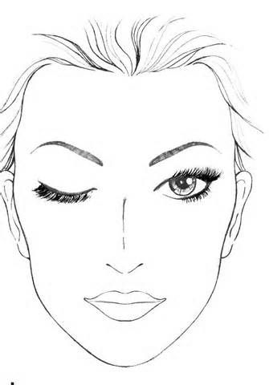

In the space below create your make up design.

Costume design
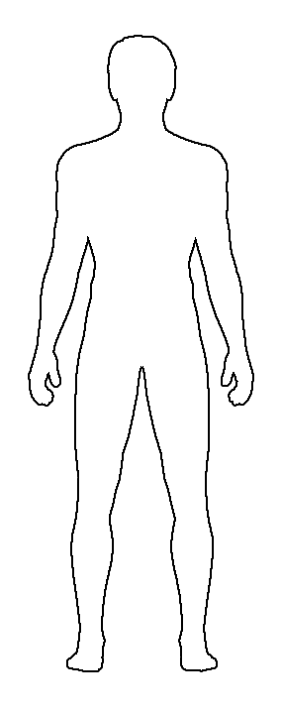
(Remember to label it and explain why the person may be wearing ripped jeans etc)

Costume design 2

DVD COVER DESIGN
Front cover.
Again, add some labelling explaining your design.

