Background information
Germ Theory was developed in 1860 and published in 1861 by Louis Pasteur. It revolutionised medicine because it finally showed the true cause of disease was infection by bacteria. However, Pasteur’s work alone did not provide the treatments for many diseases. Pasteur did create a vaccine for rabies in 1880, but the majority of vaccines and later chemical treatments were developed by other scientists who built upon Pasteur’s work. | 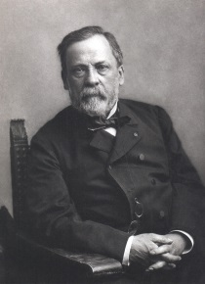  Louis Pasteur
Why did Germ Theory need developing?
There were two key limitations to Pasteur’s work:
- Pasteur was a chemist rather than a doctor. This meant that not only were his findings more scientific than medical, but his work was rarely directly relevant to humans. Pasteur himself was focussed on the cause of disease and infection more generally, but not so much the application to illness in humans.
- Pasteur had not proved that there were different germs which caused different diseases. His work was a broad theory on the cause of disease in general, rather than the causes of specific diseases.
For Germ Theory to be properly applied in medicine others were required to develop it. Robert Koch was the breakthrough scientist who applied Germ Theory to the treatment of disease.
Who was Robert Koch?
Koch was a German microbiologist with close links to medical professionals and he is now considered the founder of modern bacteriology. He saw Pasteur as his rival! Pasteur was a French scientist and Koch was German and at the time these two countries were in great rivalry. Koch was determined to find cures for more diseases than Pasteur, in some kind of medical competition. Koch was awarded the Nobel Prize in 1905 for his work on treating diseases. | 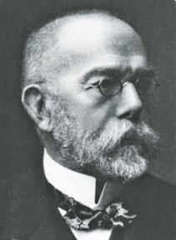  Robert Koch
What were Koch’s methods?
Koch is most famous for his methodology, as his scientific approach and dedication to rigorous experimentation not only made many breakthroughs in his own work and lifetime, but enabled the development of the science of bacteriology, leading to countless other discoveries since.
The most famous of Koch’s methods was that he invented a way to ‘stain’ bacteria with dyes, so that they could be more easily seen under microscopes. This led to a vast improvement of the ‘specificity’ of Germ Theory and experiments on germs. Doctors could see, separate and treat different types of germs for the first time. In doing this, Koch identified the bacteria that cause anthrax, tuberculosis and cholera. He and his team also isolated the causes of diphtheria, typhoid, pneumonia, plague, tetanus and whooping cough. Now they had isolated the cause of these diseases scientists could look for a treatment. In particular, Koch himself produced a serum to fight diphtheria which was used in Britain after 1895. This led to a halving of death rates by 1905. (A serum is a part of the blood that can be separated out to help fight disease.)
Koch developed a new experimental method to test whether a particular micro-organism is the cause of a disease. Building on Pasteur's work on Germ Theory, Koch used experiments to prove that the bacterium Bacillus anthracis was the cause of anthrax – the bacterium could be observed in the tissue of anthrax victims. He extracted this bacterium from a sheep which had died of anthrax, grew it and injected a mouse with it. The mouse developed the disease as well. Koch repeated this process over 20 generations of mice, before he announced in 1876 that he had proved this bacterium caused anthrax. This massively furthered Germ Theory, and its application to the understanding of specific diseases.
Koch continued to improve his methods and techniques. By solidifying liquids such as broth with gelatine and agar, for instance, he created a solid medium for growing bacteria which was easier to handle than the liquids used by Pasteur. Koch's assistant Julius Richard Petri (1852-1921) developed the Petri dish, which made the observation of bacteria even easier.
Robert Koch and microbe hunting
Staining bacteria
Use of microscopes
This helped Koch make progress because …
Tasks:
- Read the background information. Highlight or annotate the key terms and dates in this information.
- Read through the paragraphs on ‘What were Koch’s methods?’ Highlight methods in one colour, and highlight results in another colour.
- Use this information to complete the mind-map above.
- Using your prior knowledge, compare the work of Pasteur and Koch (similarities only).
Bonus: Research how vaccines can be used as an early form of treatment for diseases.

