Lesson 6

You will need to do some research to complete the following worksheet.

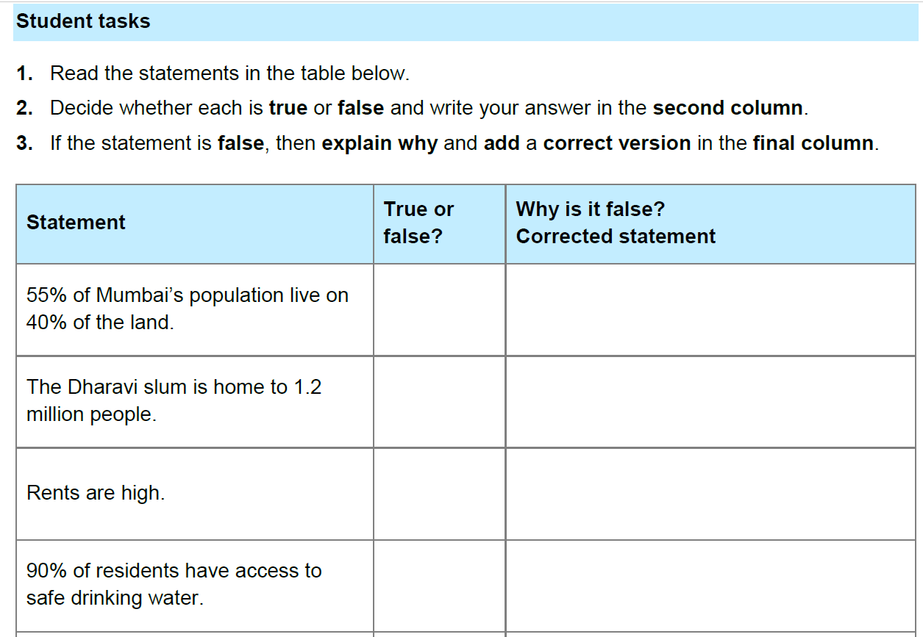

Now, check your answers. Correct in purple pen if necessary.

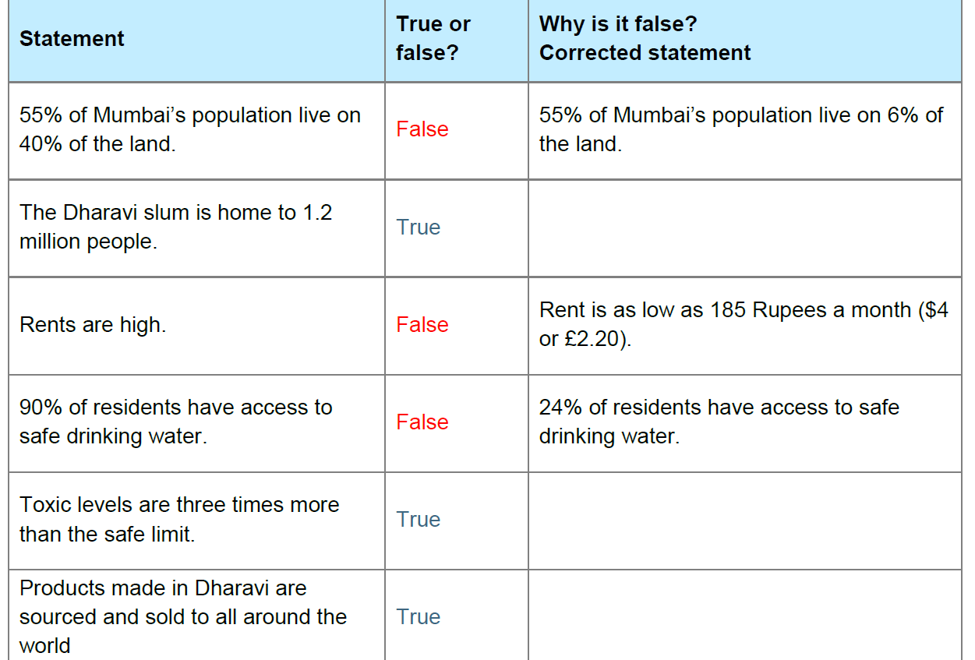

Assessment – To be handed in on return to school

If you do not have access to a printer, you might need to write the labels onto pieces of paper and cut them up.

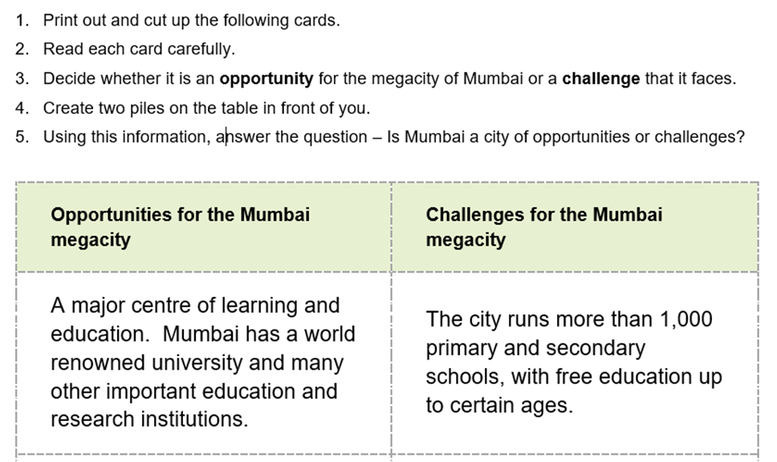

You should now have two piles of paper in front of you.

Stick these in your book if you want to.

Now,

Use the following structure for your work

Title
Is Mumbai a city of opportunity or challenges

Paragraph 1 | Describe where Mumbai is.  Explain what an ‘opportunity’ is.  Explain what a ‘challenge’ is
Paragraph 2 | Decide if you think Mumbai has more opportunities or more challenges. Say what you think and why.
Paragraph 3 | Write about the three most important opportunities in this paragraph.  Describe what each opportunity is. Explain why it is an opportunity and give an example of how it is a benefit to the city.
Paragraph 4 | Write about the three most important challenges in this paragraph.  Describe what each challenge is. Explain why it is an challenge and give an example of how it is a problem for the city.
Paragraph 5 | Sum up your findings and restate your decision. (Your statement in paragraph 2)

Finally

Using materials that you can find at home (and don’t worry if you do not have anything) – Build a model of a typical home in the Dharavi slum.

It should be no larger that 20cm square at the base, and no larger than 25cm tall.

