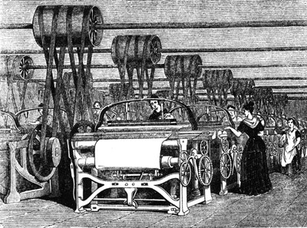
The changing UK economy:
Lesson 1

- Use the data below to describe how has the UK economy changed since 1800?

How the UK economy has changed since 1800. (each block = 10% - figures representative, not absolutely accurate).
1800
1900
2006
2015

Key:
Primary Industry
Secondary Industry
Tertiary Industry
Quarternary Industry

- Why has the economy of the UK changed?

- What is De-industrialisation? …………………………………………………………………………………………

………………………………………………………………………………………………………………………………

………………………………………………………………………………………………………………………………

Why did it occur in the UK?

- Globalisation: What is this and why did it lead to a change in the UK economy? ……………….

……………………………………………………………………………………………………………………………….

……………………………………………………………………………………………………………………………….

……………………………………………………………………………………………………………………………….

……………………………………………………………………………………………………………………………….

- Government policy:
2010 onwards
1979 - 2010
1945 - 1979

A post-industrial economy:
What is a post – industrial economy? | How has the use of information technology transformed life and work in the UK?  1.  2.  3.  4.
6. How have developments in IT affected the UK economy?  1.  2.  3.  4. | 7. How much does the service sector contribute to the UK economy? ___________  What does the finance industry include? __________________________________________________  How much of UK GDP is from finance?  How many people are employed?
8. Research:  Jobs:  £ to UK  Some UK research organisations: | 9. Describe the work of the British Antarctic Survey.
10. What is science park?  University of Southampton Science Park.  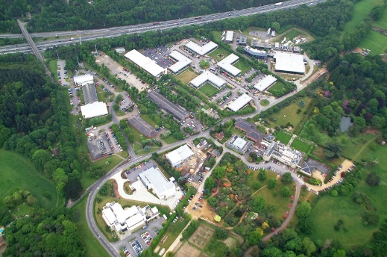  Date opened?  Examples of companies in the science park:  Benefits of the science park for companies?  1.  2.  3.  4. | 11. What is a business park?  Why are they usually located on the edge of towns?  a.  b.  c.  d.  Cobalt Business Park.  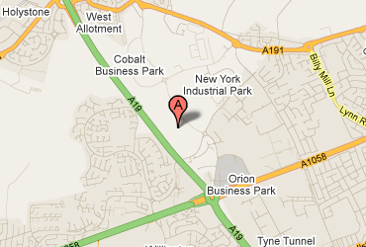  Describe the main features of the Cobalt Business Park.

