Lesson 4 The North-South Divide
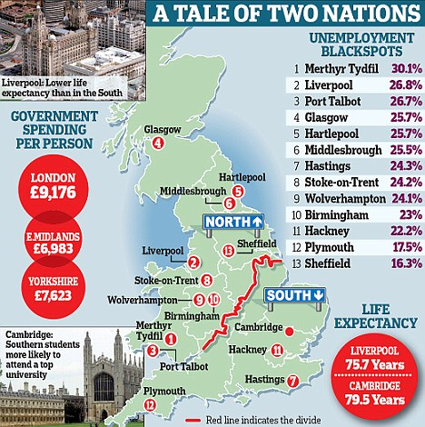
The north-south divide in the UK and strategies used in an attempt to resolve regional differences.

What is the north-south divide?

What evidence is there for the north-south divide?

Why is there a north-south divide?

Research Needed here
How can regional strategies address the issue?
A. Foreign investment: ________________________________________________________

B. The ‘Northern Powerhouse’: __________________________________________________
____________________________________________________________________________
____________________________________________________________________________
C. Transport improvements: ____________________________________________________
________________________________________________________________________________________________________________________________________________________
D. Enterprise zones: ___________________________________________________________

What is a local enterprise partnership?

How does the Lancashire LEP plan to encourage more business in the area?

