Lesson 5
The place of the UK in the wider world. Links through trade, culture, transport and electronic communication.
What international organisations does the UK belong to? (Remember, we do not leave the EU until January 2021 – you may still need to answer a question about it).

Rank order the top 10 countries that the UK exports to. Shade in the EU countries. (Trade)  1.  2.  3.  4.  5.  6.  7.  8.  9.  10. | 47 .Rank order the top 10 countries that the UK imports from. Shade in the EU countries. (Trade)  1.  2.  3.  4.  5.  6.  7.  8.  9.  10
What is culture?

What cultural links does the UK have with the rest of the world?

What transport links do we have with the rest of the world?

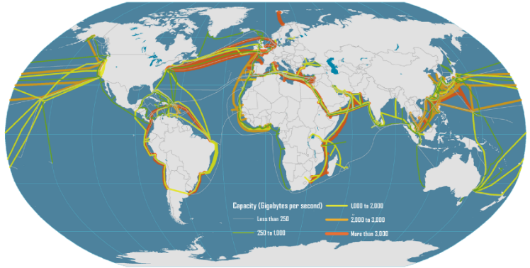
Describe and suggest reasons for the pattern of submarine e-communication cables shown on the map.

How does the UK benefit from having close links with the rest of the world?

