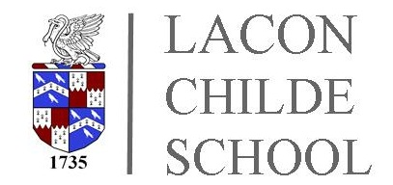

FREE SCHOOL MEAL INFORMATION

Families who receive certain benefits may be eligible for free school meals. Your child is eligible for free school meals if you are in receipt of one of the following benefits:

- Universal Credit with an annual net earned income of no more than £7,400.
- Income Support
- Income-based Jobseeker’s Allowance
- Income-related Employment and Support Allowance
- Support under Part 6 of the Immigration and Asylum Act 1999
- The guarantee element of Pension Credit
- Working Tax Credit run-on (paid for the four weeks after you stop qualifying for Working Tax Credit)
- Child Tax Credit (with no Working Tax Credit) with an annual income of no more than

Parents/carers can make an application online through the Shropshire Council website :

https://www.shropshire.gov.uk/free-school-meals/apply-for-free-school-meals/

October 2020

