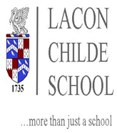
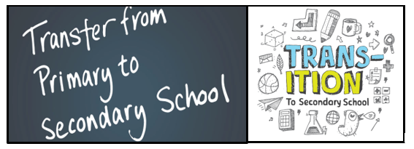

Welcome to the transition section of the Lacon Childe School Website.
We aim to make parents and new students feel confident about moving to our school and to make sure that there is highly effective transition from our outstanding feeder primary schools.
If you have any queries regarding transition, please email Kristien Wood : Transition Manager and he will endeavour to answer any queries promptly: kristien.wood@laconchildeschool.co.uk

We believe that you will have a great time at Lacon Childe School and we look forward to welcoming you. Young people excel at Lacon Childe with opportunities in the arts, drama, on the sporting fields, practical-based learning, as well as traditional academia. Children develop into young adults developing life skills. The five years pass by very quickly; the children who arrive in Year 7 flourish and become confident, ready for their next steps and roles in the wider community and life after Lacon.
Lacon Childe School continues to be a popular option for the continued education of children with the school being over-subscribed and accepting children from eighteen different feeder primary schools.
The school offers Taster Days for children in Year 5 and Year 6 (Pre-Covid), enabling them to get a real feel for the school and experience a day in the life at Lacon Childe School. These days are not possible currently, but tours of the school can be arranged.
We look forward to greeting you at Lacon Childe School in the future
Kristien Wood
Transition Manager / Head of Year 7

