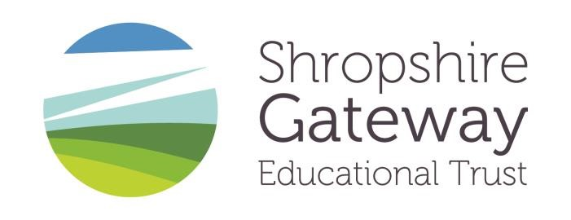
Lacon Childe School
Teacher of Science (temporary maternity cover)

Teacher of Science
MPS/UPR
Required for September 2022
This is an exciting opportunity for an enthusiastic teacher to deliver Science at Lacon Childe School.
Science is a thriving and very popular subject at Lacon Childe School. At Key Stage 3 Science is taught three times a week, where pupils have one lesson of Biology, Chemistry and Physics each taught as separate subjects by separate teachers. At Key Stage 4 all pupils follow the Edexcel Combined Science specification, with 9 hours a fortnight split into three lessons of each Biology, Chemistry and Physics. There is also the opportunity to opt for the Separate Sciences course where pupils then have an extra 5 hours a fortnight of Science lessons.
Science is taught in dedicated laboratories, it is well resourced with a full-time technician.
The successful candidate will be able to teach Chemistry and Biology at Key Stage 3 and 4 and will be able to inspire learning, promote interest in the subject and ensure high achievement, both within the curriculum and through extra-curricular activities such as lunch time clubs.
Applicants must be outstanding and motivated and able to demonstrate a commitment, initiative and a can-do approach. They must be willing to make a contribution to the full life of the school and to ensure that all our students achieve the best possible outcomes.
Full details and an application form can be found on our website www.lacon-childe.org.uk or contact gill.bradley@laconchildeschool.co.uk
Please submit your application form and covering letter by email to the above address by closing date: Monday 13th June 2022 at 9am.

The school and Trust are committed to safeguarding and promoting the welfare of children, young people and vulnerable adults and expects all staff and volunteers to share this commitment. Rigorous child protection procedures are in place. Appointments are subject to an Enhanced DBS check and appropriate pre-employment checks.

Registered Office: Lacon Childe School, Cleobury Mortimer, DY14 8PE
Company number 9115941

