LACON CHILDE SCHOOL PE 2023-2024

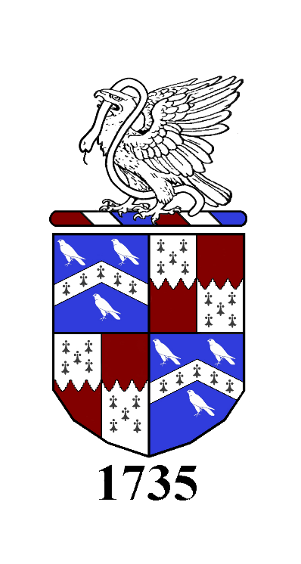

WELCOME
The P.E. department at Lacon Childe School are hard-working and extremely enthusiastic about sport, health and participation, while setting high standards for themselves and pupils. We are committed to delivering a curriculum that provides pupils with key knowledge and understanding as well as developing skills and allowing students to challenge themselves.
The teaching and learning environment are very positive and the curriculum we offer has a wide variety of activities giving pupils the opportunity to find something that they enjoy and can succeed in. Our aim is for pupils to be competent in a broad range of activities and enjoy their PE journey in lessons, through extracurricular activities and competitions.
PE kit:
All students are required to wear a Lacon logo PE polo, which can be purchased from the school shop. A black PE jumper is also available to purchase. Initials are not required. Black PE hoodies are no longer allowed. Girls can wear Lacon logo black leggings; these should be ankle or 3/4 in length. Any other leggings are not allowed. Boys and girls can wear black unbranded shorts. Lycra or cycling shorts are not allowed. All of these items can be purchased from the school shop.

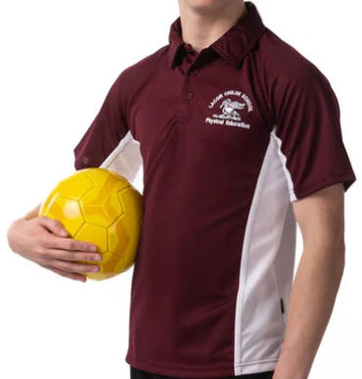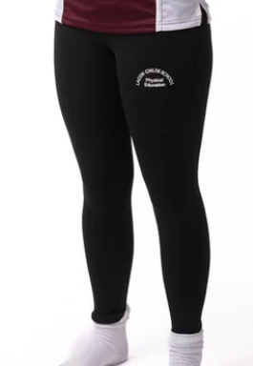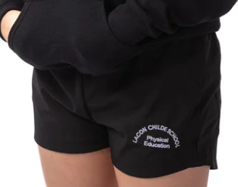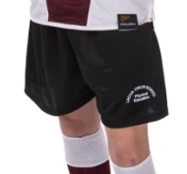

It is advisable that students also have plain black knee-high socks for hockey and football. Students should bring white socks for all other activities. It is advisable that girls wear a sports bra for comfort and injury prevention during all PE lessons.
All students should have suitable trainers and moulded boots for outdoor activities. Shin pads for football and hockey will be provided and although gumshields for hockey and rugby are recommended, it is up to students to wear them. The PE staff do ensure the risk of injury to mouth is minimal in lessons.
NB: current students don’t need to buy new kit e.g. black cocks, unless and until they’re no longer wearable.

PE kit rules and sanctions:
Pupils are expected to bring PE kit into every lesson – ‘Sick or fit, bring your kit’. We strongly believe that PE develops the whole person, not just the performer, and wearing PE kit will allow the non-doers to adopt different roles in lessons more effectively and feel part of the group, if unable to take part in lessons as a performer.
Any student who forgets/fails to wear the correct uniform, will have their conduct card signed. If PE kit is forgotten, the PE department will be able to provide students with clean sports clothing where needed. However, persistent/deliberate wrong or missing kit will result in break and lunch time detentions and further action from subject lead/year lead where needed.
Non-doers:
Students must bring a note if they can’t participate in PE, and if the illness/injury is long term, a note from a doctor is also required. Pupils will be expected to get changed even if they have a note excusing them from taking part in physical activities (‘Sick or fit, bring your kit’) and they will take on the role of a coach/leader/referee. If pupils’ injury makes it hard/painful to get changed (e.g. broken wrist), they will stay in their uniform.
Jewellery and nails:
All jewellery (earrings, nose studs, necklaces, belly button piercings etc.) must be removed for all lessons and taping is not allowed. We strongly suggest that pupils do not get their ears pierced until the summer holidays. Nails need to be sufficiently short and fake nails are not allowed. Due to health and safety, any student who fails to follow these rules will not be able to take part in lessons as a performer. Conduct card will be signed every time this happens, and a break and lunch time detention will be set due to not being able to take full part in lesson.
As a department, we pride ourselves on the wide range of opportunities we provide for our students and strongly believe that respect for the rules and expectations helps pupils grow into respectful and well-presented members of our community, who are proud to represent the PE department in the best way possible. We want to lead by example and will also aim to show the highest standards of presentation, attitude, and sportsmanship into all that we do.
Assessment:
Students will be assessed at the end of each unit of work. Each sport and activity, focuses on the different areas of ‘Me in PE’ with the aim of developing the whole person.
Assessment
The focus is on pupils’ ability to perform the core skills both in isolation and ever-demanding situations.
The focus is on pupils’ ability to work as part of a team, their leadership skills, and the effectiveness of their communication with other pupils.
The focus is on pupils’ ability to solve problems, using different tactics in different situations to be successful, and their ability to assess and evaluate others and provide feedback on their peer’s performance.
The focus is on pupils’ knowledge of health and what it means to be healthy. Knowledge of the body and activity levels are also assessed in this strand.
Social ME Physical ME Thinking ME Healthy ME

LACON CHILDE PE LEARNING JOURNEY
Lacon ME in PE .
PRIMARY
OUTREACH
AND
FESTIVALS
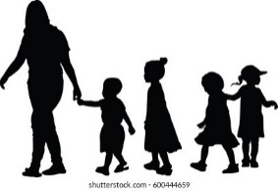

Before their Lacon ME journey, primary pupils are introduced to a range of skills and competitions, in and outside of Lacon Childe School, to start developing their Social, Physical and Thinking skills, as well as educate them about Health in physical activity and sport.

7
YEAR

In Year 7, pupils are introduced to a range of sports where they are mainly assessed on Physical ME and Social ME, building a strong base of skill and collaboration at the start of their journey. Pupils have an OPPORTUNITY to take part in a broad curriculum.

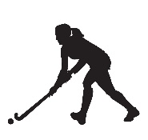
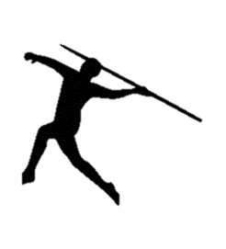
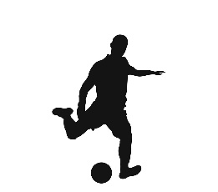
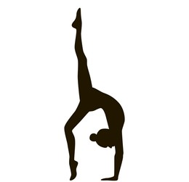
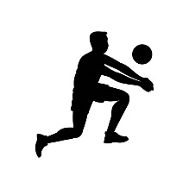

OPPORTUNITY
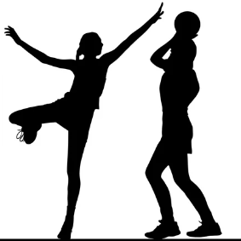

8
YEAR

In Year 8, pupils’ skills are developed further to allow clear PROGRESS in their performance and understanding of physical activity and sport, with an additional focus on Thinking ME and Healthy ME. Further opportunities for competition and tactical play are introduced.
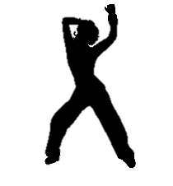

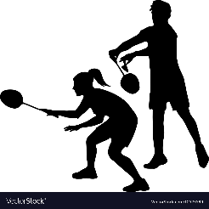

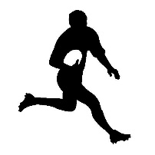
PROGRESS

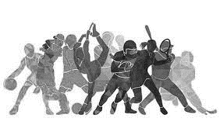
Progress into further education in Physical Education/Sport
Continued lifelong participation.
Elite performance
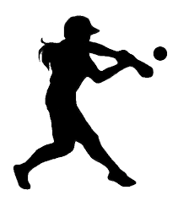

In Year 11, pupils choose which activities they want to take part in so that their ENGAGEMENT in sport and physical activity is as high as it was at the start of their journey. A range of opportunities provide different pathways for all students to take on as they leave Lacon Childe School.
10
YEAR
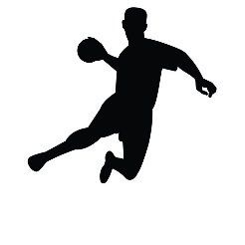

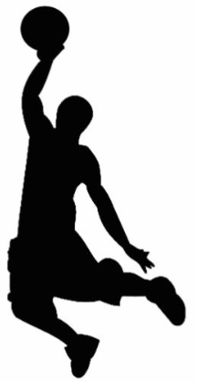
ENGAGEMENT

In Year 10, an INCLUSIVE approach to sport and physical activity means that students can start thinking about future in PE through two different pathways, GCSE and BTEC PE. Other INCLUSIVE sports to increase participation are also introduced.

10
YEAR

INCLUSION

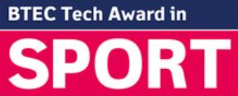
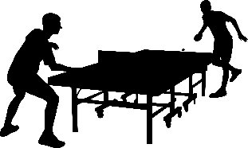
ENGAGEMENT
11
YEAR

In Year 9, pupils will have a well-developed skills base and tactical knowledge for a range of activities. Further physical activities are introduced to allow ENJOYMENT of being physically active, healthy, and competitive.

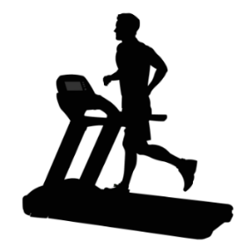
9
YEAR

ENJOYMENT
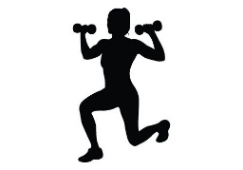

EXTRACURRICULAR AND FIXTURES PROGRAMME

At Lacon Childe, we are committed to offering a wide range of extracurricular opportunities and fixtures to give students possibilities to develop in their chosen sport or activity competitively or as part of leading healthy and active lifestyles. Sport fixtures are organised regularly against local schools and see our students take part in competitions in and around Shropshire. A great number of sports at Lacon are also delivered by specialist staff and coaches. From national level players and coaches in hockey, rounders, football, and volleyball; to experienced performers in boxing, tennis, netball, and badminton. We are passionate about providing our students with the highest levels of knowledge and experience.
Our extracurricular opportunities aim to develop experiences, teamwork, and social skills in a safe environment, which is why students are not allowed to use their phones until they leave the school premises or are collected by parents. Use of social media, text messaging and photo/video can make pupils vulnerable and at risk. Although we encourage all students to bring their phones with them for emergency contact purposes, or phones will need to be handed in for the duration of the fixture. Any student who fails to follow the rules will not be able to take part in away fixtures.

MEET THE PE TEAM

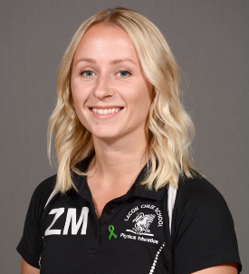
Mr S Edmondson
Teacher of Physical Education
Samuel.Edmondson@laconchildeschool.co.uk
Mrs Z Traylor
Subject Lead of Physical Education
Zaneta.Traylor@laconchildeschool.co.uk

Mr K Wood
Teacher of Physical Education
Assistant Headteacher
Kristien Wood@laconchildeschool.co.uk
Mrs R Croxton-Broome
Teacher of Physical Education
Deputy Headteacher
Rachel.CroxtonBroome@laconchildeschool.co.uk

Mr S Adams
Behaviour Mentor
Steven.Adams@laconchildeschool.co.uk
Mrs K Guise
Teacher of Physical Education
Assistant Headteacher
Kara.Guise@laconchildeschool.co.uk

